目录

目录 1

**一、** **S2S简述** 3

**二、** **S2S配置记录** 6

1. 实例验证 6

1.1 开启配置工具 6

1.2 打开配置工程 6

1.3 Check/Code 8

2. 上位机配置 9

2.1 DBC文件加载 9

2.2 CAN模块绑定 11

2.3 GeneralConfiguration配置 12

2.4 SignalToService配置 16

2.5 CM 23

2.6 APP配置 26

**三、** **Linux编译环境执行** 36

1. SVN Check code 36

2. Source FileName 36

3. Get sdk 36

4. Source工具链 36

5. 生成sdk设置 36

6. Make setup 37

7. 编译 37

8. Sdk放置路径 37

9. 上位机连接 37

10. 上位机build 38

**四、** **CAN模块代码** 40

1. 手写代码 40

2. 上位机生成 42

**五、** **S2S模块代码** 43

1. 手写代码 43

2. 上位机生成 44

**六、** **阅读py代码：需要维护** 45

1. 解析dbc到上位机 45

1.1 analyzeDbc() 45

1.2 generateISignal() 46

1.3 generateCanCluster() 46

1.4 generateECUC() 47

2. 上位机Generate code 48

2.1 模块py解析注册 48

2.2 S2s部分 48

2.3 Can部分 50

七、 后续待办 52

**八、** **函数调用关系（自写和自动）** 53

1. APP接收ABM2_VehDynYawRate信号 53

2. APP发送ACC1_RollingCounter_ACC1 54

**九、** **开发工具安装** 55

1. 安装eclips，并使其GeneralCode 55

1.1 安装失败 55

1.2 安装成功 55

1.3 环境配置 56

2. 安装Artop 59

十、 设备调试 61

1. CRT串口连接设备 61

2. 开发板下载程序（S2S） 63

(1) 虚拟机进入opt路径下 63

(2) scp拷贝文件夹到开发版本的制定目录 63

(3) 虚拟机上传成功 63

(4) 开发板查看上传文件 64

(5) 运行进程 64

十一、 需阅读资料 65

十二、 上位机与Linux连接失败 65

1. **S2S简述**

S2S（Signal To Service）：为客户提供信号与服务之间——映射的配置，当需要发送信号时，可通过服务的发送接口，S2S颞部会将对应信号发生出去；

19_03:

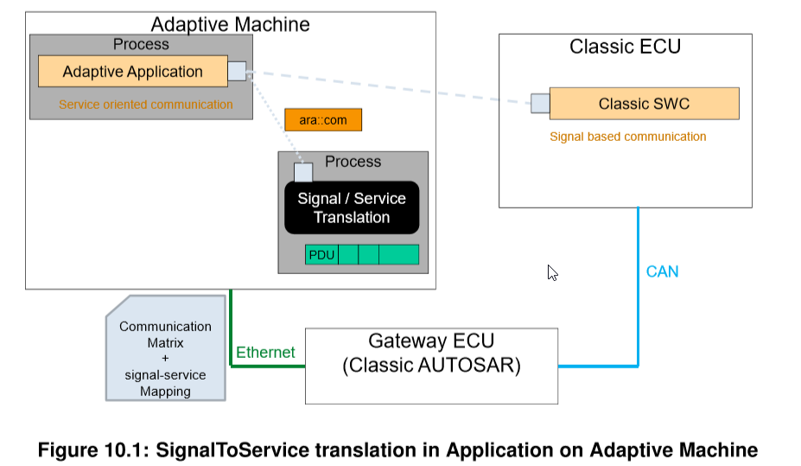

1903具体实现：

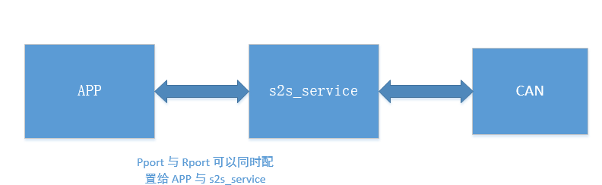

19_11:

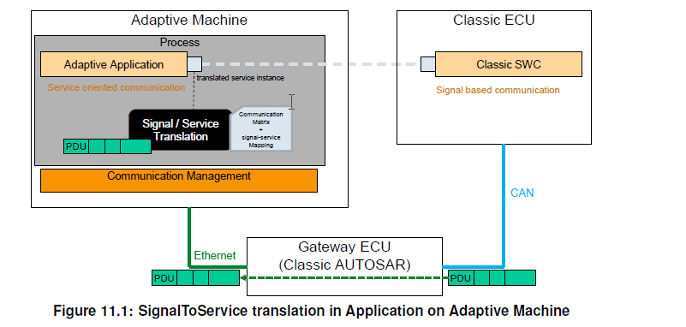

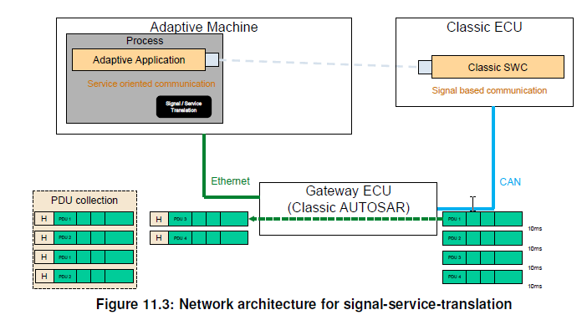

1903/1911差异点：

|  |  |  |
| --- | --- | --- |
|  | 1903 | 1911 |
| 守护进程 | AP和S2S各自一个Process | AP和S2S共用一个Process |
|  | 1. ECU直接CAN连接发送到Ethernet口（LinuxCan Drive）; 2. S2S接收+解析+映射服务，发送给AP； | 1. ECU通过以太网发送到Ethernet口CM模块; 2. S2S通过CM_API获取Pload数据+解析+映射服务，发送给AP； |
| 上位机配置/服务映射 | ProvidedUserDefineserviceInstance | ProvidedSomeipServiceInstance |
|  |  |  |

19_11信号源区分：1903目前只支持同源单元素；

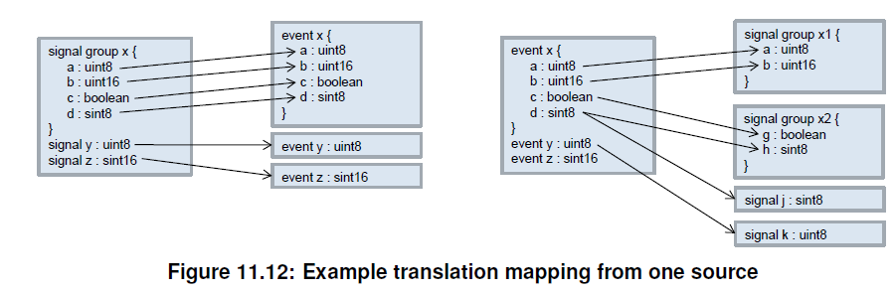

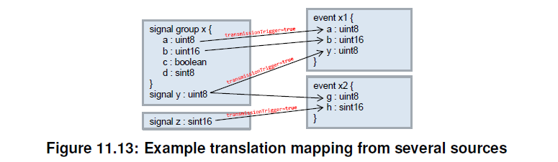

1. **S2S配置记录**
2. 实例验证

以19_03为例验证S2S上位机配置。

* 1. 开启配置工具

上位机配置工具：

D:\SDC-EOS-aCore\SourceCode\tools\配置工具运行程序\NeuSAR Adaptive Tool.exe

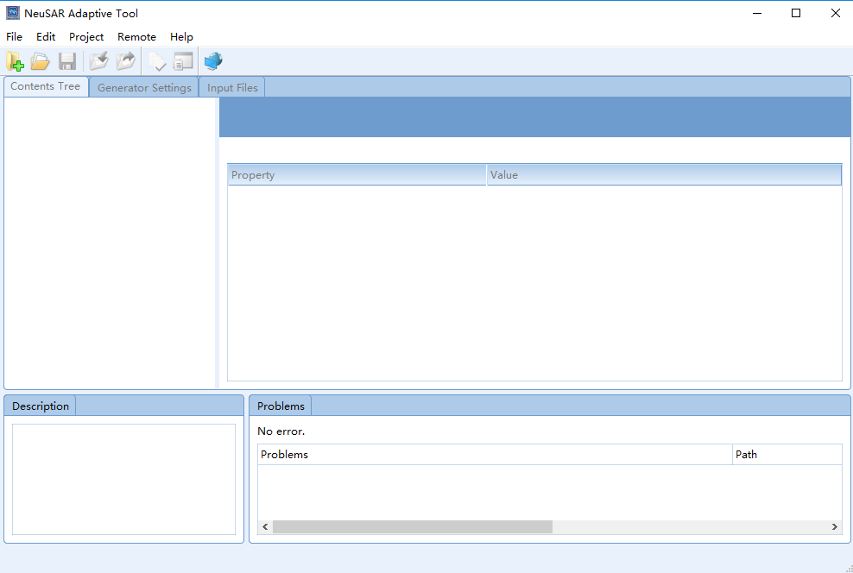

* 1. 打开配置工程

D:\SDC-EOS-aCore\SourceCode\tools\配置工具运行程序\configFile\initialConfig\initialConfig.neusarpro

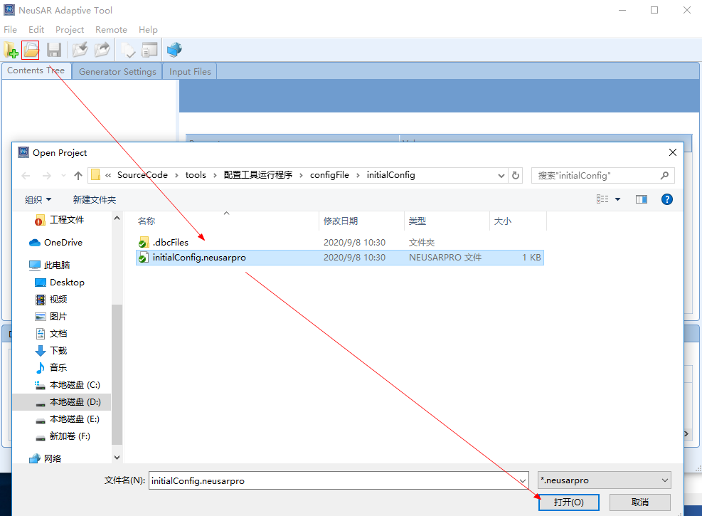

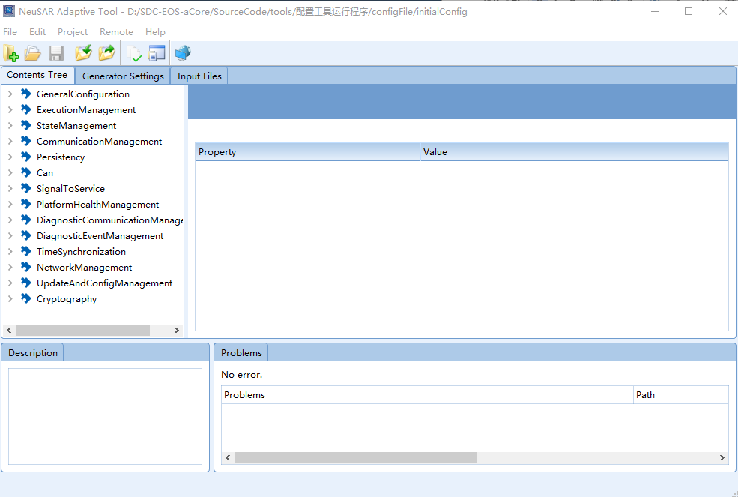

**注意：**

加载的initialConfig工程无上位机配置，加载对应模块的配置文件，选择如下；

[文件] 🡪 [Import] 🡪 [+] 🡪 选择需要加载的arxml（如下图）。

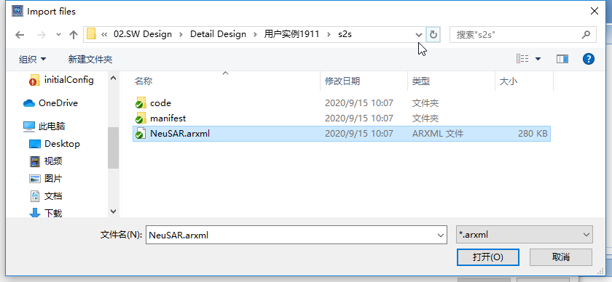

* 1. Check/Code

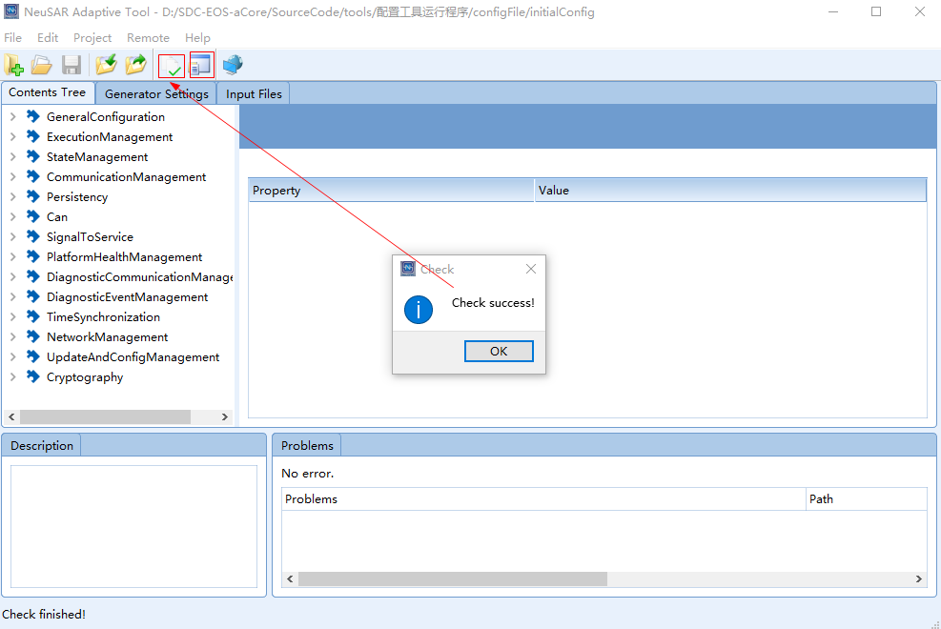

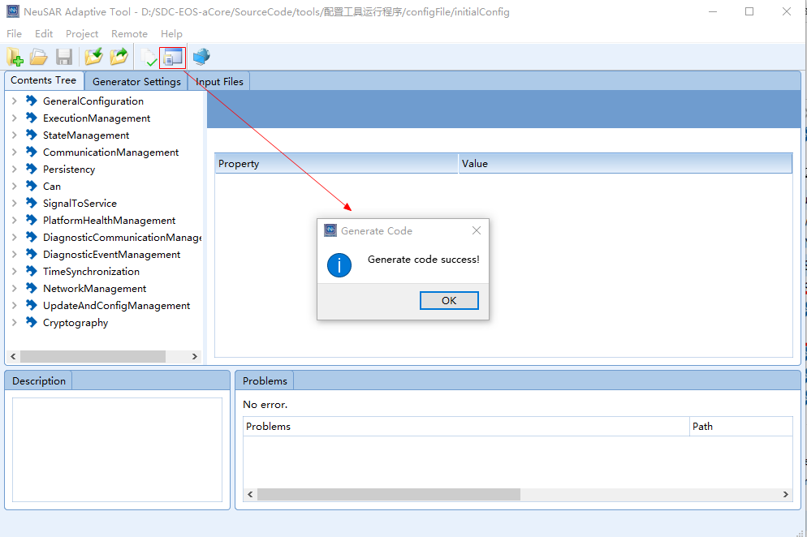

Check和Code成功后，生成output文件夹（**文件夹内容待解析**???），目录如下；

D:\SDC-EOS-aCore\SourceCode\tools\配置工具运行程序\configFile\initialConfig\output

成功后，再按照（二、Linux编译环境执行）；

1. 上位机配置
   1. DBC文件加载

DBC文件用户提供：DBC内signal数据格式在配置时用（一、2.4.4）；

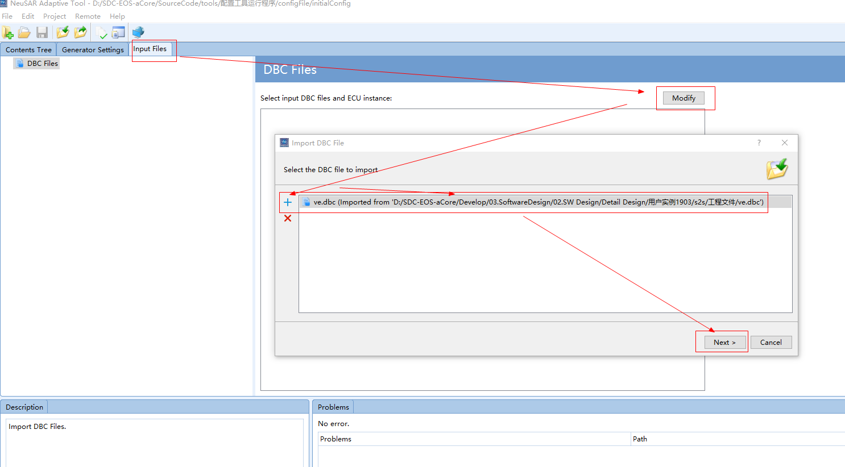

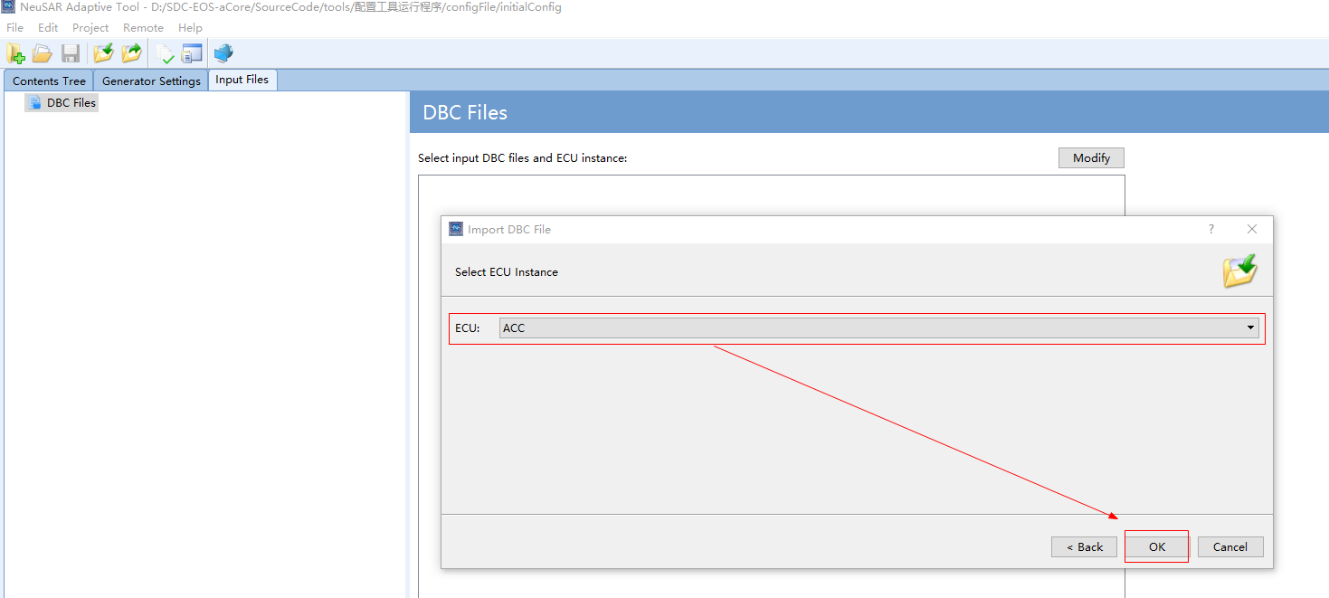

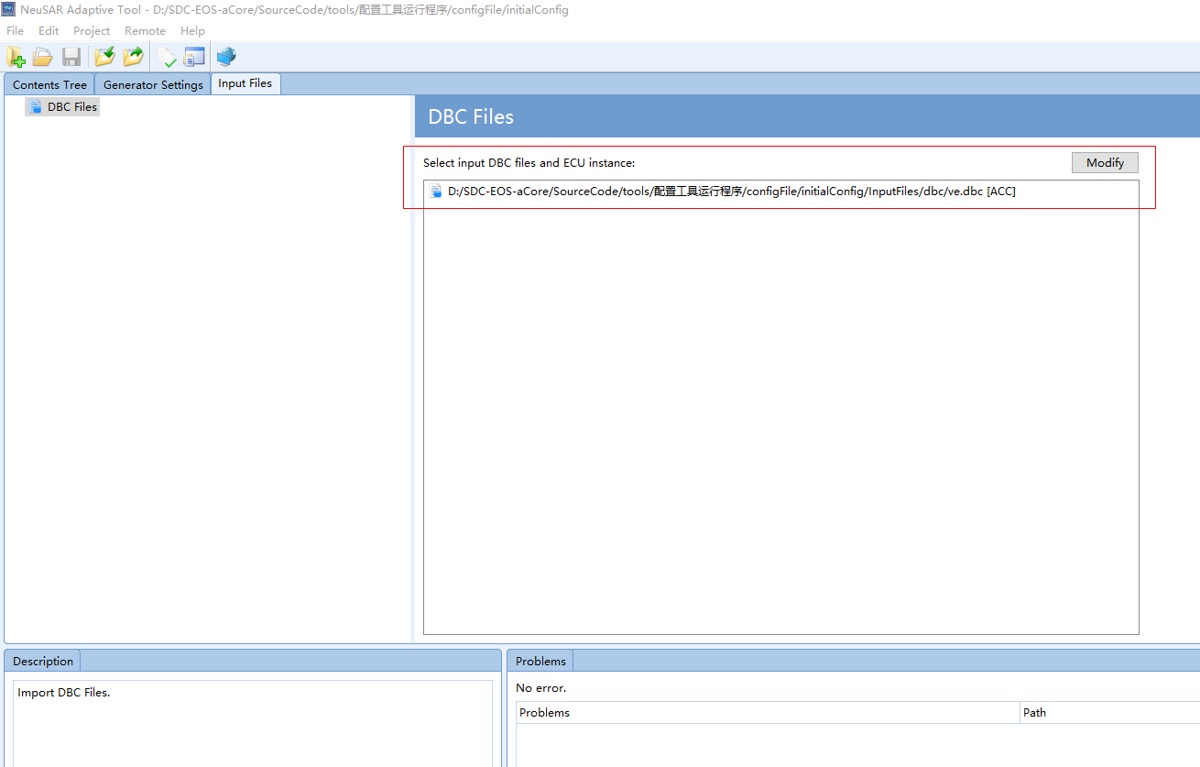

* 1. CAN模块绑定

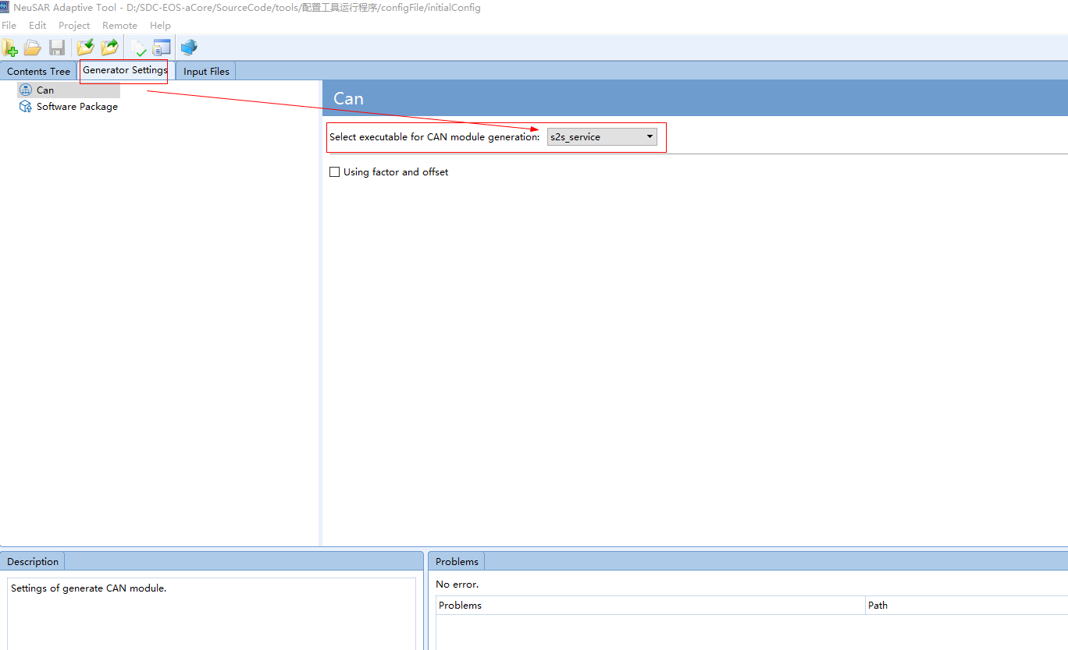

注意：

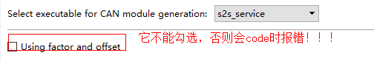

作用：特殊运算（例如偏移运算、负值运算等）；

原因：运算中存在浮点类似数据，而代码中接收或发送目前全部为整型（int8/16/32）;

如协调代码所示：D:\SDC-EOS-aCore\SourceCode\tools\tools1911\配置工具运行程序\configFile\initialConfig\output\code\s2s_service\can\src\ComArray.cpp

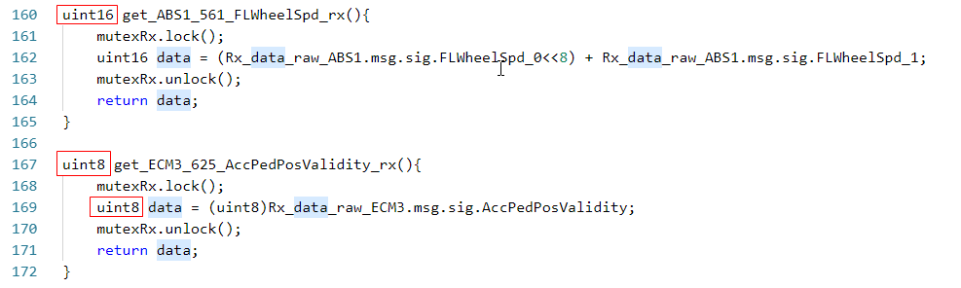

后续修改方案：

处理Using factor and offset的是Py代码，如下。

D:\SDC-EOS-aCore\SourceCode\tools\jsonGenerator\modules\can\CreateComArrayC.py

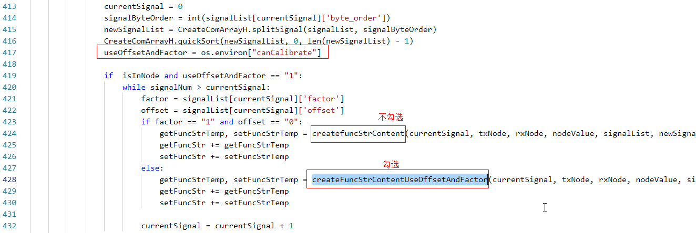

* 1. GeneralConfiguration配置

此部分为aCore平台的应用运行时需要的一些基本配置；

* + 1. SWC配置（s2s_service是默认配置）

本功能集群使用的ServiceInterface在上位机中属于默认配置，在创建新工程的时候，会默认带上ServiceInterface本身的配置（即S2SServer和S2SClient）。

但是需要手动添加AdaptiveApplicationSwComponetType下的PPort和RPort，使之引用ServiceInterface。

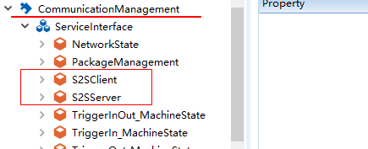

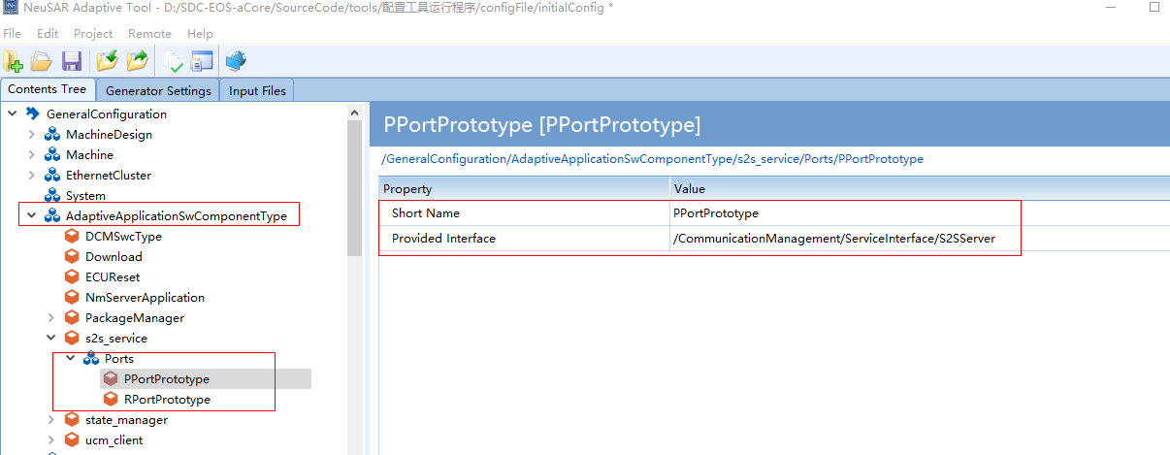

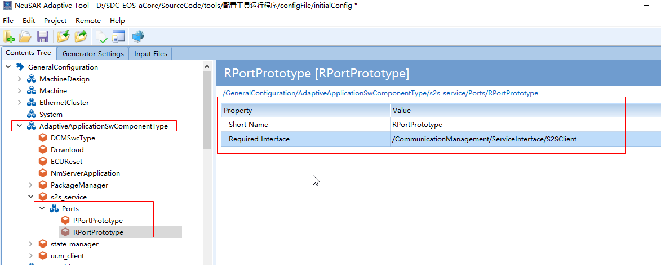

* + 1. Executable配置（默认配置）

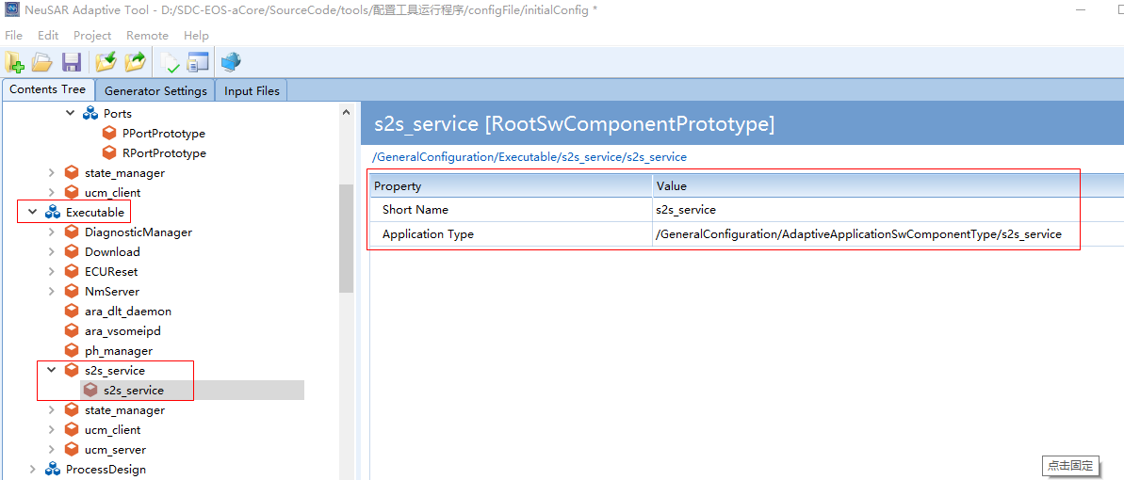

* + 1. ProcessDesign配置（默认配置）

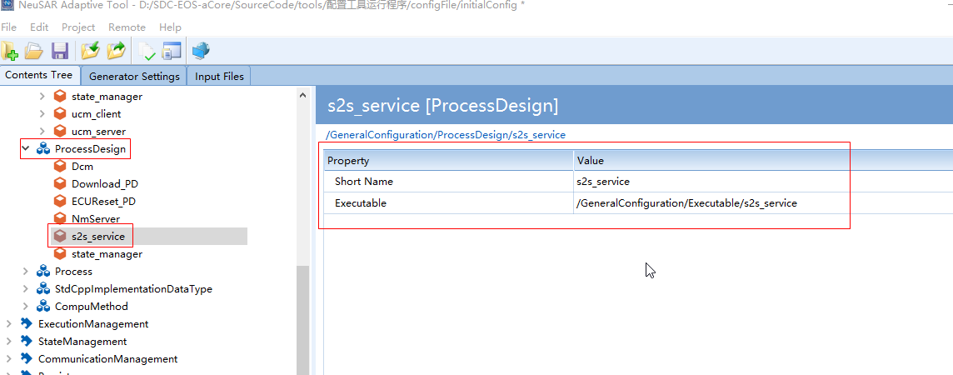

* + 1. Process配置（默认配置、Log配置）

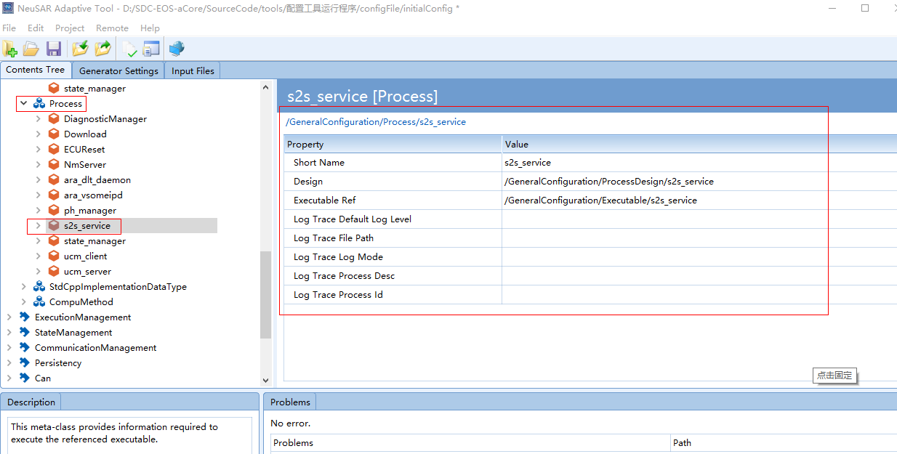

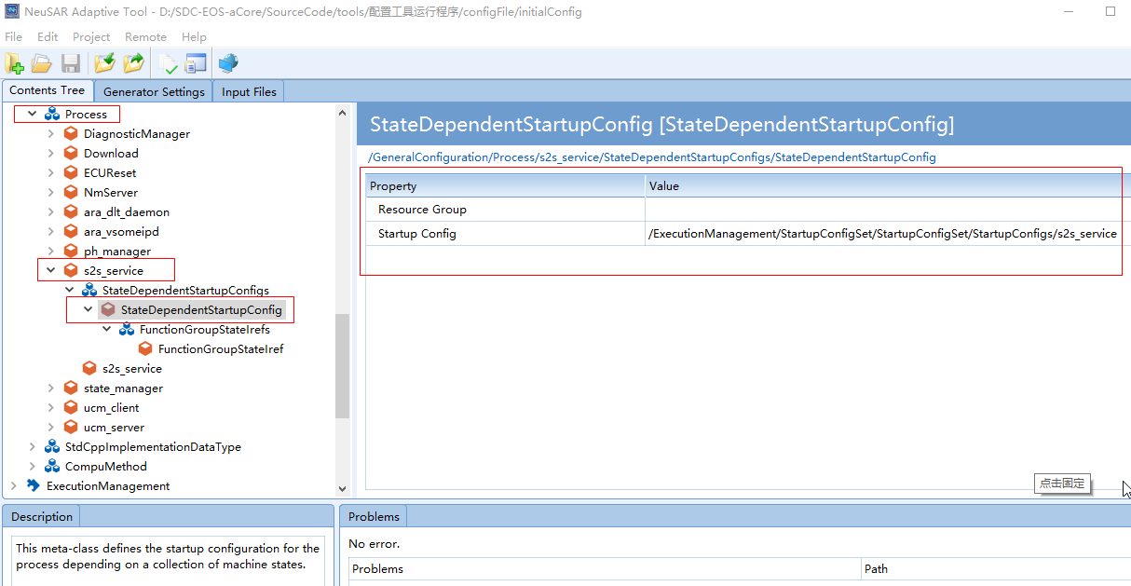

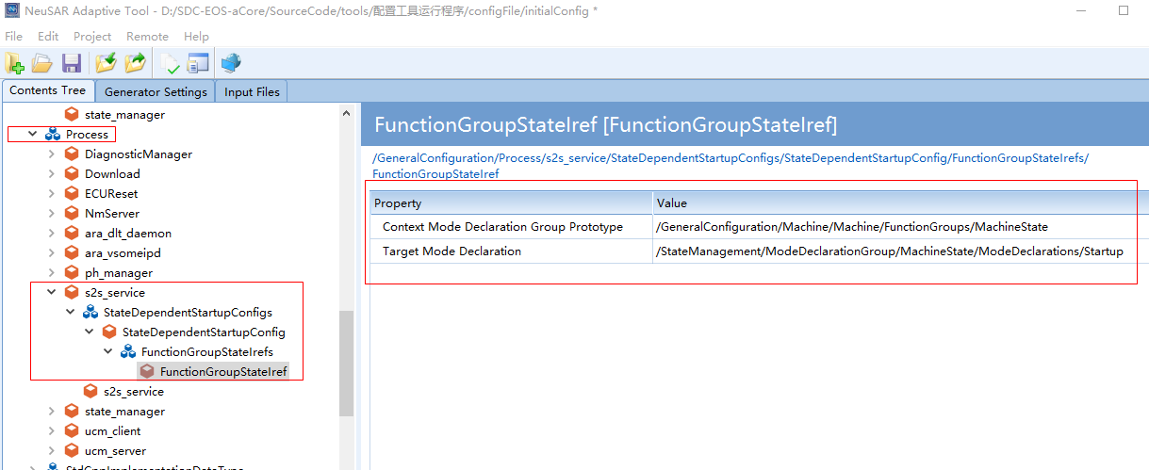

* 1. SignalToService配置
     1. Signal定义（加载dbc）

I-Signals在加载（2.1）dbc文件时自动导入信号(参阅七、1)；

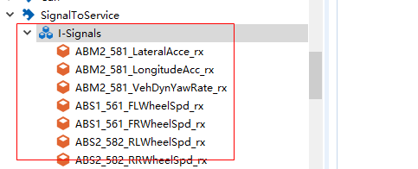

* + 1. Signal触发器（加载dbc）

此节点与上面的信号定义节点存在一一对应关系，导入dbc时生成。

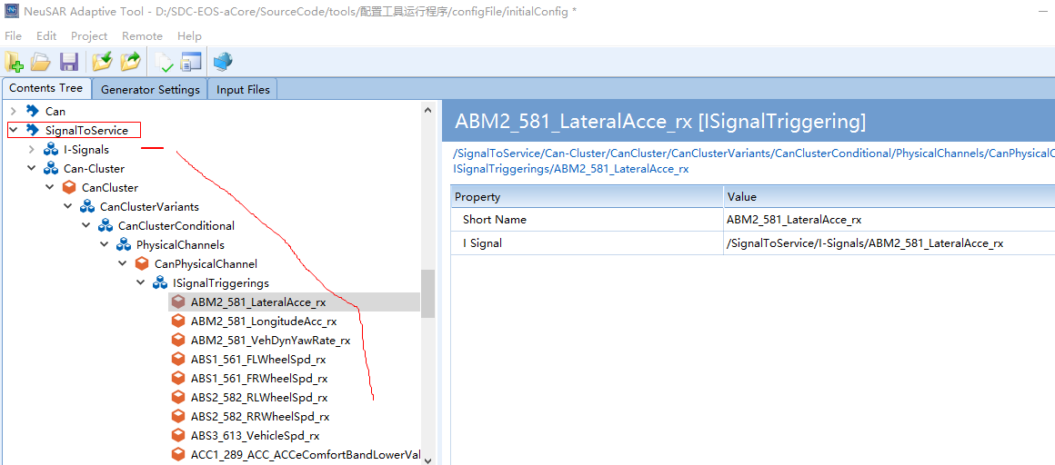

* + 1. Instance和mapping配置

这个容器内部会映射这个instance下的interface与上面定义的signal的一一对应关系，instacne与interface是在CommucationManagement下定义的节点。

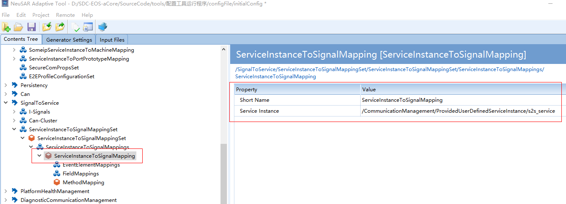

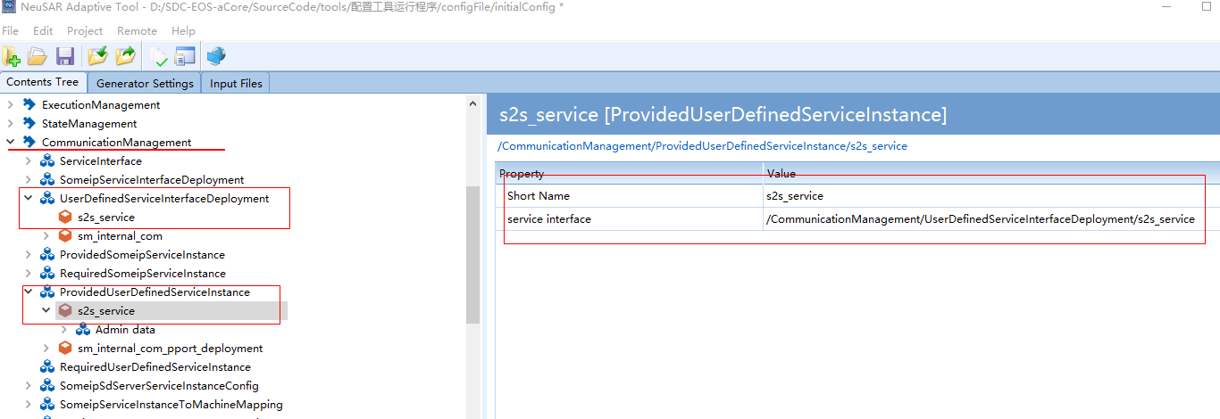

* + 1. Signal发送方式配置

2.4.4.1 定义信号event发送

接收与发送信号的定义方式

|  |  |
| --- | --- |
| Event方式发送的信号 | 对应的event定义在S2SClient下 |
| Event方式接收的信号 | 对应的event定义在S2SServer下 |

例如：要发送ACC1_RollingCounter_ACC1信号，在S2SClient（默认配置）下定义对应interface

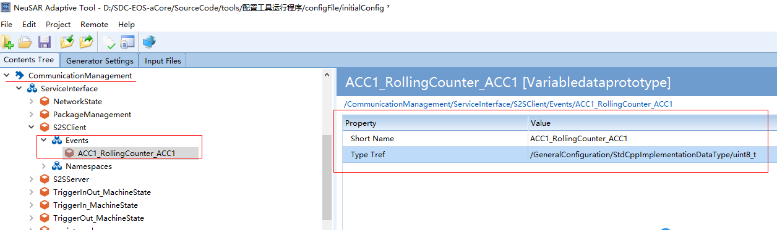

接收信号ABM2_VehDynYawRate，在S2SServer（默认配置）下定义对应interface

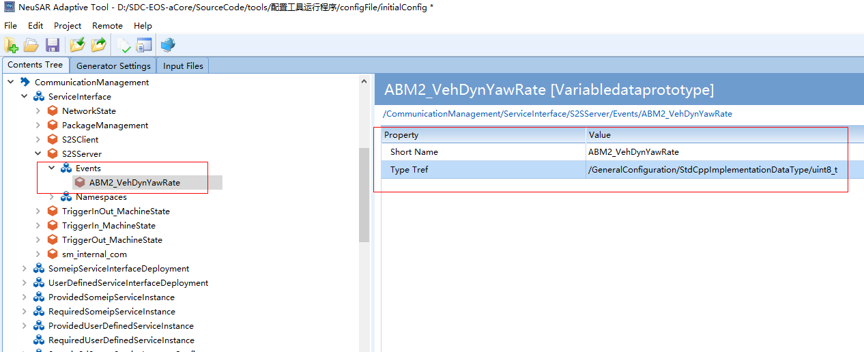

定义event与信号触发器的映射（SignalToService下节点）

选择信号触发器（上面导入dbc后自动生成的trigger）

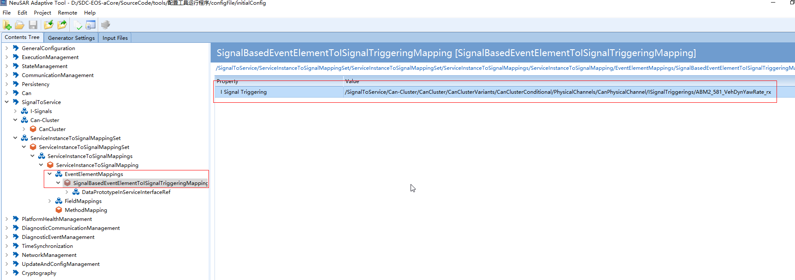

定义信号触发器映射的interface，需要引用上面定义的interface

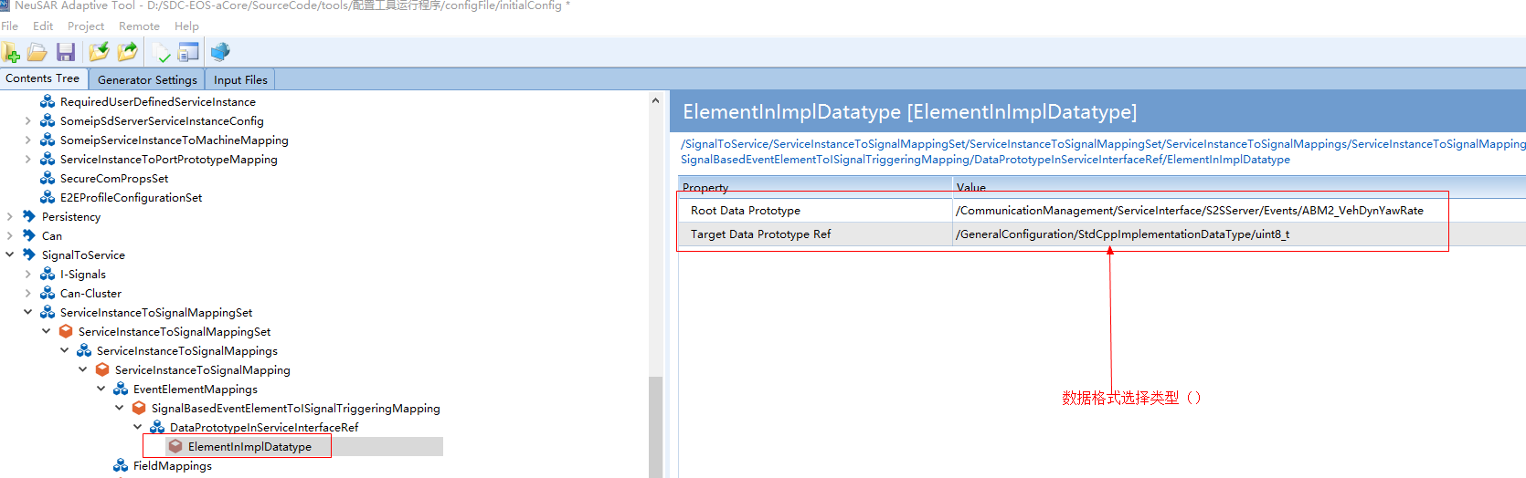

2.4.4.2 定义信号field发送

接收与发送信号的定义方式

|  |  |
| --- | --- |
| Field方式发送的信号 | 对应的Field定义在S2SClient下，set为false，get、notify为true |
| 对应的Field定义在S2SServer下，set为  true，get、notify为false |
| Field方式接收的信号 | 对应的Field定义在S2SClient下，set为true，get、notify为false |
| 对应的Field定义在S2SServer下，set为  false，get、notify为true |

例如：ABS3_VehicleSpd，SAS1_SteeringWheelAngle为要接收信号ABS3_VehicleSpd的set为true，get、notify为false，SAS1_SteeringWheelAngle的set为true，get、notify为false（此处用例设置与描述不符合）。

ACC2_ACC_ABA_Level的set为false，get、notify为true，ACC_ShutdownMode的set为true，get、notify为false。

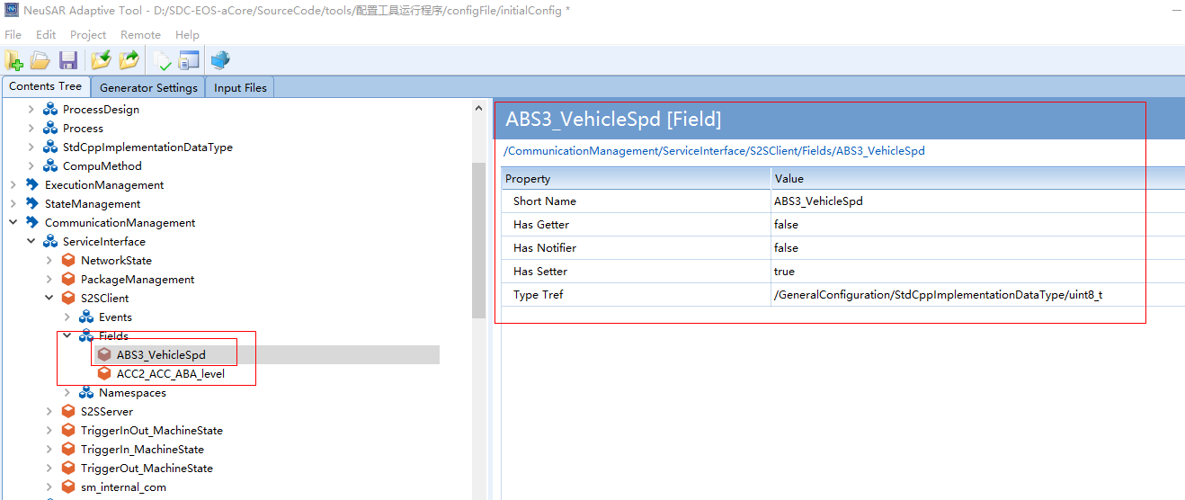

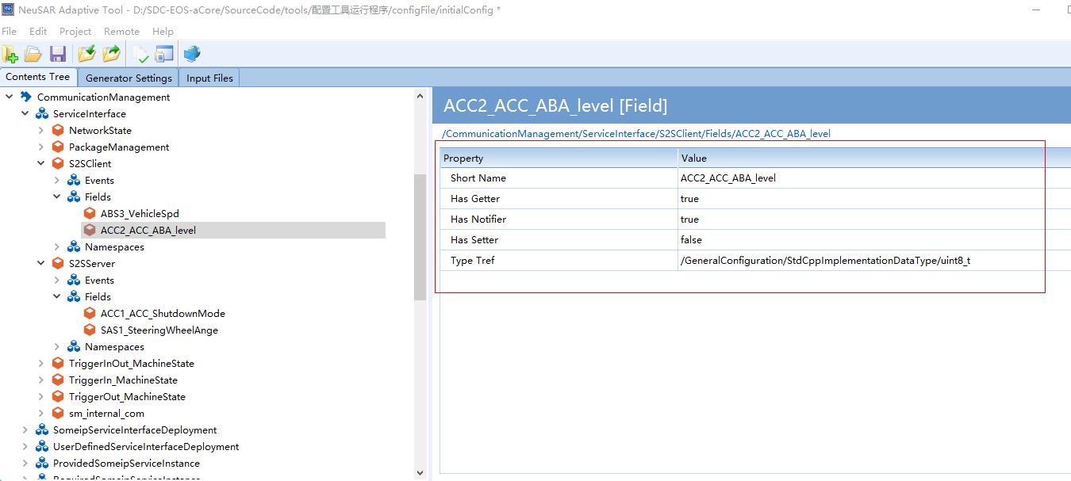

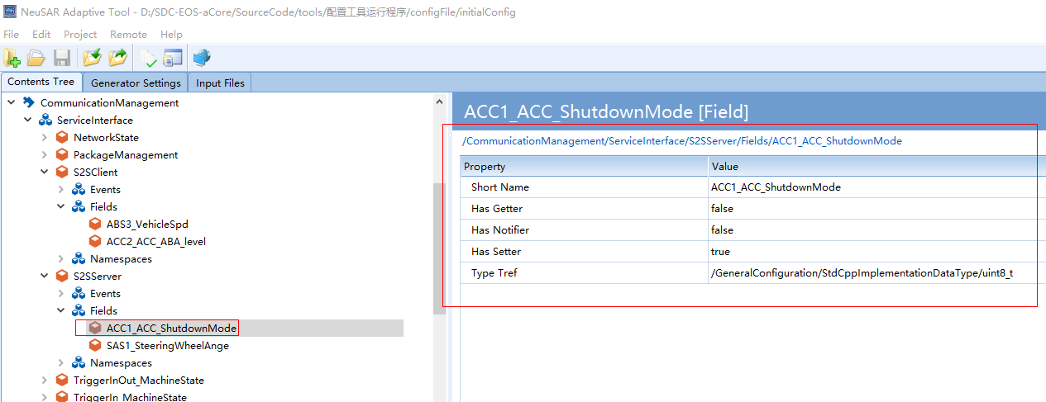

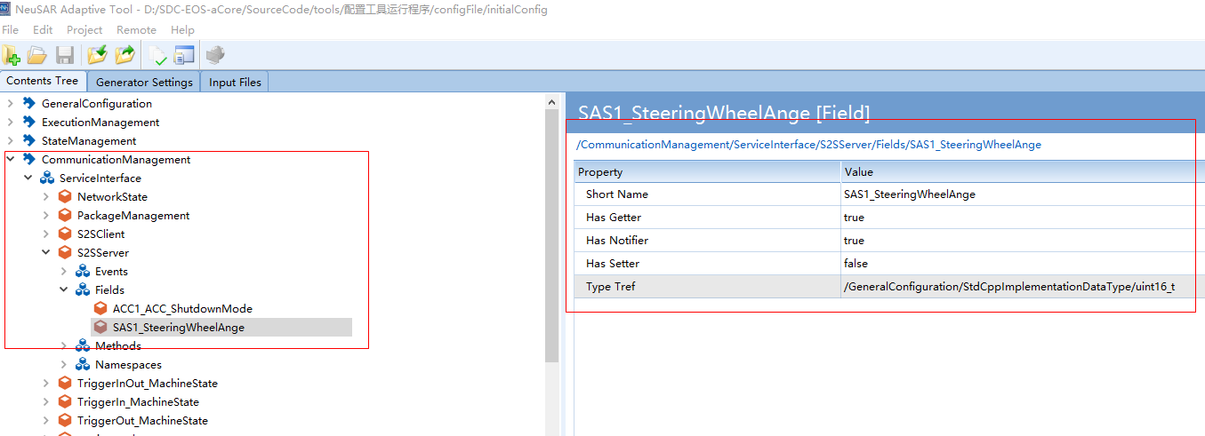

要发送的信号选择Setter Call Signal，接收的信号选择Getter Call Signal（二选一）。

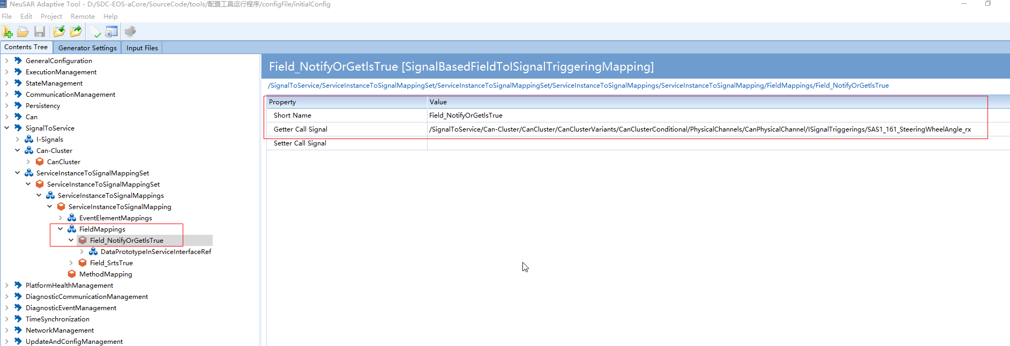

定义信号触发器映射的interface（signalToService下节点）。

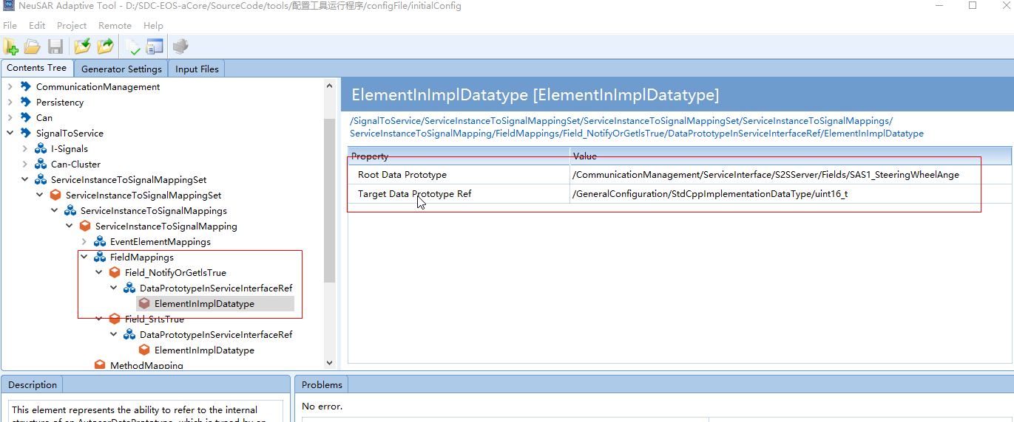

2.4.4.3 定义信号method发送

接收与发送信号的定义方式

|  |  |
| --- | --- |
| Method方式发送的信号 | 对应的method定义在S2SServer下 |
| Method方式接收的信号 | 对应的method定义在S2SClient下 |

例如：SAS1_SAS_Status为要接收信号，**ACC1_CheckSum_ACC1**为要发送信号。

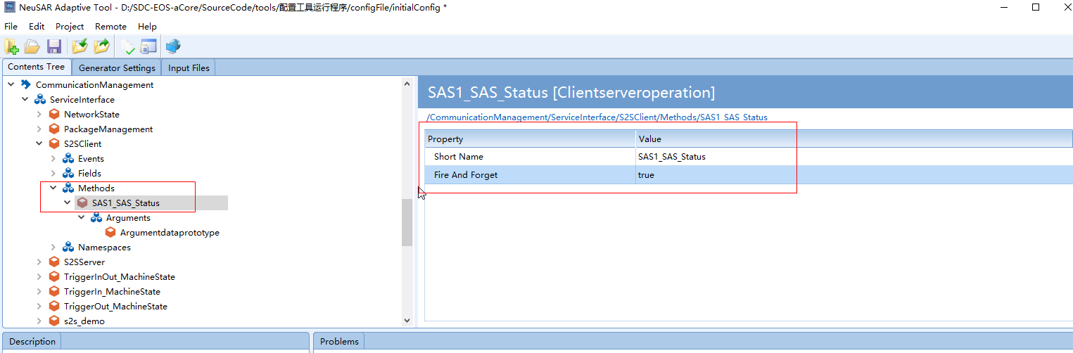

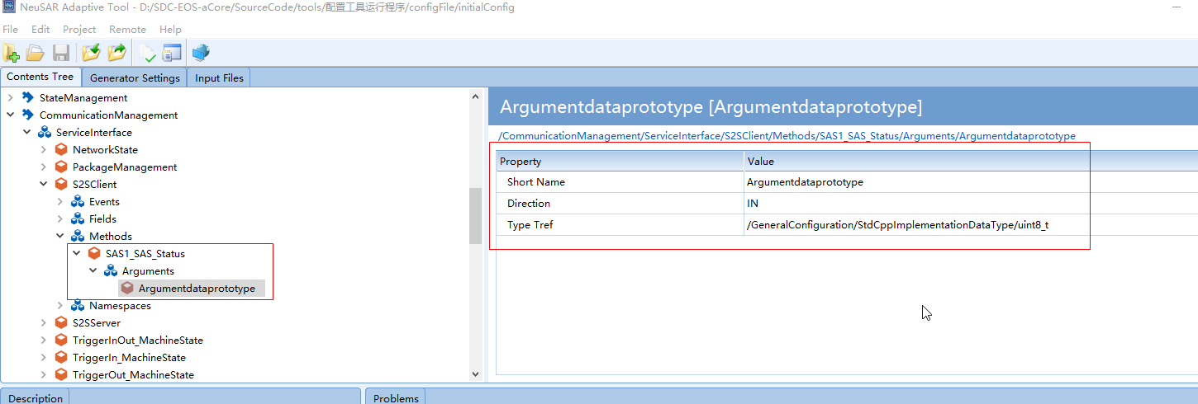

定义method的映射关系（signalToService下节点）。

发送的信号选择**Call Signal Triggering**，接收的信号选择Return Signal Triggering。

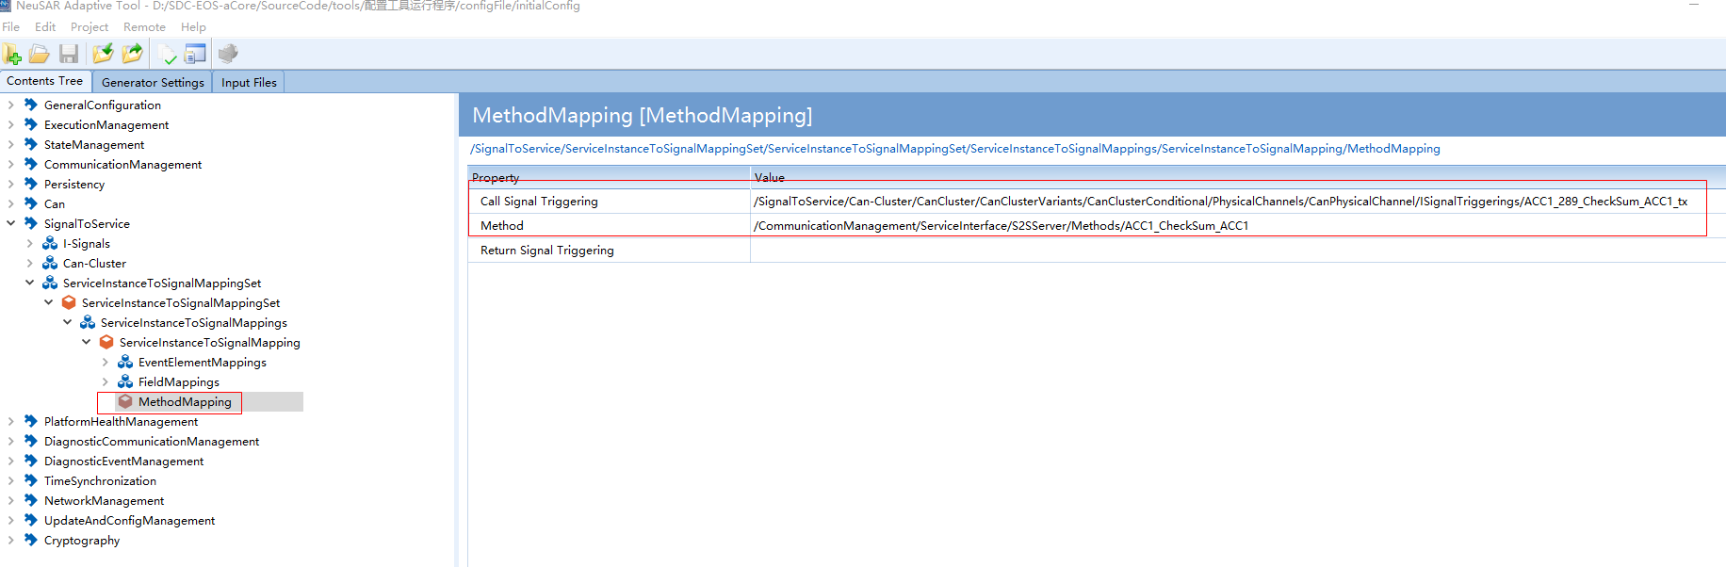

* 1. CM

此处需要注意通信的方式选择IPC，此处的详细配置可以参见《NeuSARaCore_CM_API》。

* + 1. ServiceInterface

interface下的S2SClient与S2SServer为默认配置，下面的event、field、method需要手动配置。

疑问，每发送一个signal，需要新建一个事件；

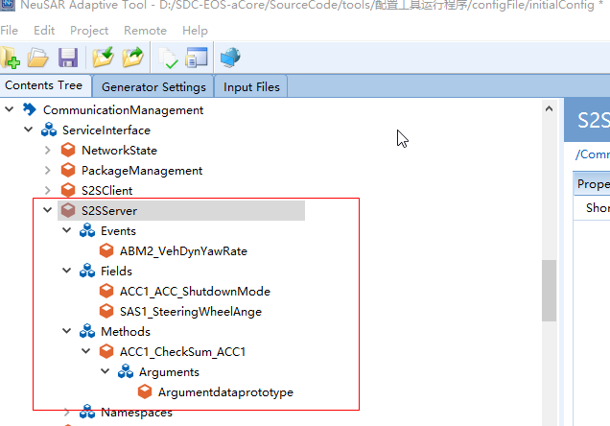

* + 1. Deployment

注意此处需要选择UserDefinedServiceInterfaceDeployment

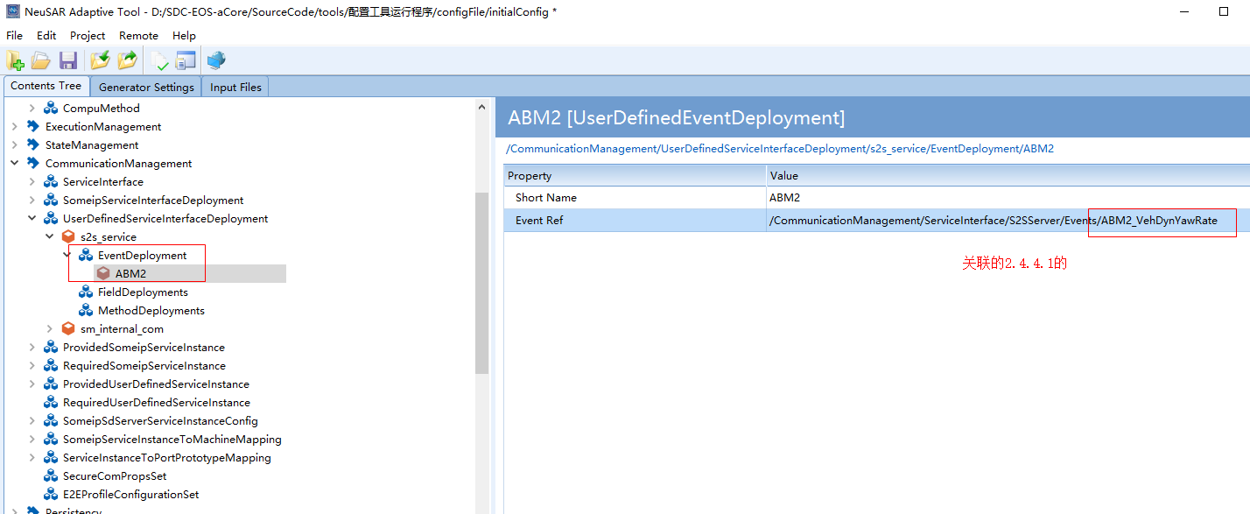

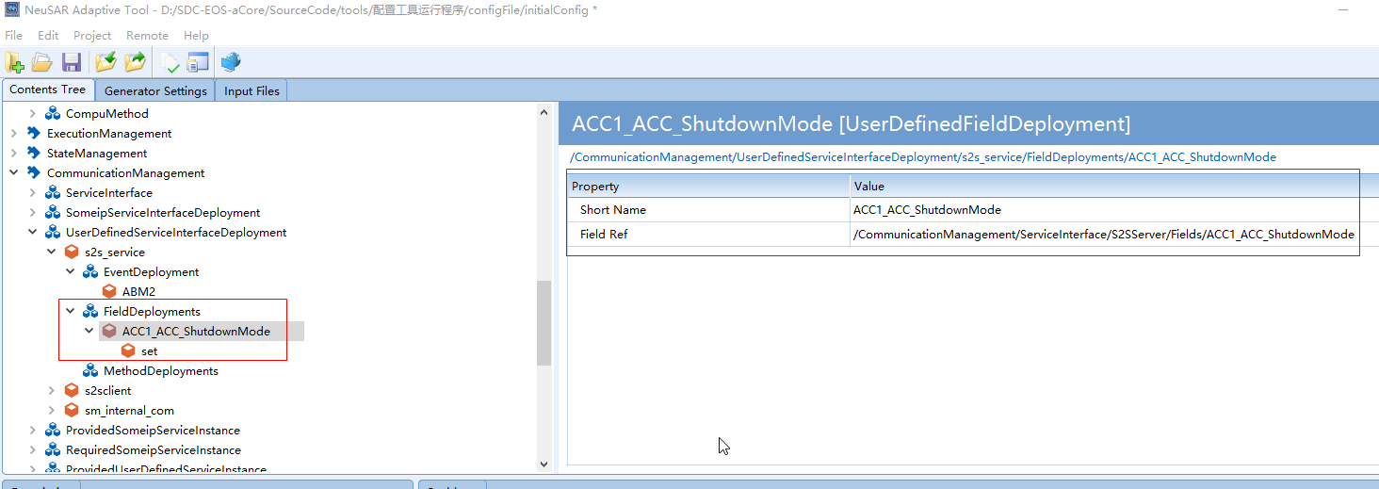

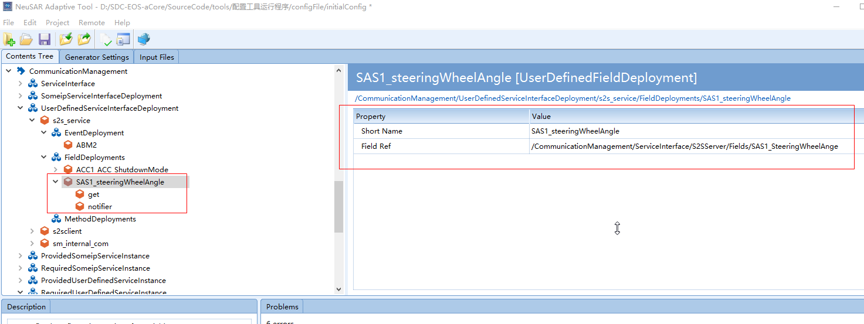

* + 1. 定义ServiceInstance

注意此处需要选择ServiceInstanceToPortPrototypeMapping

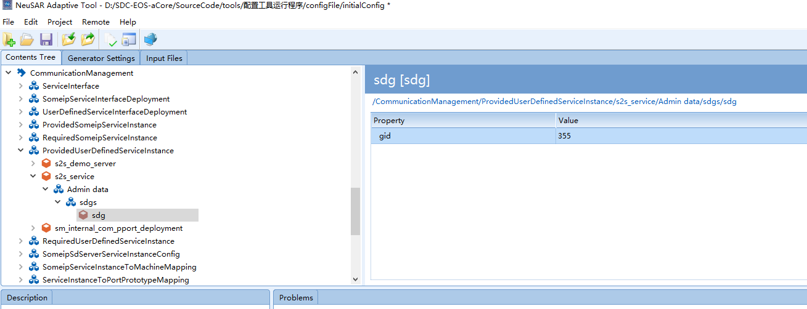

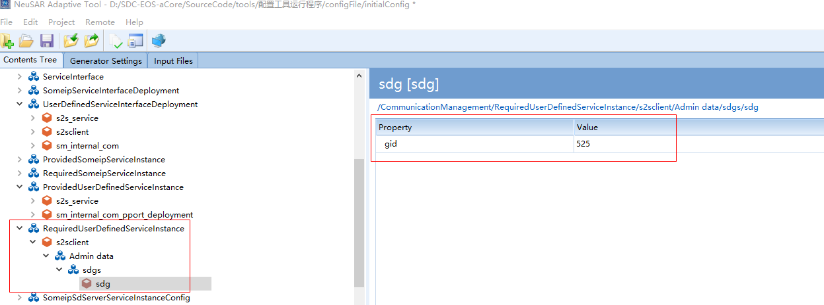

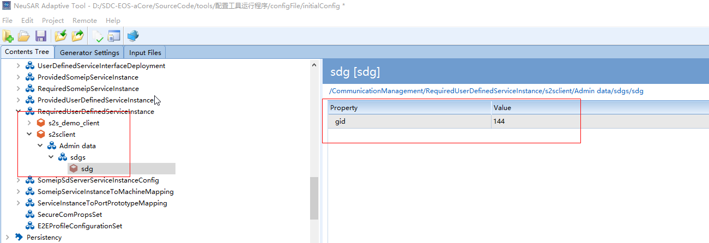

* + 1. 定义ServiceInstanceToPortPrototypeMapping

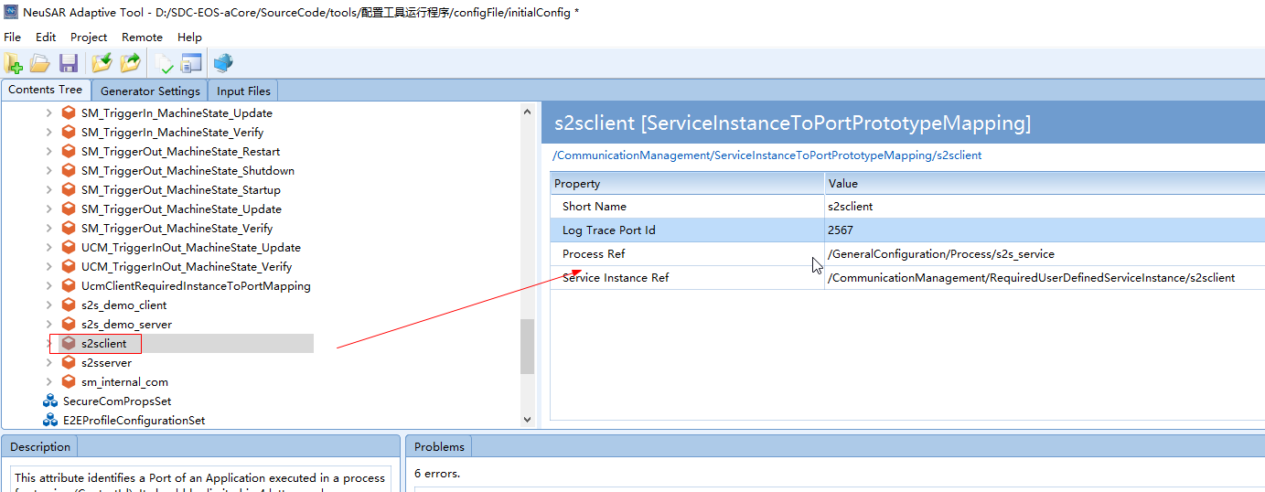

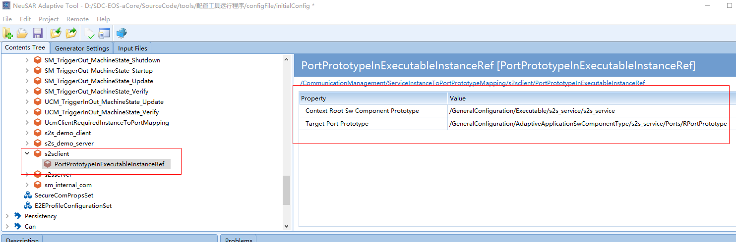

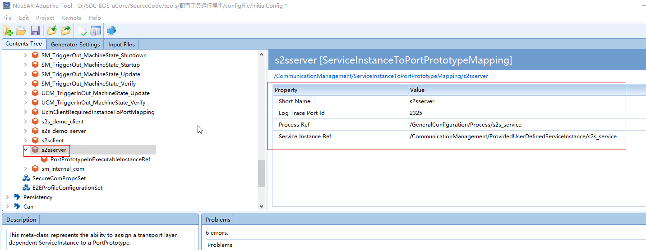

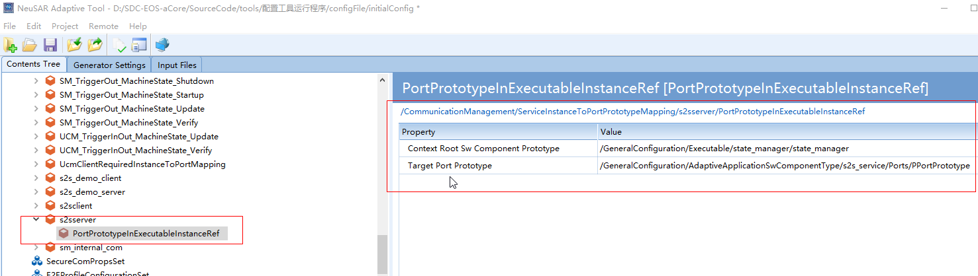

* 1. APP配置

GeneralConfiguration下的配置：

* + 1. 配置AdaptiveApplicationSwComponentType

注意：配置port的PPortPrototype与RPortPrototype时需要选择S2S的默认ServiceInterface：PPortPrototype选择S2SClient，RPortPrototype选择S2SServer

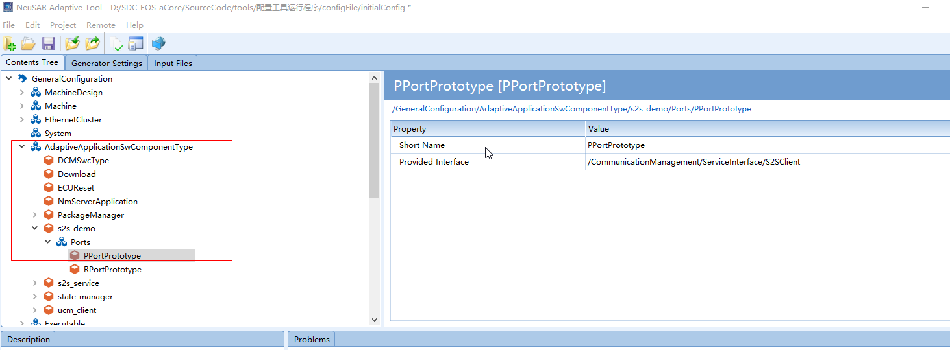

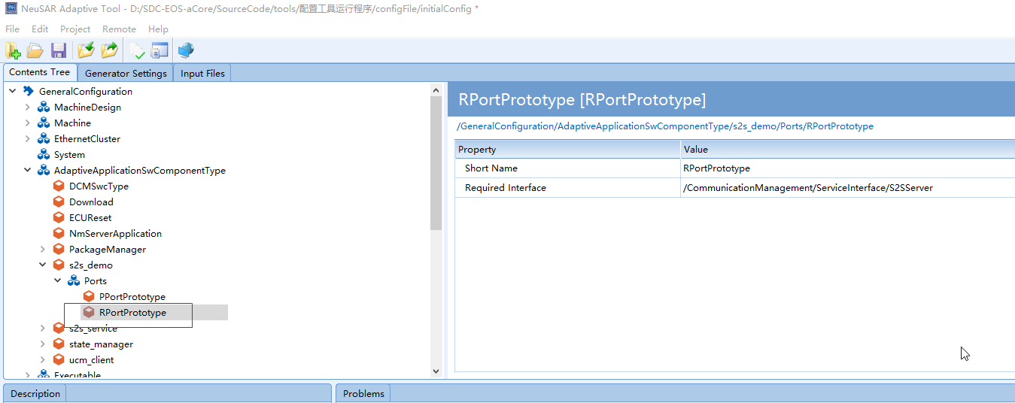

* + 1. 配置Executable

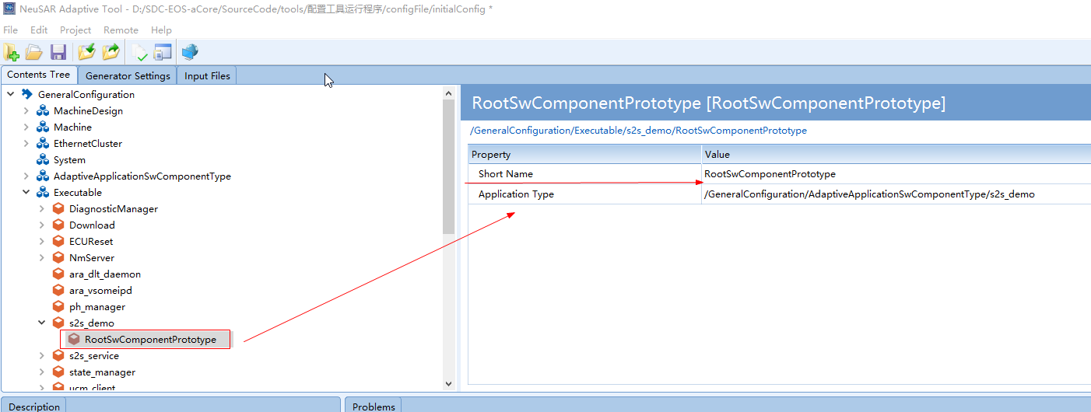

* + 1. 配置ProcessDesign

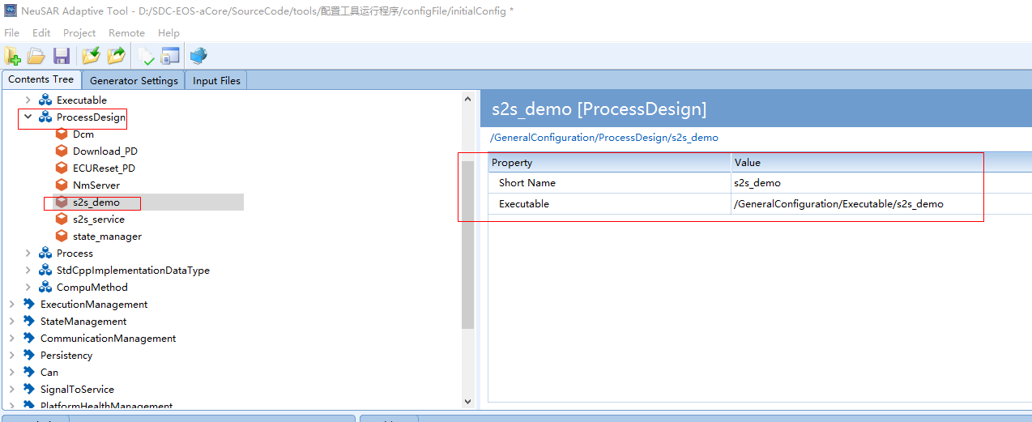

* + 1. 配置Process

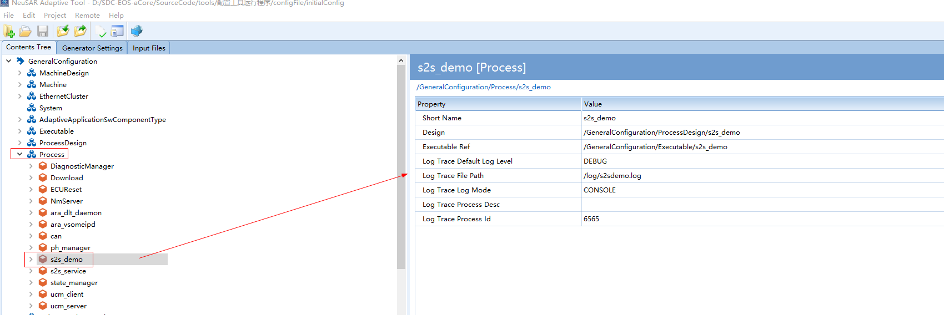

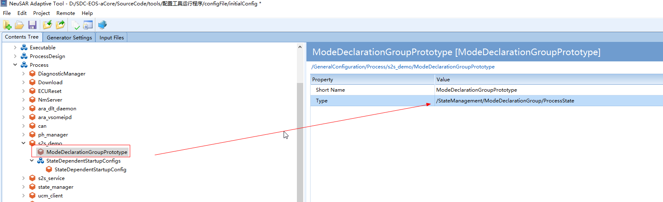

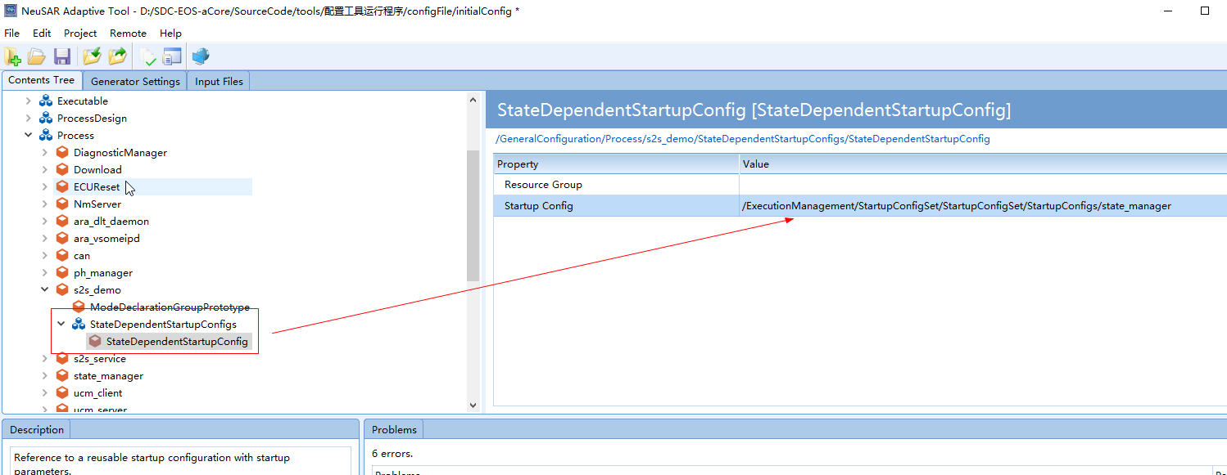

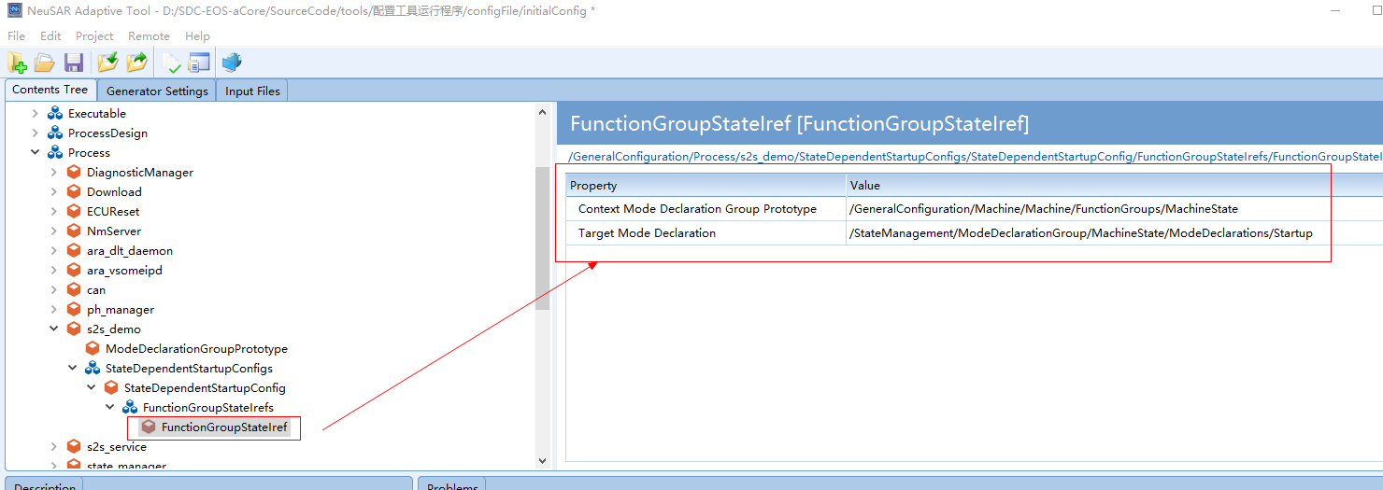

* + 1. 配置CommucationManagement下的instance

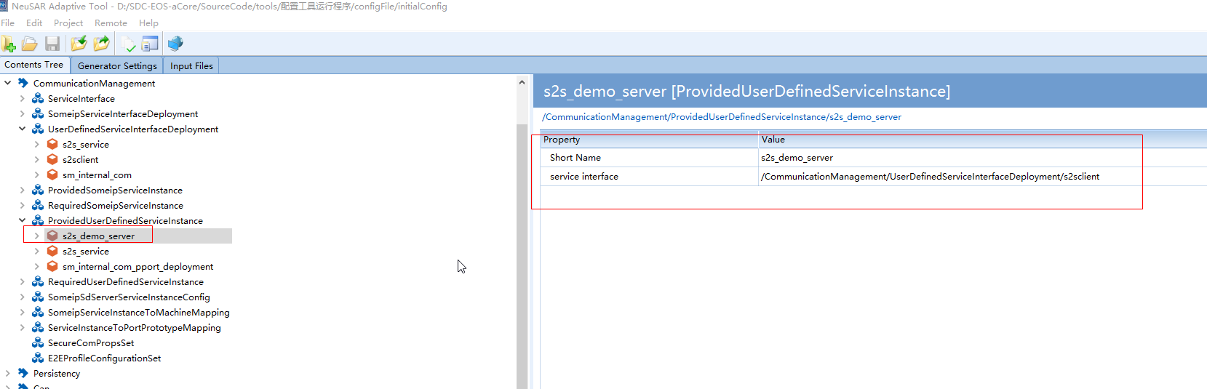

///////////////////////////////////////////////////////////////////////////////////////////////

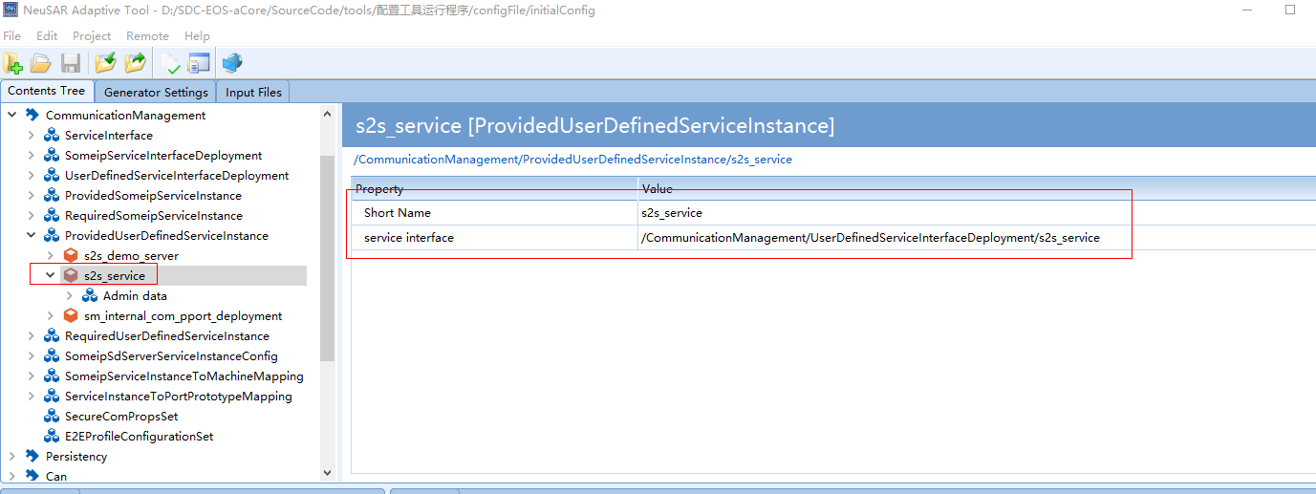

**备注：ProvideUserDefine的interface来自UserDefine，配置如下；**

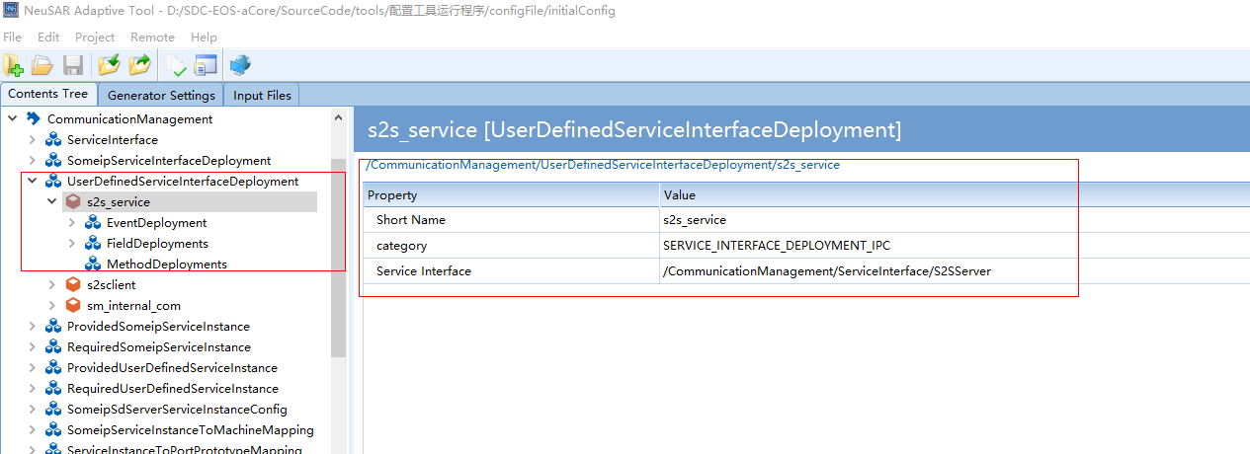

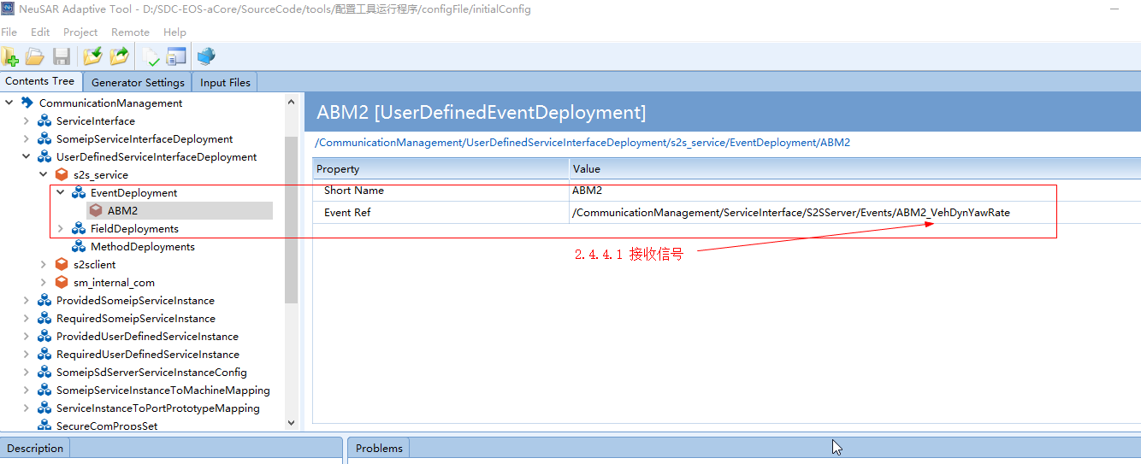

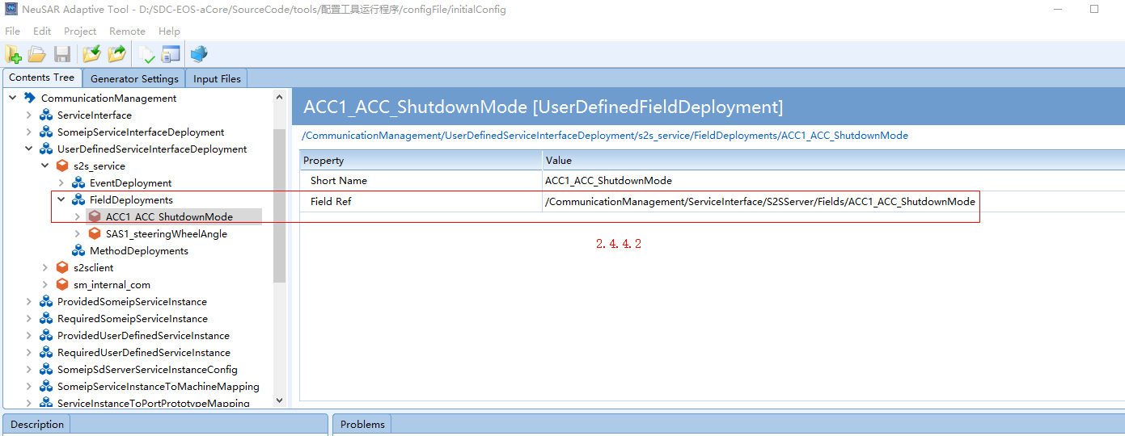

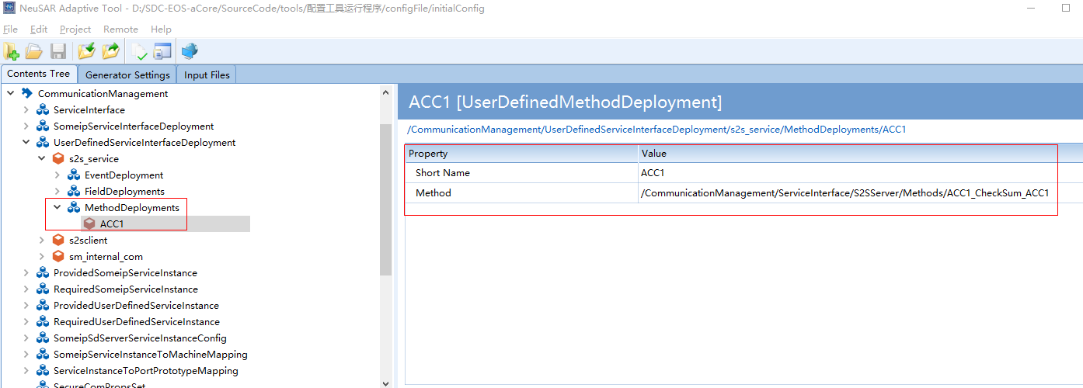

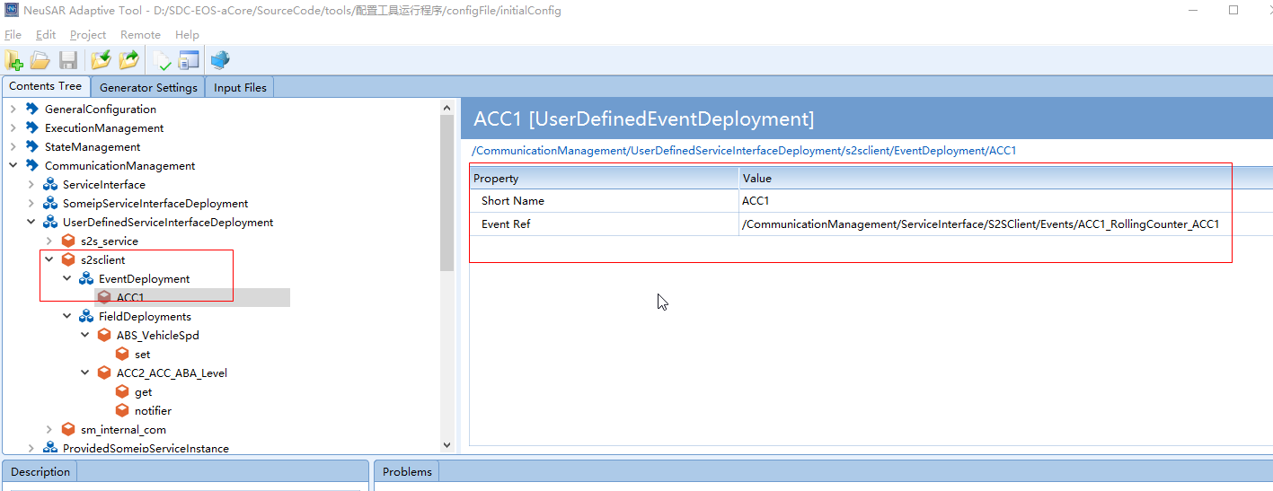

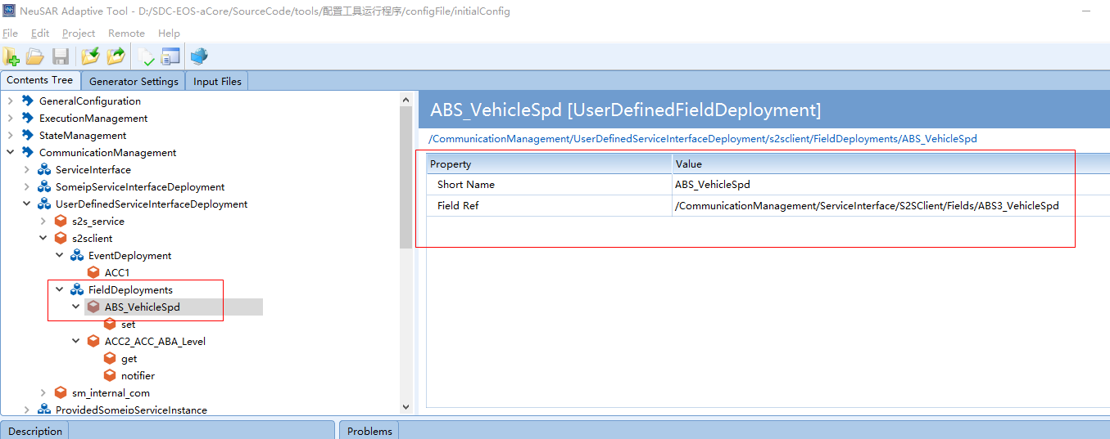

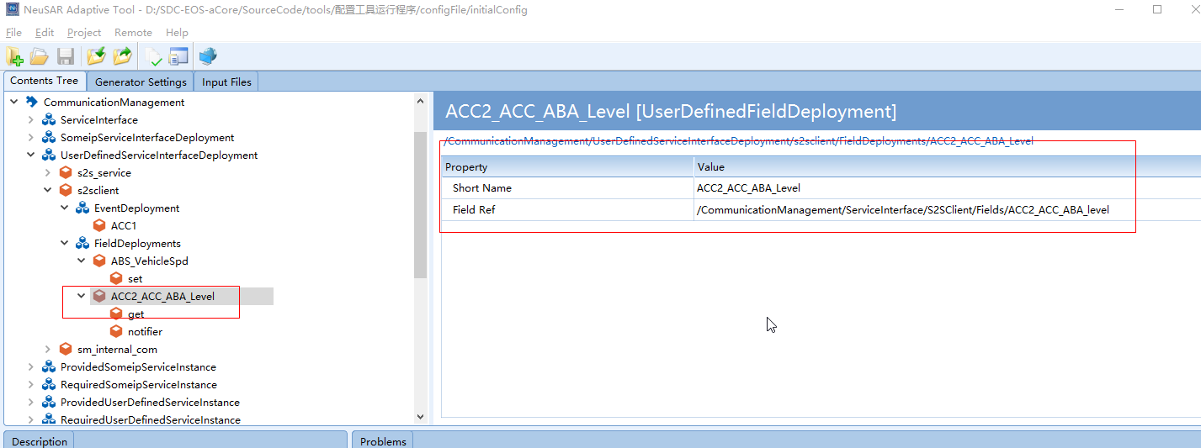

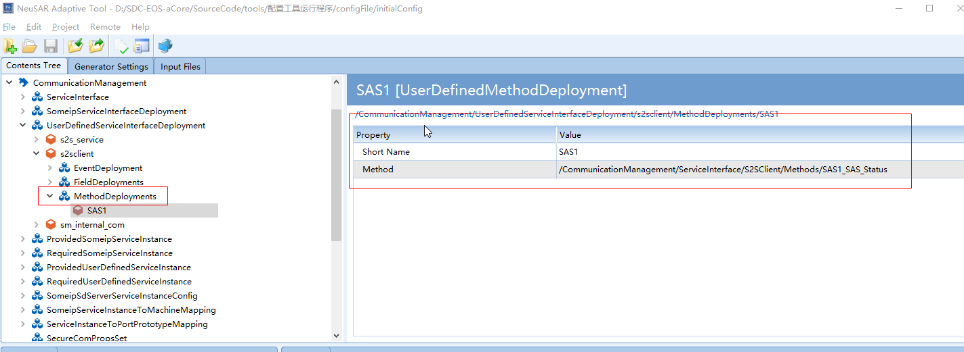

* + 1. 配置ServiceInstanceToPortPrototypeMapping

S2s_demo_client:

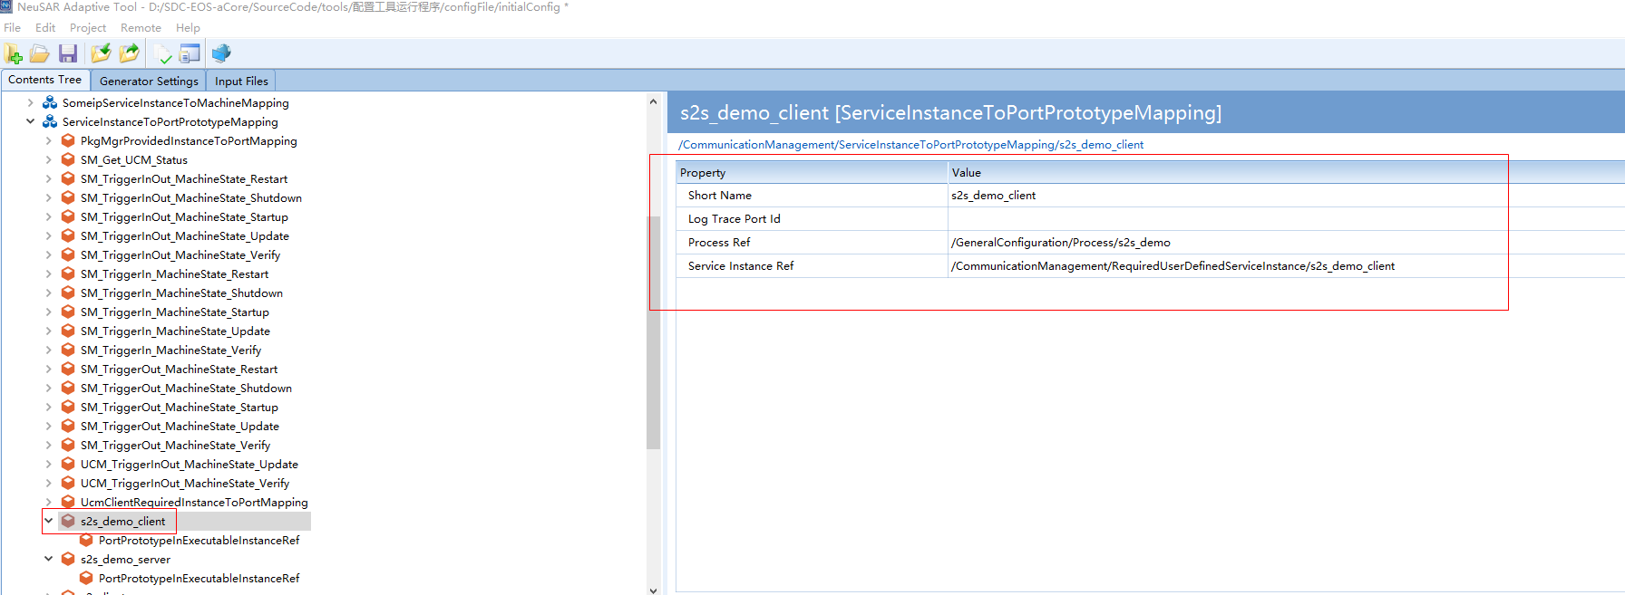

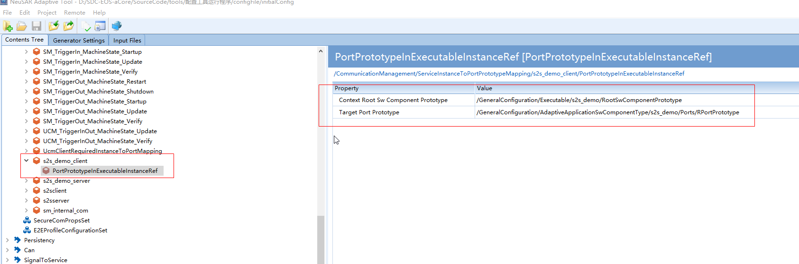

S2s_demo_server:

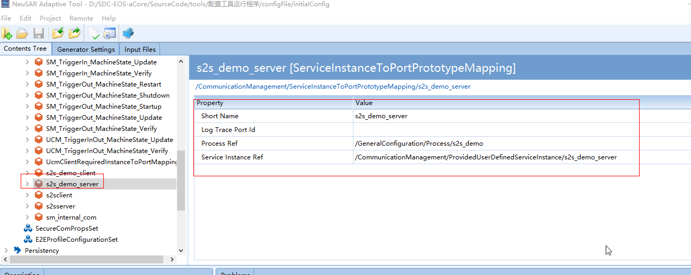

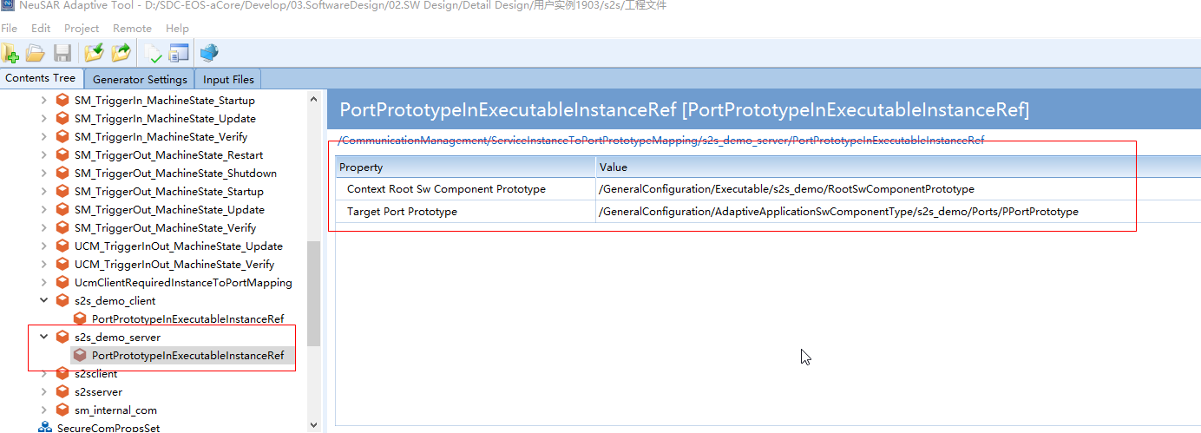

///////////////////////////////////////////////////////////////////////////////////////////////

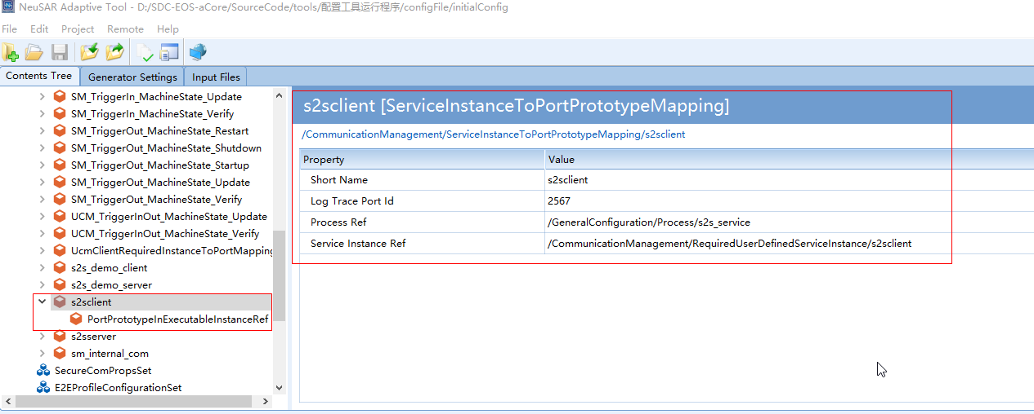

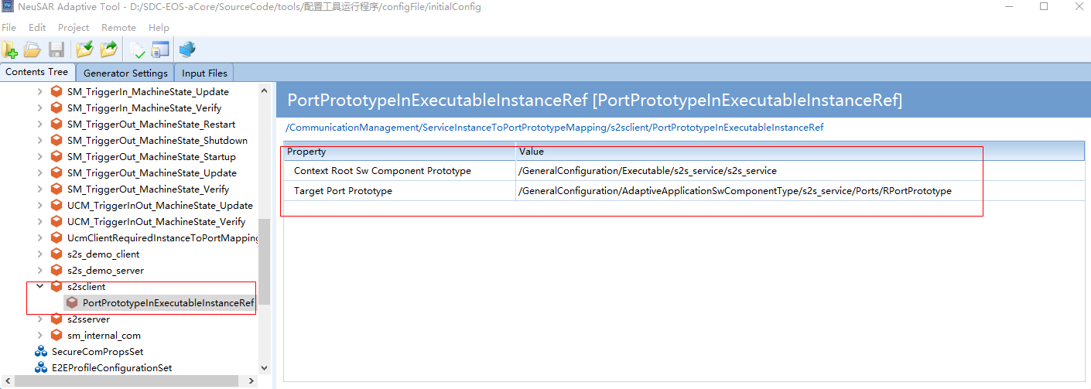

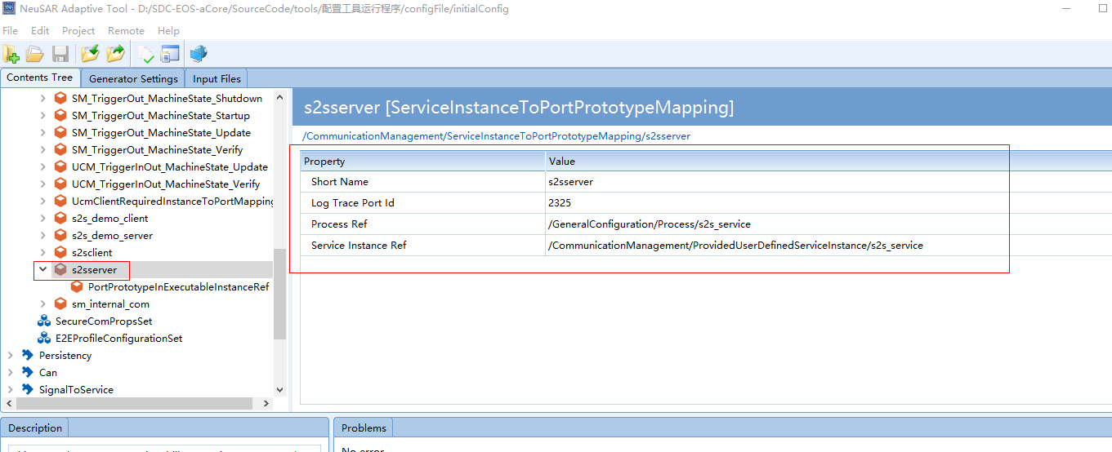

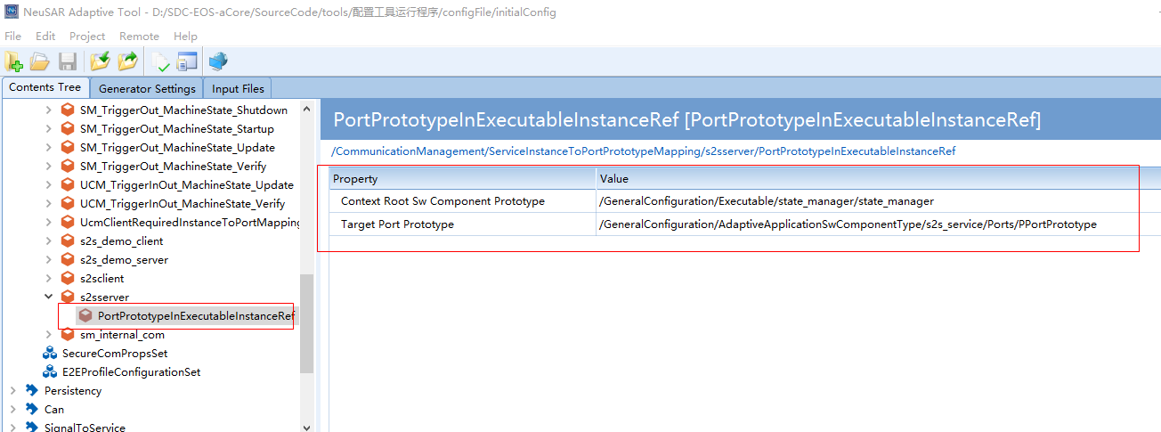

1. **Linux编译环境执行**

Linux直接加载Ubuntu（D:\ubuntu_linux\NeuSAR_build_environment\NeuSAR）。

源码为19_03/19_11。

1. SVN Check code

**svn co** [**https://10.170.133.203/svn/SDC-EOS-aCore/SourceCode/compile/build_auth**](https://10.170.133.203/svn/SDC-EOS-aCore/SourceCode/compile/build_auth)

//新路径

svn co <https://10.170.133.203/svn/SDC-EOS-aCore/02.Develop/02.SoftwareDevelopment/04.PlatformSourceCode/01.Trunk/build_auth>

**cd build_auth/**

19_03 check build路径：

<svn co <https://10.170.133.203/svn/SDC-EOS-aCore/SourceCode/compile/build> > //checkout

1. Source FileName

**source selectProject.sh –p aCore1903_auth**

或：./selectProject.sh –p aCore1903_auth

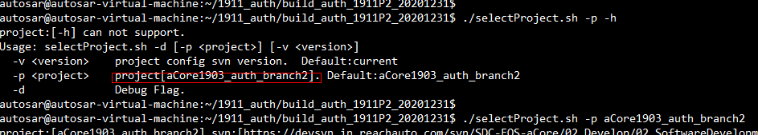

19_03的build不执行此条命令；

1. Get sdk

**./getsdk.sh -p s32v2_linux**

19_03 build需执行./getsdk.sh -p s32v2_linux_1903

./getsdk.sh -p x86_linux

1. Source工具链

**source toolchain/environment.config**

**cd product/access/**

如果之前source过别的工具链，则执行make distclean（这步会把makefile都删除了）//不需要执行

1. 生成sdk设置

**vi config/build.config**

将最后一行的BUILDCONFIG_IS_CREATE_SDK=1

然后保存退出

注意：不设置，会导致编译make release成功无法生产某些文件夹（deploySdk）或文件；

1. Make setup

**make platform.setup**

**make product.setup**

1. 编译

**make software**

**make software-clean**

新增asio库，编译时如果报错，执行如下指令：

sudo apt install automake -y

make software-asio-clean

make software-asio

需要安装Git工具

sudo apt install git –y

编译单独模块命令如下：CM模块

make software-ara_com

make software-ara_com-clean

模块命令规则在…/app/Makefile_RAR文件中

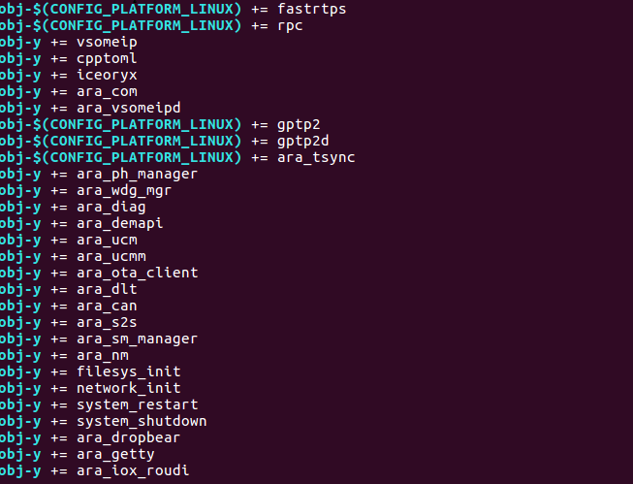

编译中如下先clean，再编译导致某个文件或文件夹找不到，手动删除，重新svn up 后再继续执行编译。

**make release**

1. Sdk放置路径

**cd product/access/release/output/deploySdk/**

./sdk_s32v_linux.sh –o xxx（其中xxx表示自己的sdk想要放置的位置，任意目录）

<1903执行./sdk_s32v2_linux_1903.sh –o xxx>

xxx:

1911: /home/autosar/1911_auth_sdk

1903: /home/autosar/1903_auth_sdk

1. 上位机连接

配置上位机：

Remote 🡪 Setting ……

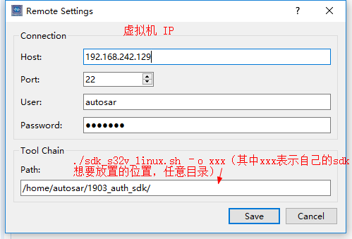

Remote 🡪 Connect ……

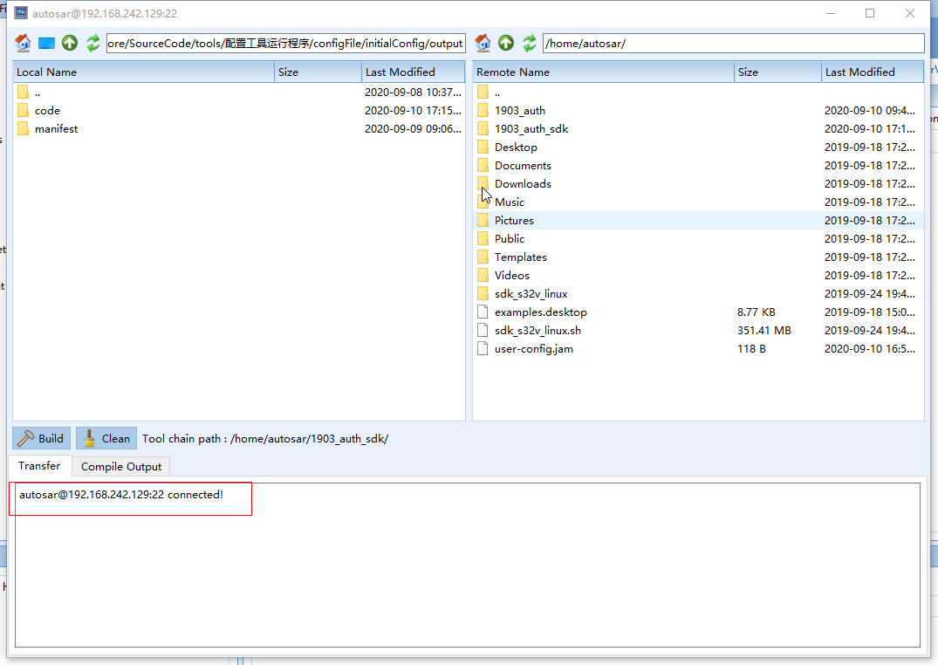

Connect可能存在失败现象，举例如下；

1. 上位机build

编译成功，对应模块线程：/home/autosar/autosar_auth_1903/release/opt/s2s_service/bin

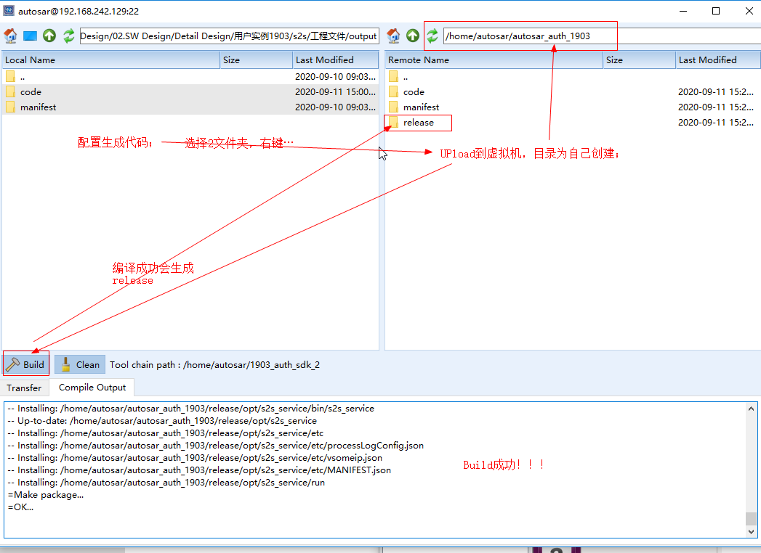

vim ../../app/rules/rpc.mk

vim Makefile_ARA

1. **CAN模块代码**
2. 手写代码



实现CAN数据的Tx和Rx:

void Com::init(bool tx, bool rx) {

if tx

txFunction创建发送线程(shutdown退出时删除Timer)

createTimmer创建定时器(.detach()挂起，sigwait)

Notify处理(sigwait解除,唤醒所有等待在mCondVar等待队列上的线程)

BlockUntilCallback当前线程挂起(等待Notify)

txMain发送循环

CanIf_Transmit发送(定时器到期发送)

getInstance(LinuxCan中创建socket并绑定can)

transmit

Write(socket发送)

帧格式Frame = can_id + dlc + data;

if rx

channelNum定义；//find遍历查找

rxMain创建接收线程(根据channel分别创建)

CanIf_RxIndication

getInstance(LinuxCan中创建socket并绑定can)

rxIndication(遍历定义数组，接收报文是否在定义范围内)

read(socket接收)

是，数据接收

否，丢弃

}

**备注：**

1. .detach()，主调线程继续运行，被调线程驻留后台运行，主调线程无法再取得该被调线程的控制权;
2. join()，主调线程(main函数里有一个主调线程)阻塞，等待被调线程终止，然后主调线程回收被调线程资源，并继续运行；上面这段话的意思就是，使用join(),线程运行完,main函数才能结束。

txThread和rxThread线程在end时调用了join；

1. createTimmer，上位机默认为0（10ms），上位机还需配置定时器偏移；

sigwait，它提供了一种等待信号的到来，以串行的方式从信号队列中取出信号进行处理的机制

定时器到期，系统会自动发送对应信号解锁sigwait；

sigwait（&set， signo）监听信号集set中所包含的信号，并将其存在signo中。注意：sigwait函数所监听的信号在之前必须被阻塞。

sigwait函数将阻塞调用他的线程，直到收到它所监听的信号发生了，然后sigwait将其从未决队列中取出（因为被阻塞了，所以肯定是未决了），但是有一点需要注意的是：它从未决队列取出之后，并不影响那个被取出的信号原来被阻塞的状态。

1. wait方法将当前线程挂起在mCondVar等待队列上；
2. Notify唤醒所有等待线程(notify_all()方法用于唤醒所有等待在mCondVar等待队列上的线程)；
3. std::move()就是将左值转换为对应的右值引用类型，且调用后销毁；
4. BlockUntilCallback函数原理？？？

把cyclicLock挂起在mCondVar等待队列，等待Notify唤醒；

1. find(channelArray.begin(), channelArray.end(), channelNum)

从头到尾遍历channelNum；

1. 上位机生成
2. **S2S模块代码**
3. 手写代码



int main(int argc, char* argv[]){

ShutdownHandler定义shutdown退出函数

Instance获取实例

Startup

comEntry()->init CAN初始化

aPduCoordinator->Init() 初始化服务调用和pduconfig配置

offerService服务提供

startFindService发现服务

因s2s兼任service和client，所以CM模块提供和发现服务初始化；

addPduConfig把PDU信号和数据add到pduconfig中

调用上位机自动生成代码ImpCollection::instance()->getConfigList();

Run()，守护进程，仅shutdown时退出

RegisterPeriodicCallback

(创建定时器，创建sighandler线程并.detach()挂起，线程中sigwait)

PeriodicHandler

Notify(sigwait解除，唤醒所有等待在mCondVar等待队列上的线程)

ReportExecutionState通知EM模块，s2s运行(如果shutdown，通知EM模块，s2s停止)

BlockUntilCallback当前线程挂起(等待Notify)

ProcessCoreTasks()

HandlePdu

GetPduConfigById(configNo) 获取PDU

It->receive()发送数据

RemovePeriodicCallback删除定时器

}

1. 附录：

AddSignal() //把信号add到tPdu；

GetPayload() //直接返回tPdu；

receiveTrigger.setRecv16(ara::can::get_ABM2_581_VehDynYawRate_rx);

2.1 1903代码工作流程：

2.1.1 can模块接收数据

rxMain //接收can数据

**Com_RxInfo[arrayId]**.dataraw //把接收的数据copy到Com_RxInfo

//Com_RxInfo根据上位机配置生成

2.1.2 S2S守护进程event发送

s2sExec->Run() //S2S守护进程

HandlePdu

receive(); //S2S发送

get_ABM2_581_VehDynYawRate_rx //获取要发送的数据

get_ABM2_581_VehDynYawRate_rx() //获取数据

**Com_RxInfo[]**

ABM2_VehDynYawRate.Send(data); //CM接口发送（2.4.2）

2.2 初始化读取配置文件：

Application_impl.cpp (applications\vsomeip\implementation\runtime\src) 99794 2020/11/9

2.2.1 初始化加载配置文件

init() {

    configuration_->**load**(name_);

}

**load**(const std::string &_name) {

    const char *its_env = getenv(**VSOMEIP_ENV_CONFIGURATION**);

    its_input.insert(its_file);

}

//VSOMEIP_ENV_CONFIGURATION 为配置文件路径

2.2.2 配置元素赋值

//如下举例：配置元素sd_initial_delay_min_的赋值和使用

read_data(its_input, its_optional_elements, its_failed, false); //读取加载的文件

load_data(its_mandatory_elements, false, true); //读取加载的数据

load_services(e);

load_servicegroup(i->second);

load_delays(i->second); //读取对应元素

sd_initial_delay_min_ = i->second.get<uint32_t>("minimum");

2.2.3 使用

Service_discovery_impl.cpp (applications\vsomeip\implementation\service_discovery\src) 171181 2020/11/9

void service_discovery_impl::init()

initial_delay_min = get_sd_initial_delay_min();

return sd_initial_delay_min_;

2.3 CM处理Message

C:\Users\mly\Desktop\aCore1903_auth\applications\vsomeip\implementation\message\src\message_impl.cpp

2.3.1 获取和设置payload

get_payload

set_payload

2.3.2 序列化：

header_.serialize

payload_->serialize

2.3.3 反序列化：

payload_ = runtime::get()->create_payload();

header_.deserialize

payload_->deserialize

2.3.4 举例说明

创建一个payload

Payload组包

Set payload

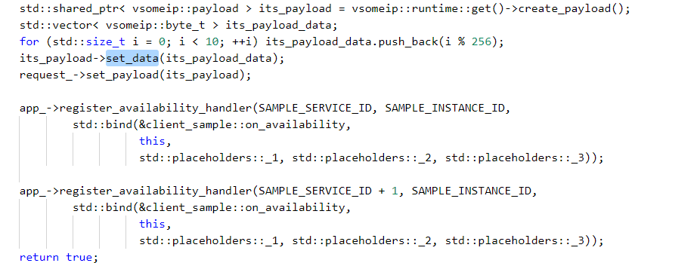

2.4 CM实际实现

2.4.1 event接收数据

……vsomeip\proxy\vsomeip_event_impl.h

onMessage ()

checkMessage() //check有效性

message_queue_.push_back(response); //消息放入队列

receive_handler()

GetNewSamples()

rawDataSample = message_queue_.front();

payload = *rawDataSample->get_payload();//调到2.3.1

Deserializer() // Vsomeip_marshalling.h

2.4.2 event发送数据

……vsomeip\skeleton\vsomeip_event_impl.h

Send()

//根据上位机配置的类型，执行序列化

Serializer<std::decay<T>::type, EventDescriptor> marshaller(data);

marshaller.pushbackTo(bytes);

create_payload()

//把序列化的数据设置到payload

payload->set_data(std::move(bytes));

//接口调用发送

application.notify(EventDescriptor::service_id, instance_, EventDescriptor::event_id, payload);

2.5 获取pdu

**自动生成代码：**

inConfigList.push_back(pduServerConfig);//初始化得到

void addPduConfig(std::vector<S2SPduConfig>& inConfigList)

{

    inConfigList = ImpCollection::instance()->getConfigList();

    return;

}

std::vector<S2SPduConfig> getConfigList()

    {

        return inConfigList;

    }

**手动撰写代码：**

addPduConfig(pduConfigList);

pduConfigFrontEnd.SetUPtr(std::make_unique<std::vector<S2SPduConfig>>(pduConfigList));

bool S2SPduCoordinator::**HandlePdu**(void)

{

    bool rv{false};

    const uint32_t totalConfigs{pduConfigFrontEnd.GetNumberOfPduConfigs()};

    for (uint32_t configNo = 0u; configNo < totalConfigs; configNo++) {

        std::shared_ptr<S2SPduConfig> sptrConfig = pduConfigFrontEnd.GetPduConfigById(configNo);

        if (RX == sptrConfig->Direction) {

            for (auto itService : sptrConfig->signal) {

                std::shared_ptr<S2SSignal> it = std::dynamic_pointer_cast<S2SSignal>(itService);

                it->receive();

            }

            rv = true;

        } else {

            cout <<

                "S2SPduCoordinator::HandlePdu : Send PDU failed (expectedBytesFromUdp != "

                "recvBytes)." << endl;

            rv = false;

        }

    }

    return rv;

}

1. 上位机生成
2. **阅读py代码：需要维护**
3. 解析dbc到上位机

D:\SDC-EOS-aCore\SourceCode\tools\configGenerator\s2s

解析dbc信号名称格式有特点要求，如ABM2_581_VehDynYawRate_rx，接收信号来自581报文；

* 1. analyzeDbc()

1. 根据BO_解析，得到msgObj (包括canId、magName、TxNode,其中msgSize被注释掉？默认8字节)；

解析文件名称：ve.dbc

Dbc文件格式举例如下：

“BO_”表示PDU，”SG_”表示Signal；

59|4，表示起始位59，长度4Bit；

0+，表示byte_orde为Motorala（1+表示Intel）；

(1,0), [0|15]表示如下图；

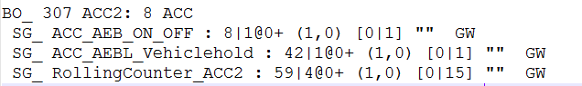

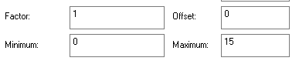

1. 根据SG_解析，得到signalObj；

如果TxNode = ecuName()，解析得到signalObj_tx(txMsgDict)；否则解析得到signalObj_rx(rxMsgDict)；

解析得到文件：ve.json

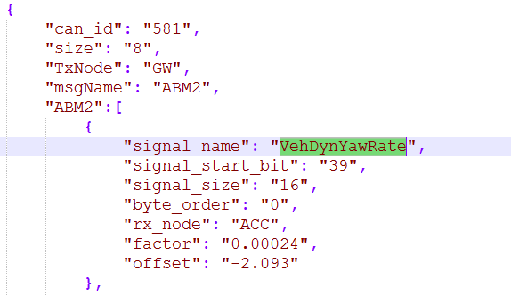

* 1. generateISignal()

1. 上位机创建SignalToService 🡪 I-Signals元素

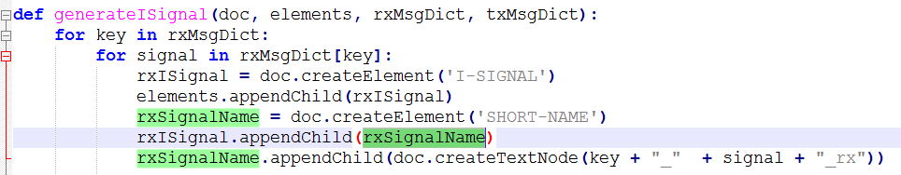

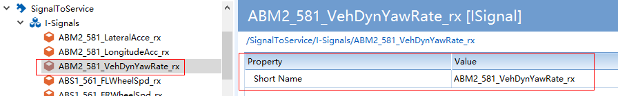

* 1. generateCanCluster()

1. 上位机创建SignalToService 🡪 Can-Cluster元素

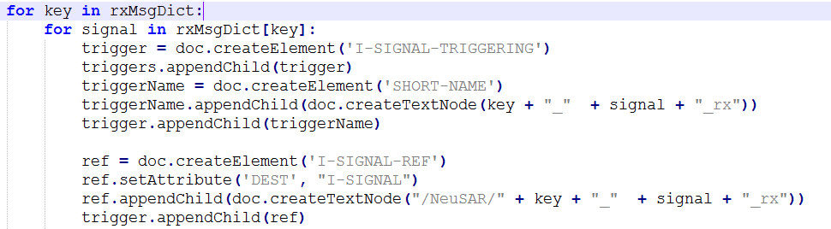

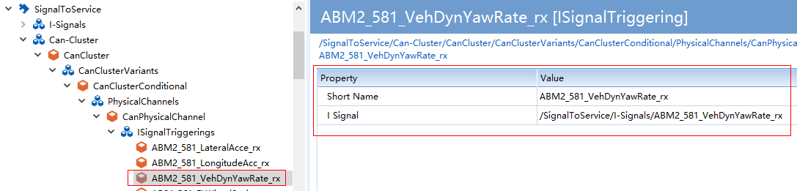

* 1. generateECUC()

1. 上位机创建Can 🡪 EcucModuleConfigurationValues元素

包括发送周期、偏移周期、CAN-Chanel；

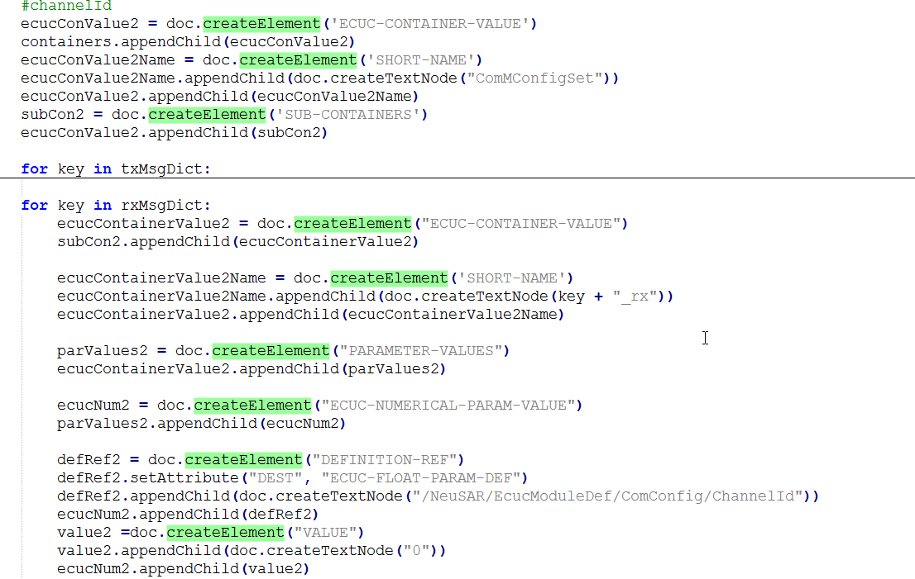

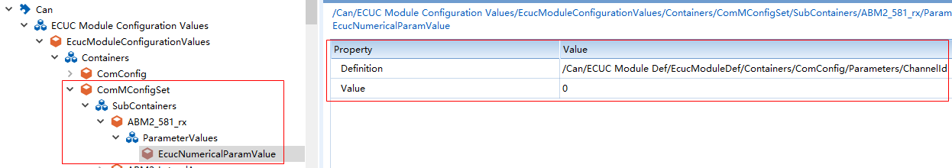

1. 上位机创建Can 🡪 EcucModuleDef元素(该元素作用是什么？？？设置默认值吗)

原理同上；提供引用默认配置

**备注1:**

先把dbc文件解析成json文件，如D:\SDC-EOS-aCore\Develop\03.SoftwareDesign\02.SW Design\Detail Design\用户实例1911\can\code\can\json，然后再解析Json文件；

1. 上位机Generate code

D:\SDC-EOS-aCore\SourceCode\tools\jsonGenerator\modules\s2s

D:\SDC-EOS-aCore\SourceCode\tools\jsonGenerator\modules\can\JsonToCode.py

* 1. 模块py解析注册

D:\SDC-EOS-aCore\SourceCode\tools\jsonGenerator\modules\moduleList.py

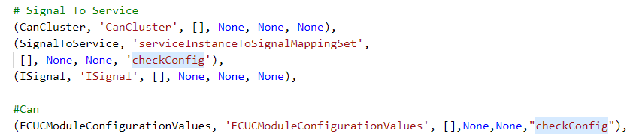

* 1. S2s部分

实现方式也是根据上位机逐级创建对应元素……

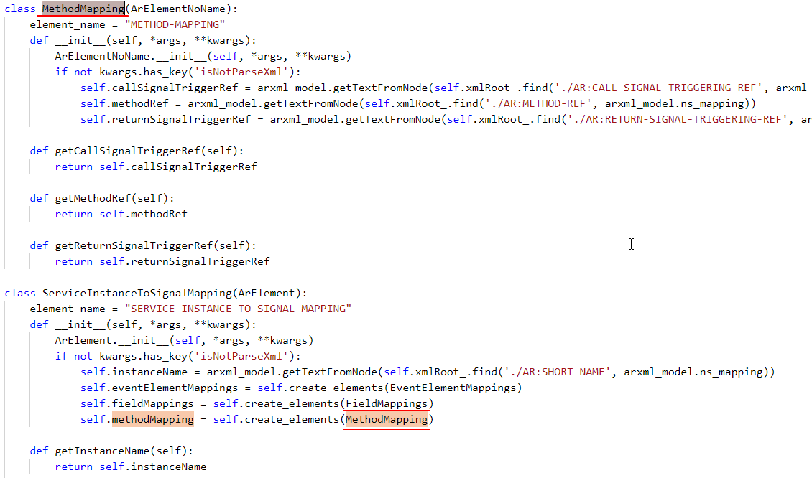

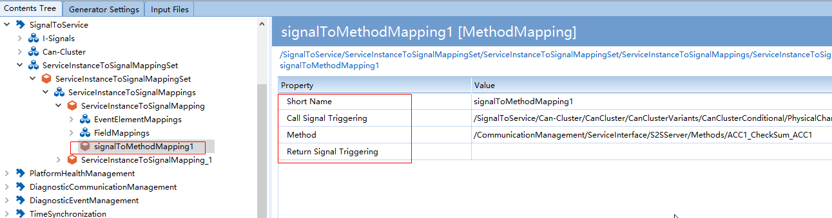

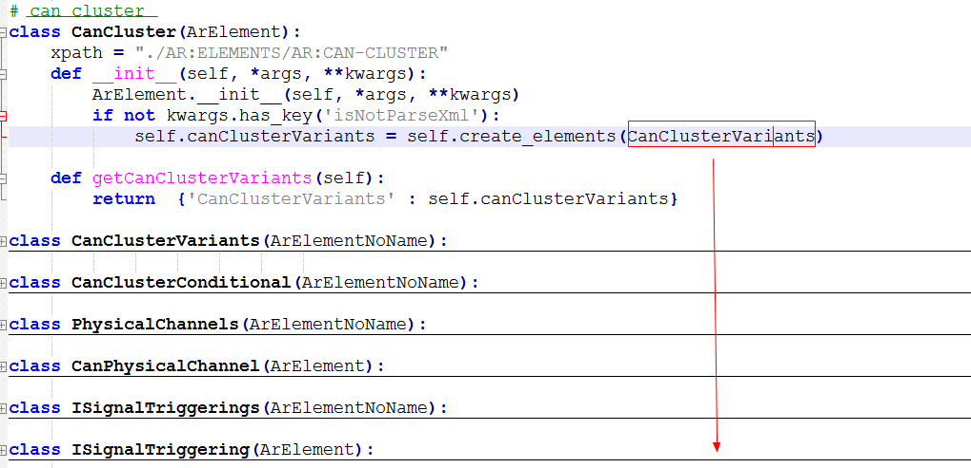

创建对应的.h/.cpp文件：举例如下event server

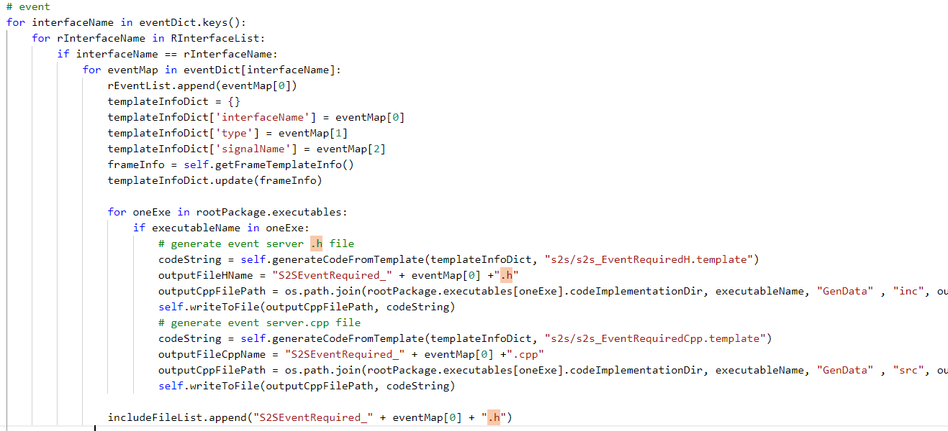

D:\SDC-EOS-aCore\SourceCode\tools\jsonGenerator\template\s2s\s2s_EventRequiredH.template

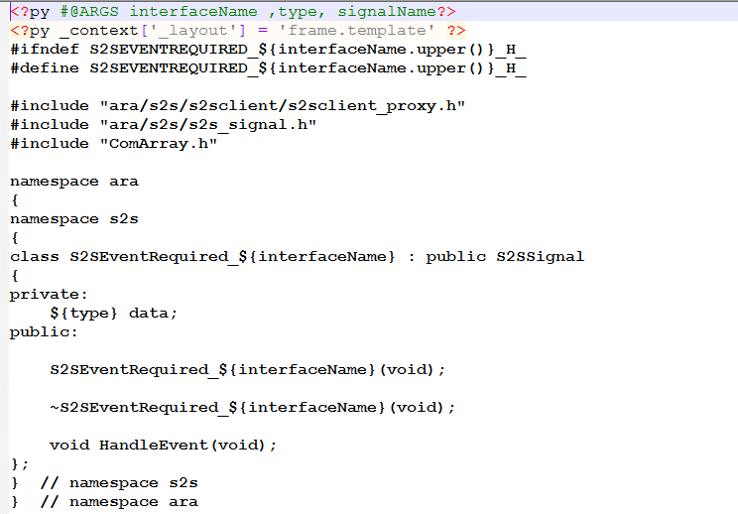 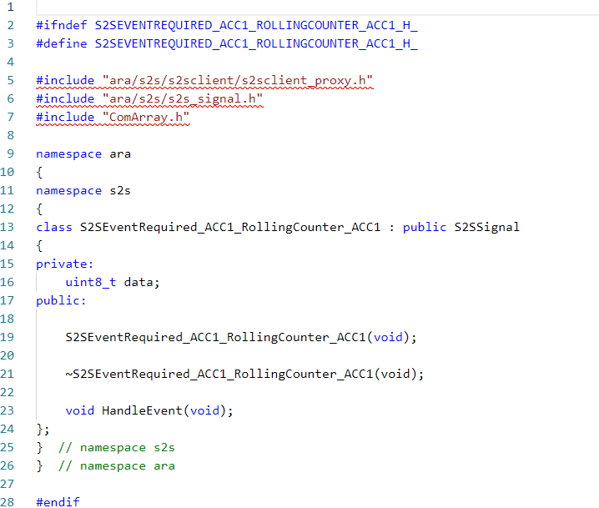

* 1. Can部分

创建节点Node：

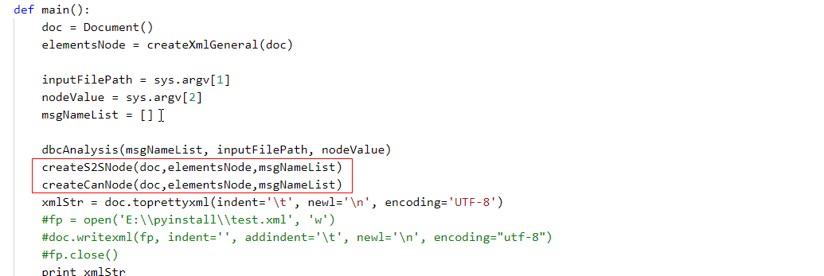

Py代码：

D:\SDC-EOS-aCore\SourceCode\tools\jsonGenerator\modules\can\CreateCanStructC.py

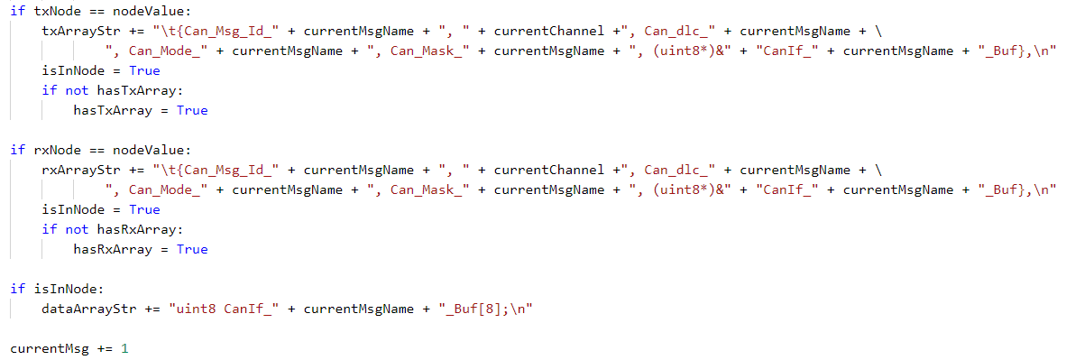

C++代码：

D:\SDC-EOS-aCore\SourceCode\tools\jsonGenerator\modules\can\CreateCanStructC.py

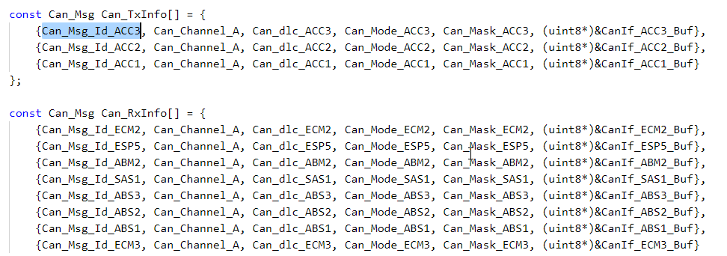

**备注：**

长度超过1字节（8bit）的Signal需要拆分；

1. 后续待办
2. 验证流程和方法？？？

CAN 和 S2S实际验证结果（验证效果和数据）？？？

1. Artop安装、使用，解析arxml

**D:\SDC-EOS-aCore\SourceCode\tools\paramsConfigTool\Arxml**

**D:\SDC-EOS-aCore\SourceCode\tools\tools1911\配置工具运行程序\configFile**

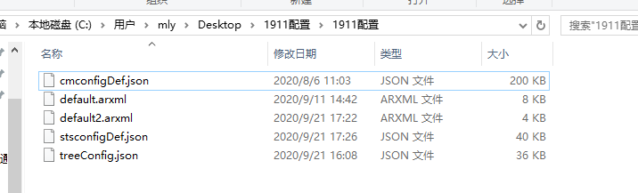

1. **函数调用关系（自写和自动）**

s2s_pducoordinator.cpp为手动编写，it->receive();函数调用自动生成的S2SEventProvider_ABM2_VehDynYawRate.cpp的

C:\Users\mly\Desktop\aCore1903_auth\ara-api\s2s\src\s2s_pducoordinator.cpp

在开始D:\SDC-EOS-aCore\SourceCode\tools\jsonGenerator\modules\moduleList.py注册需要解析的模块；

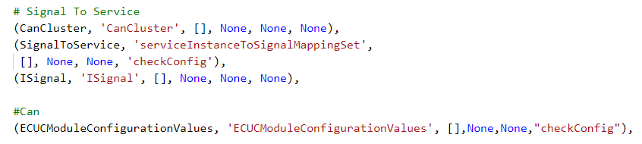

如下是上位机配置自动生成：

D:\SDC-EOS-aCore\Develop\03.SoftwareDesign\02.SW Design\Detail Design\用户实例1903\s2s\code\s2s_service\GenData\src\S2SEventProvider_ABM2_VehDynYawRate.cpp

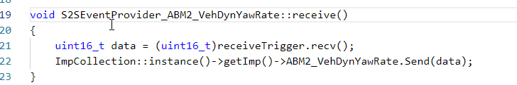

举例说明：

1. APP接收ABM2_VehDynYawRate信号



* 1. s2s发送

S2S从can中获取到数据；

C:\Users\mly\Desktop\aCore1903\ara-api\s2s\src\s2s_pducoordinator.cpp

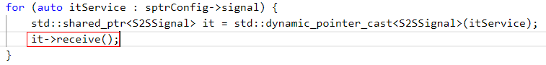

* 1. 发送调用如下

D:\SDC-EOS-aCore\SourceCode\tools\tools1911\配置工具运行程序\configFile\initialConfig\output\code\s2s_service\GenData\src\S2SEventProvider_ABM2_VehDynYawRate.cpp

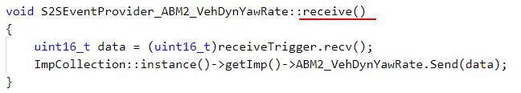

receiveTrigger.recv() 获取要发送的数据；

receiveTrigger是一个函数指针，实际调用如下get_ABM2_581_VehDynYawRate_rx

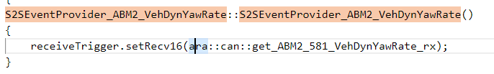

receiveTrigger.recv()实际调用的是receiveTrigger.setRecv16()

setRecv16()为函数指针在“自写代码”中（如下）；

C:\Users\mly\Desktop\aCore1903\ara-api\s2s\src\s2s_trigger.cpp

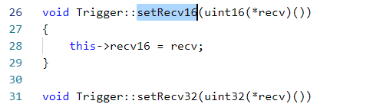

最后把ABM2_VehDynYawRate.Send(data)发送给APP

1. APP发送ACC1_RollingCounter_ACC1





1. **开发工具安装**
2. 安装eclips，并使其GeneralCode
   1. 安装失败

安装工具目录：F:\EVCC_Tool\eclips

安装jdk-15_windows-x64_bin.exe

安装eclipse-inst-jre-win64.exe，失败（原因不明）；

* 1. 安装成功

1. 直接使用eclipse-java-2020-09-R-win32-x86_64（应该是绿色版本，直接打开使用）

把PyDev 8.0.0文件夹中的文件替换安装目录中的；

1. 安装python-2.7.17.amd64.msi报错2503/2502；

原因用户权限不足（本人电脑用户非管理员账户），解决方法参考如下链接：

<https://jingyan.baidu.com/article/cdddd41c97e94853ca00e17e.html>

安装python-2.7.17.amd64.msi，成功(生产安装文件夹C:\Python27)；

1. 安装文件替换：F:\EVCC_Tool\eclips\neusar_环境_python\Python27替换掉C:\Python27；
   1. 环境配置
2. 打开工程文件：File🡪Open Projects……

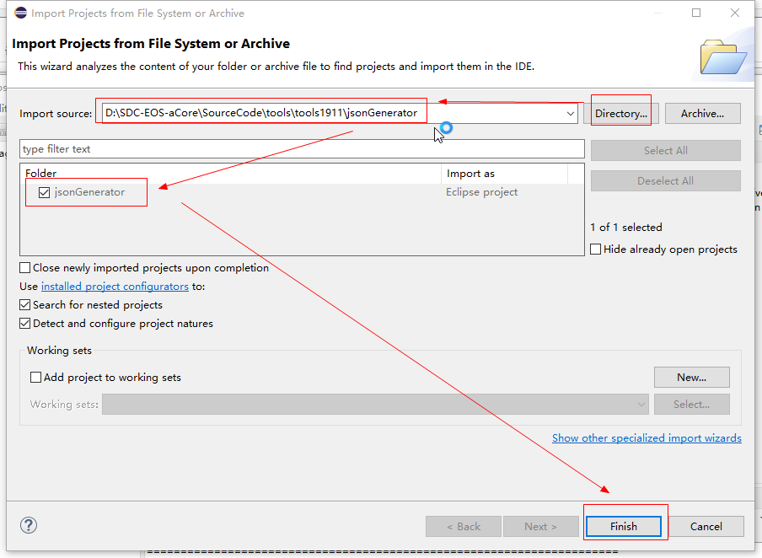

1. 链接python ：Window 🡪Preferences

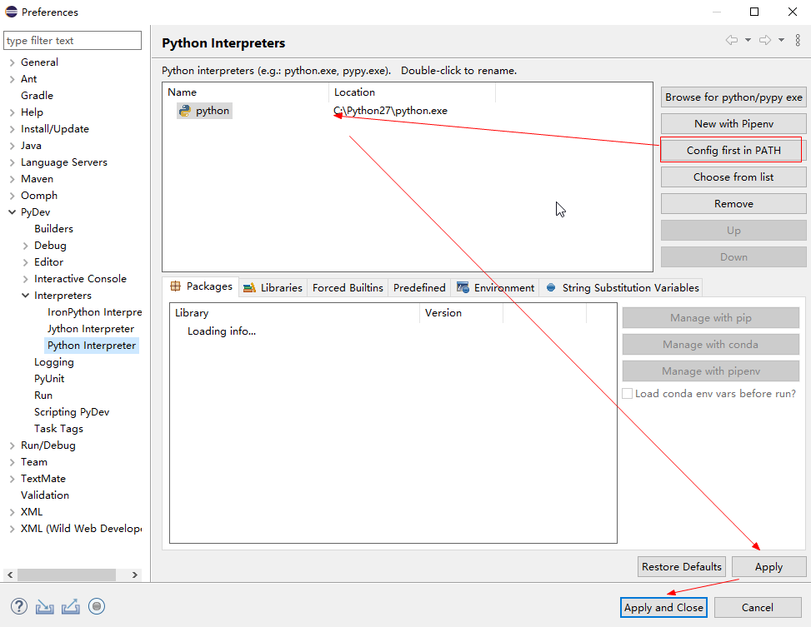

1. 链接arxml文件（Argument）

Run 🡪 Configurations 🡪 Python Run 🡪 New configurations 🡪 Arguments

--machine MACHINE --schema-version 47 --validate -d --check --generateCode "D:\SDC-EOS-aCore\SourceCode\tools\tools1911\配置工具运行程序\configFile\initialConfig\NeuSAR.arxml"

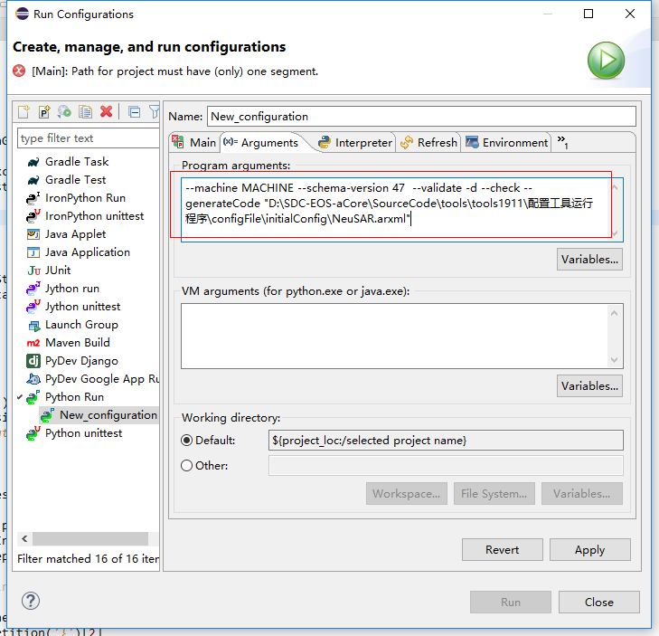

1. 链接起始文件，并Run；

Run 🡪 Configurations 🡪 Python Run 🡪 New configurations 🡪 Main

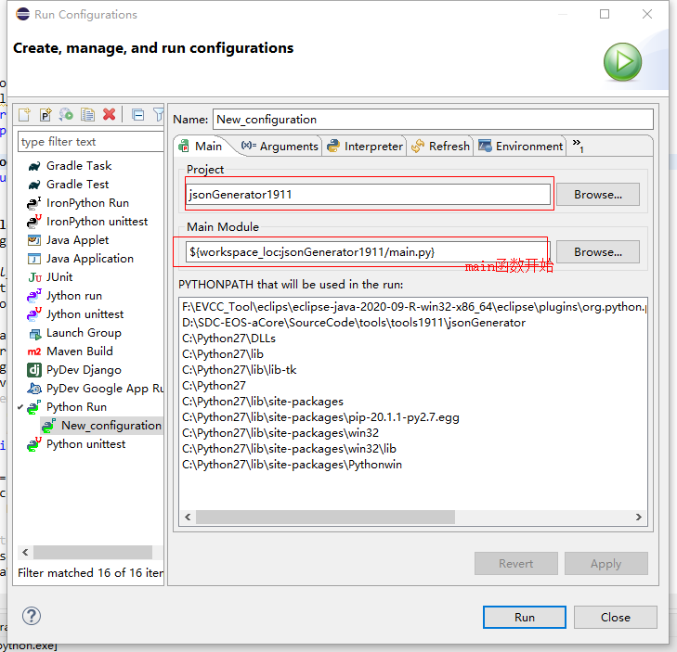

运行成功标志：

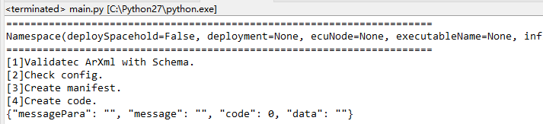

1. 生产C++代码

D:\SDC-EOS-aCore\SourceCode\tools\tools1911\jsonGenerator\output\code

1. 安装Artop

直接使用绿色工具：F:\EVCC_Tool\artop-demo-4.13.0-win32_64

原工具压缩包：F:\EVCC_Tool

另外：D:\SDC-EOS-aCore\autosar\release_18_10_localization\Tools

右键、新建

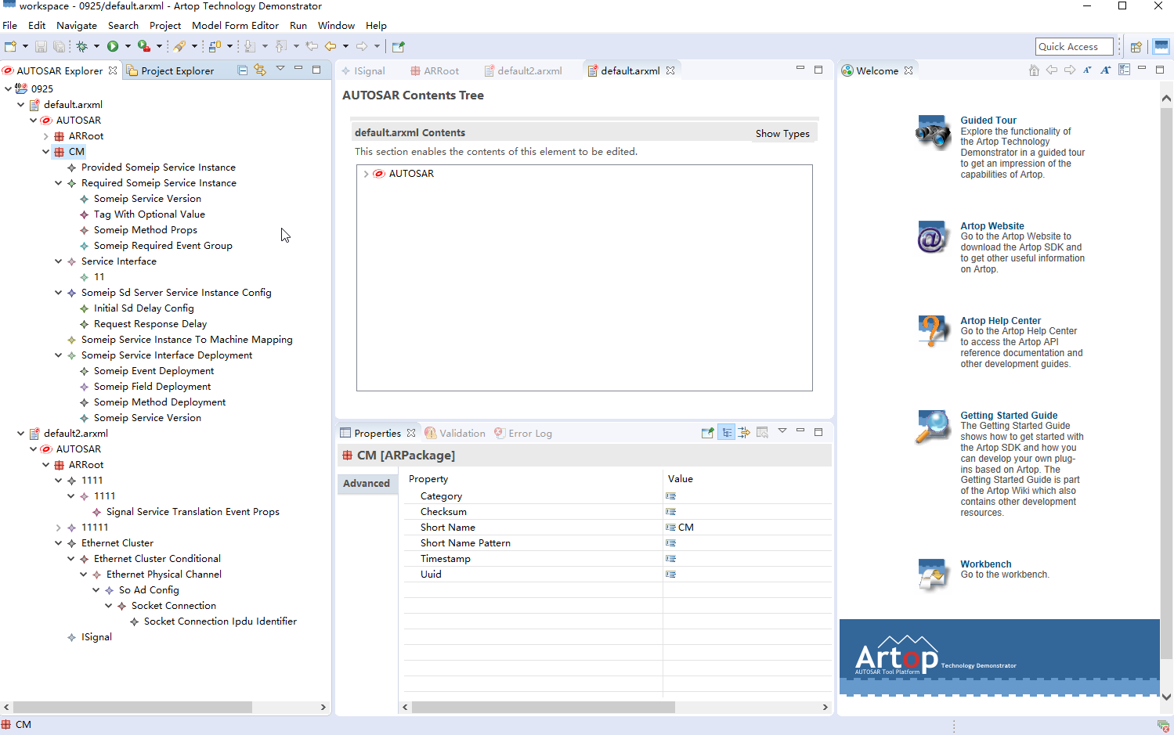

把Artop建模的.arxml通过如下脚本（如下路径为Python工程，需Eclipse加载执行）：

D:\SDC-EOS-aCore\SourceCode\tools\paramsConfigTool

文件arxml.py中注释了操作步骤（需修改路径等等）：

D:\SDC-EOS-aCore\SourceCode\tools\paramsConfigTool\arxml.py

Cmd下运行：

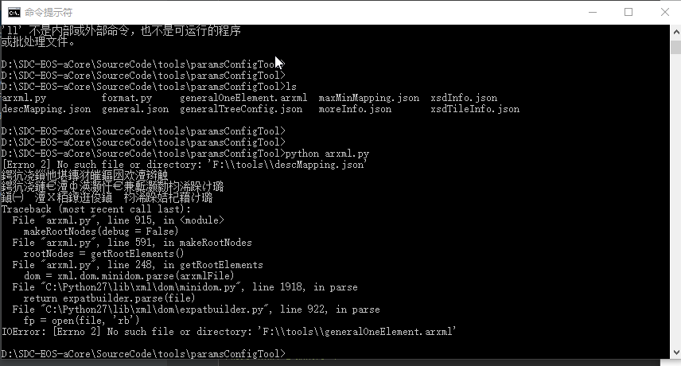

PyCharm运行脚本工具：

(Artop建模前提：value中字符串以s作为开头，数字以1作为开头)

打开工具、打开工程、选择需执行的arxml.py文件、右键、run……

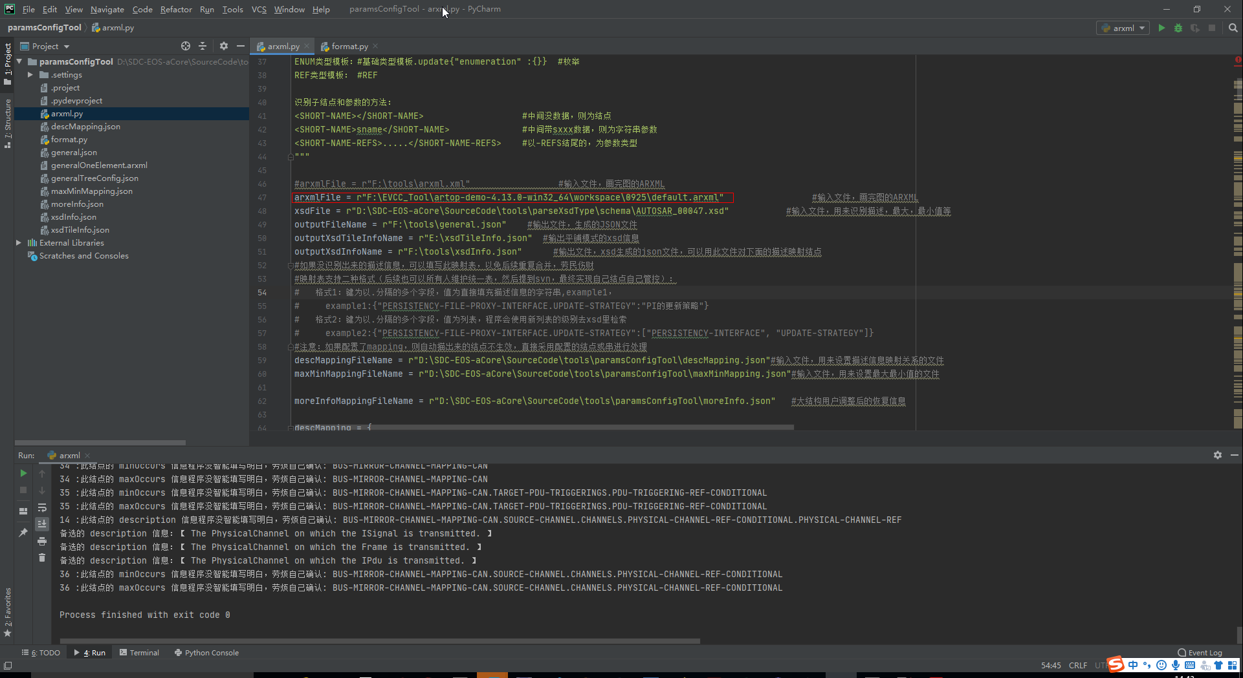

按照输出路径，查找输出的对应文件（*.json）；

1. EA工具
   1. EA利用C++自动画UML结构图



* 1. EA画时序图

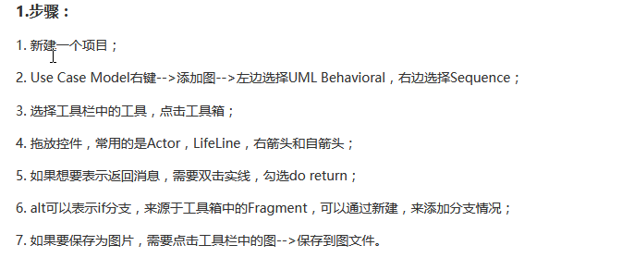

举例：S2S初始化启动





1. 设备调试（开发板）
2. CRT串口连接设备
3. 连接会话建立

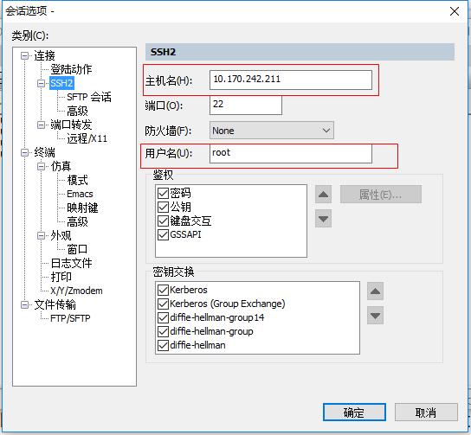

1. 串口连接成功

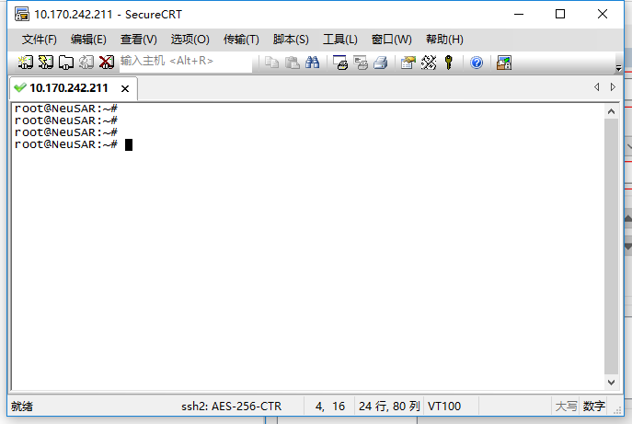

1. 配置调试质量



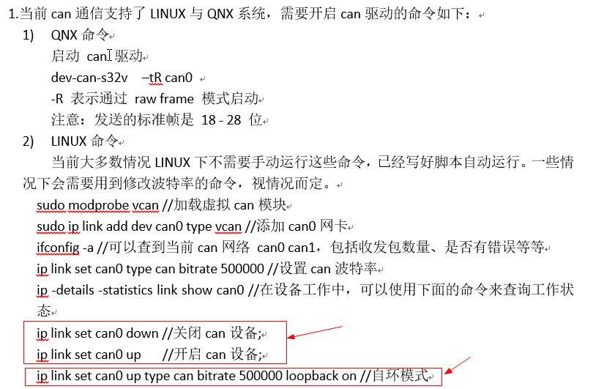

例如，查看CAN配置文件：

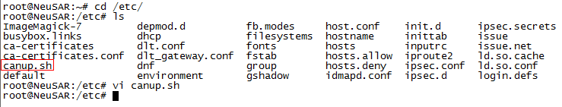

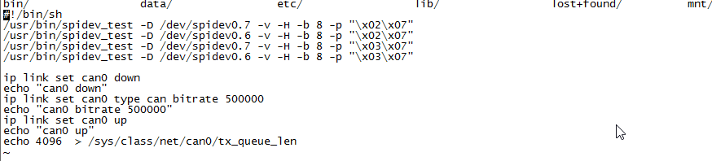

1. 开发板下载程序（S2S）

拷贝指令:

autosar@autosar-virtual-machine:~/autosar_auth_1911/release/opt$ scp -r s2s_service root@10.170.242.210:/opt/

1. 虚拟机进入opt路径下

该路径是四.10中Build上位机生成的对应模块的可执行文件夹；

1. scp拷贝文件夹到开发版本的制定目录

-r s2s_service :表示拷贝s2s_service文件夹（及文件夹内所有文件）；

如果需要拷贝文件夹下的某个可执行文件，直接进入该文件夹执行即可（如：scp s2s.bin root@10.170.242.210:/home/root/opt/）；

1. 虚拟机上传成功

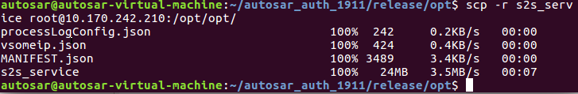

1. 开发板查看上传文件

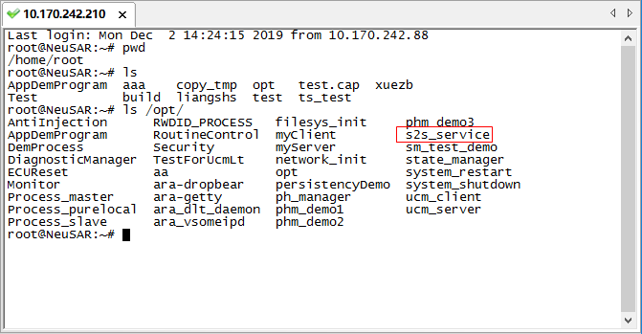

1. 运行进程



**操作中遇到问题：**



解决方法是吧ssh_config中的permitrootlogin注释掉；

常用操作指令：

# pstree ：显示进程树状图

# top ：动态实时视图（退出方式:q）

# ps -U root -u root –N ：查看非Root运行进程

# pgrep s2s_service ：显示对应进程id

# ps aux | grep s2s ：过滤查找进程

#kill -9 3827 ：按照进程杀死进程

#kill -9 s2s_service ：按照进程名杀死进程

1. 需阅读资料

AUTOSAR_TPS_ManifestSpecification.pdf

D:\SDC-EOS-aCore\autosar\autosar规范\AP_R19-11\MethodologyAndManifests

**10 Service Instance Manifest**

**11 Signal-based communication**

AUTOSAR_SWS_CommunicationManagement.pdf

D:\SDC-EOS-aCore\autosar\autosar规范\AP_R19-11\AdaptiveFoundation

**7.5.2 Signal-Based Network binding**

1. 上位机与Linux连接失败

本人环境问题导致（重装VMware），在此仅做举例参考。

问题原因：**VMware卸载时注册表未清理干净，导致VMware中无法勾选将主机虚拟适配器连接到此网络（图12.1），进而导致Linux和Windows之间未建立连接；**

解决方法1：卸载VMware，重新安装（此方法验证不可行，注册表还是未清除）；

解决方法2：**安装CCleaner，清理无用注册表，设备重启（再设置VMware中将主机虚拟适配器连接到此网络，如图12.2/12.3）；**

工具在官网下载Free版本即可：<https://ccleaner.en.softonic.com>

使用方法见图12.4/12.5；

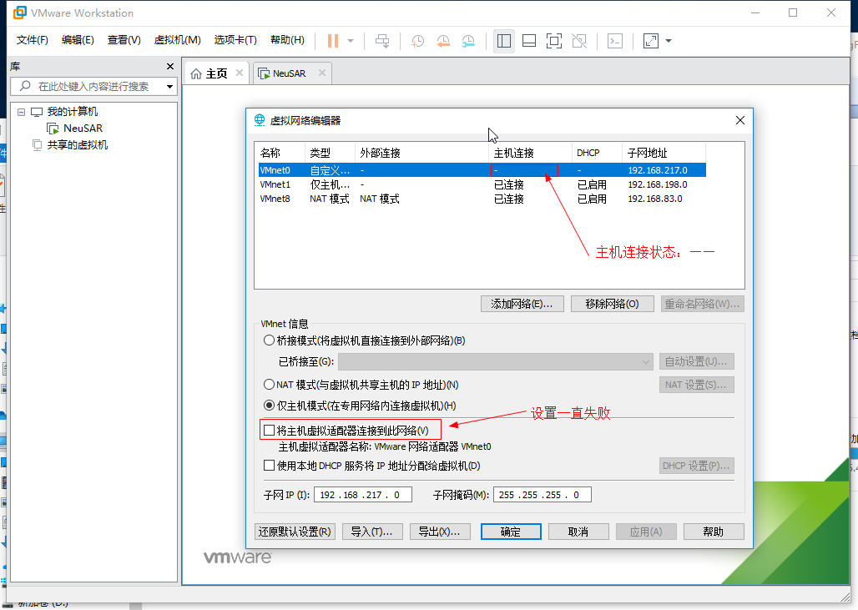

图12.1

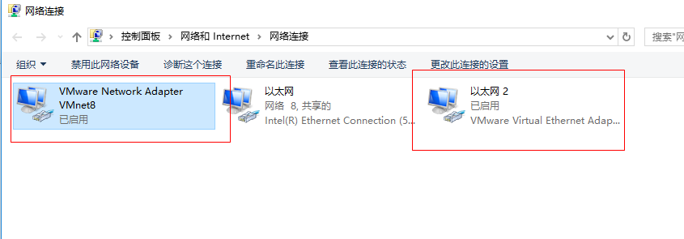

图12.2

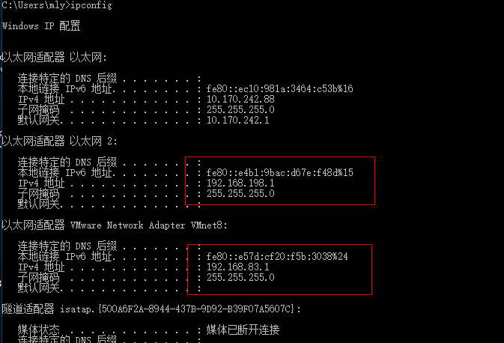

图12.3

1. 上位机开发

举例1：Event部署新增“serializer”序列化属性；

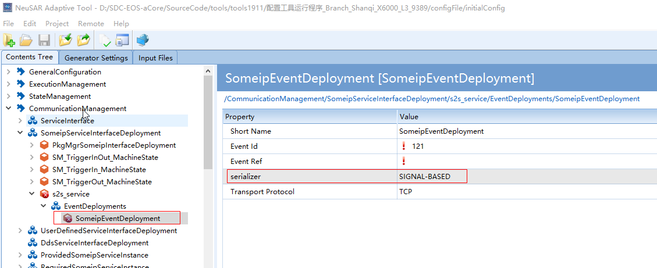

修改json文件

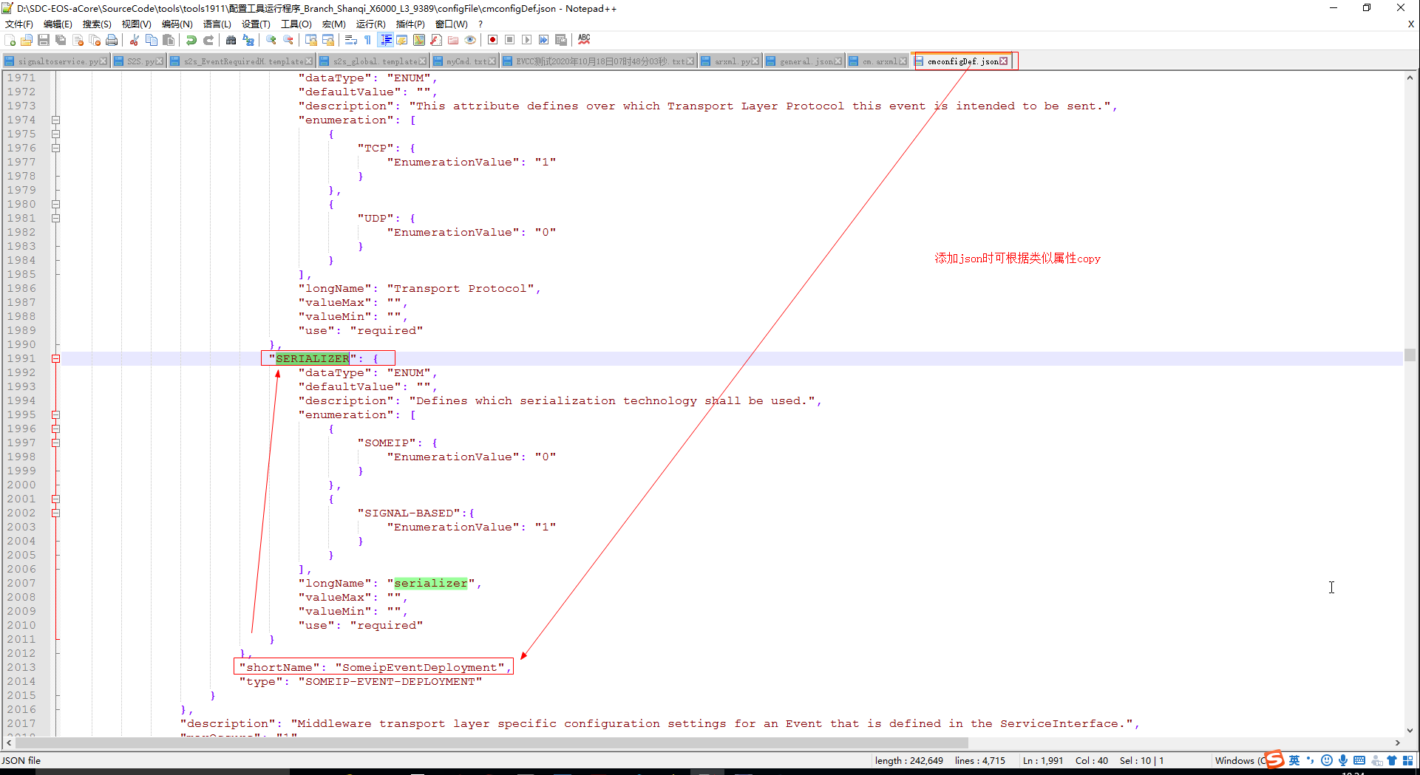

配置工具重新加载。

举例2：

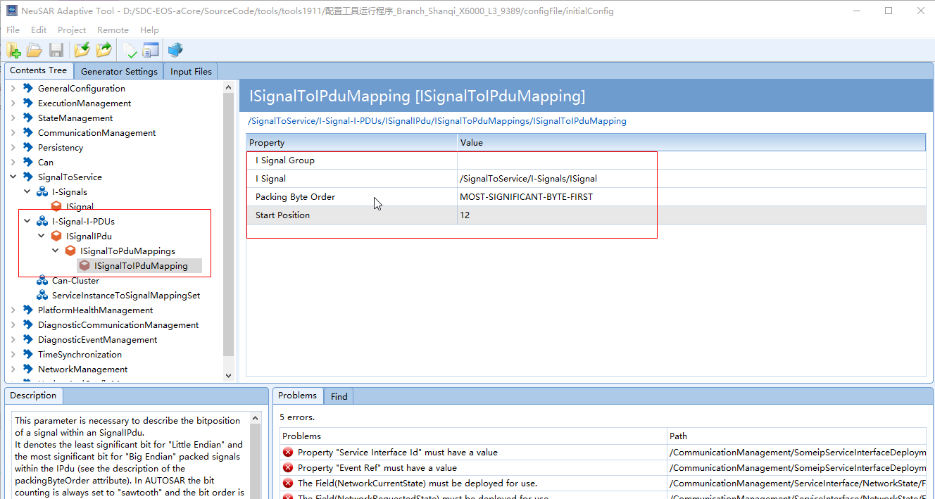

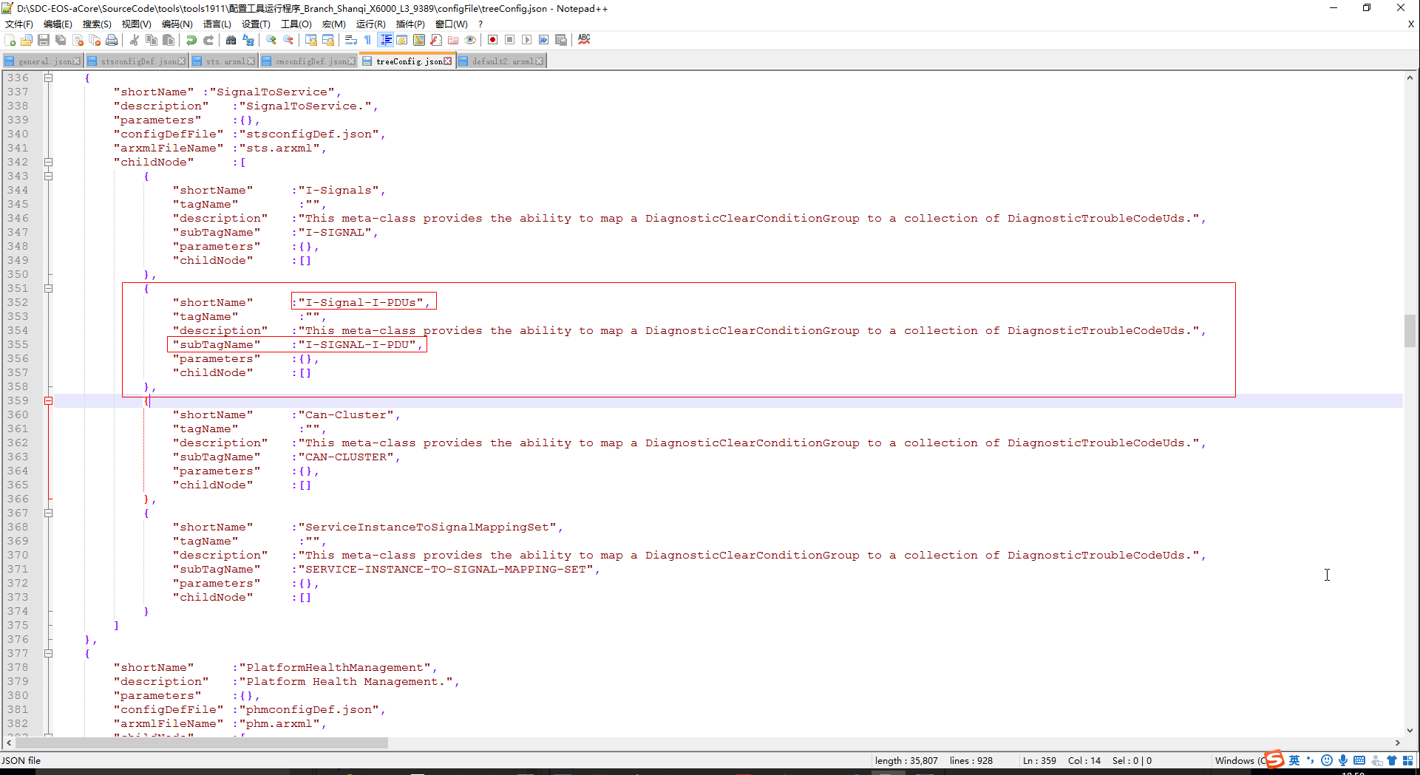

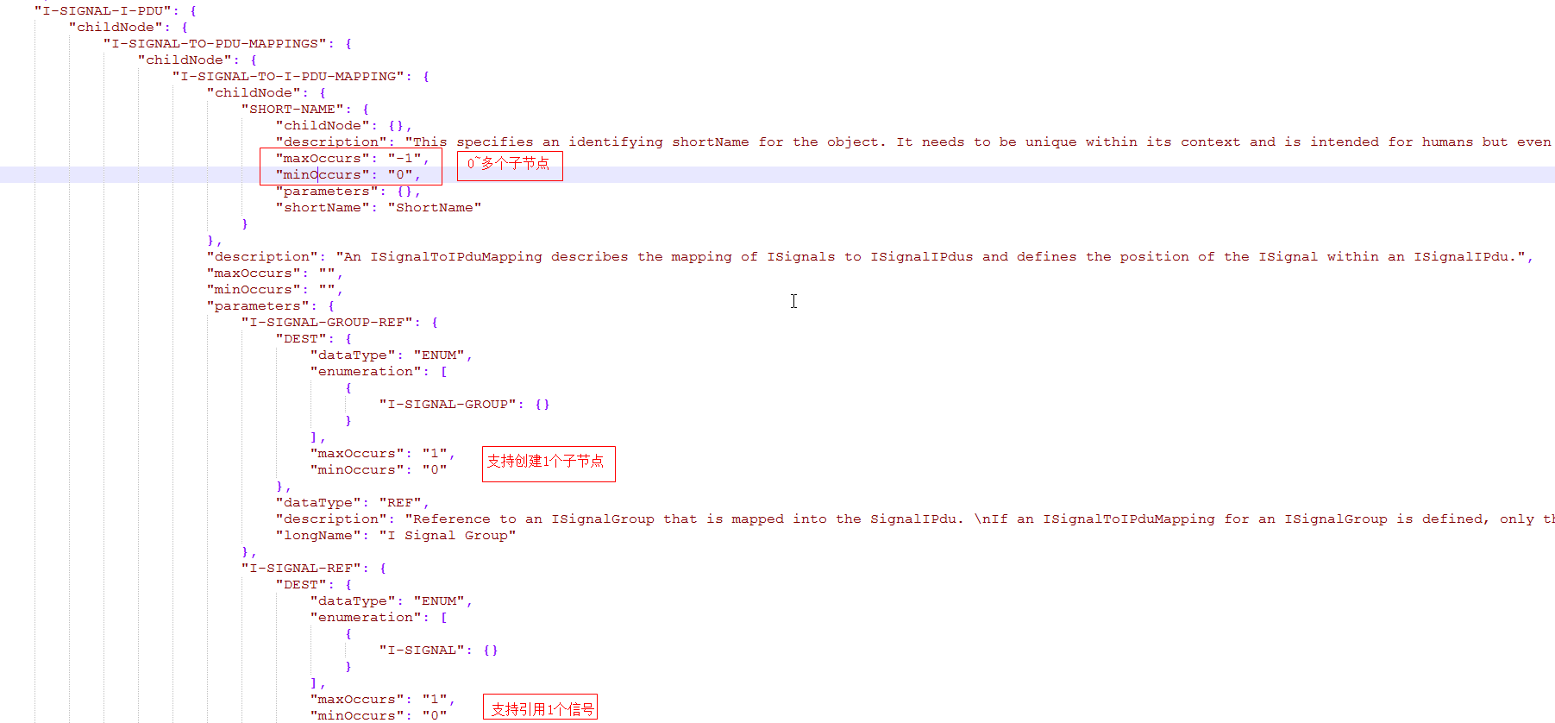

1. Vsomeip开元代码分析
2. C:\Users\mly\Desktop\aCore1903_auth\applications\vsomeip\daemon\vsomeipd.cpp

Main函数

vsomeipd_process 守护进程

1. C:\Users\mly\Desktop\aCore1903_auth\applications\vsomeip\implementation\routing\src\routing_manager_impl.cpp
2. C:\Users\mly\Desktop\aCore1903_auth\applications\vsomeip\implementation\routing\src\routing_manager_stub.cpp
3. C:\Users\mly\Desktop\aCore1903_auth\applications\vsomeip\implementation\routing\src\routing_manager_proxy.cpp
4. C:\Users\mly\Desktop\aCore1903_auth\applications\vsomeip\implementation\service_discovery\include\service_discovery_impl.hpp

APP与ECU之间服务发现通信：

routing_manager_impl.cpp 🡪 routing_manager_stub.cpp 🡪 service_discovery_impl.hpp

1. CM代码

onMessage

checkMessage check有效性

DeserializeAndSetPromise 反序列化

C:\Users\mly\Desktop\aCore1903_auth\ara-api\com\include\public\ara\com\internal\vsomeip\skeleton\vsomeip_event_impl.h

//订阅

Subscribe

DoSubscribe

application.request_event

application.subscribe

application.register_message_handler

setSubscriptionState

//取消订阅

Unsubscribe

application.unsubscribe

application.release_event

application.unregister_message_handler

setSubscriptionState

Cleanup

1. 基础C++函数
2. **std::copy(start, end, std::back_inserter(container));**

 这里，start和end是输入序列（假设有N个元素）的迭代器（iterator），container是一个容器，该容器的接口包含函数push_back。假设container开始是空的，那么copy完毕后它就包含N个元素，并且顺序与原来队列中的元素顺序一样。标准库提供的back_inserter模板函数很方便，因为它为container返回一个back_insert_iterator迭代器，这样，复制的元素都被追加到container的末尾了。

1. **reverse函数功能是逆序（或反转），多用于字符串、数组、容器。**

头文件是#include <algorithm>

reverse函数用于反转在[first,last)范围内的顺序（包括first指向的元素，不包括last指向的元素），reverse函数无返回值

1. **Inserter**

原理：其内部调用insert()

功能：在容器的指定位置插入元素

限制：只有提供了inset()成员函数的容器中，inserter才能派上用场. 所有STL容器都提供了inset()函数.

适用：所有STL容器

1. **reinterpret_cast<type-id> (expression)**

type-id 必须是一个指针、引用、算术类型、函数指针或者成员指针。它可以把一个指针转换成一个整数，也可以把一个整数转换成一个指针（先把一个指针转换成一个整数，再把该整数转换成原类型的指针，还可以得到原先的指针值）。

1. **insert**

str = "All that exists is what's ahead.";

b = str.insert(4,5,'x');

//在下标为4的位置，插入字符串5个字符x

cout << b << endl; //输出 All xxxxxthat exists is what's ahead.

举例：

tPdu.insert(std::end(tPdu), std::begin(inputPdu), std::end(inputPdu));

c.begin();           返回指向容器 最开始位置数据的指针

c.end();             返回指向容器最后一个数据单元+1的指针

1. **for (auto n : arr) 循环输出**

std::vector<int> arr{11,22,33,44,55};

for (auto n : arr)

{

std::cout << n <<" "; //输出：11 22 11 44 55

}

1. **模块编译**

make software-vsomeip 先编译vsomeip

make software-ara_com 再编译com

make software-vsomeip-clean

1. **基本操作Linux指令**
   1. //修改编译方法

vim ../../app/rules/ara_com.mk

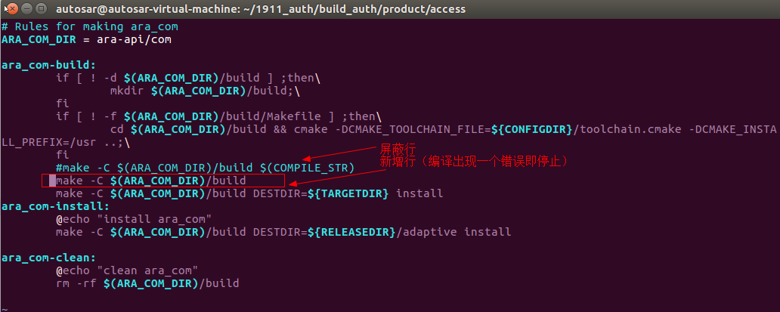

* 1. //预编译

$CXX -E ./src/libara_vsomeipbinding/skeleton/vsomeip_skeleton_base.cpp

* 1. //查找文件里符合条件的字符串

grep VERBOSE -nr ../../app/ara-api/

grep test *file //查找后缀有 file 字样的文件中包含 test 字符串的文件

grep -r update /etc/acpi //查找指定目录/etc/acpi 及其子目录（如果存在子目录的话）下所有文件中包含字符串"update"的文件

* 1. //???

aarch64-fsl-linux-g++ -c ./CMakeFiles/ara_vsomeipbinding.dir/skeleton/vsomeip_skeleton_base.cpp.o

* 1. //指定目录查找文件

find ../../app/ara-api/ -name s2s_pduconfiguration.h

* 1. //查看文件

vim /home/autosar/1911_auth/build_auth/app/ara-api/com/include/public/ara/com/internal/vsomeip/proxy/vsomeip_event_impl.h +155

* 1. //预编译-E

/home/autosar/1911_auth/build_auth/toolchain/sysroots/x86_64-fslbsp-linux/usr/bin/aarch64-fsl-linux/aarch64-fsl-linux-g++ --sysroot=/home/autosar/1911_auth/build_auth/toolchain/sysroots/aarch64-fsl-linux -DHAS_PROLOC_BINDING -DHAS_VSOMEIP_BINDING -DVSOMEIP_HAS_ARE_AVAILABLE -DVSOMEIP_REGISTER_HANDLER_WITH_VERSION -I/home/autosar/1911_auth/build_auth/app/ara-api/com/include/public -I/home/autosar/1911_auth/build_auth/app/ara-api/com/include/private -O2 -pipe -g -feliminate-unused-debug-types -g -Wall -Wctor-dtor-privacy -Wdeprecated -Wextra -Wfloat-equal -Winit-self -Wnon-virtual-dtor -Wold-style-cast -Woverloaded-virtual -Wpedantic -Wpointer-arith -Wshadow -Wsign-promo -Wuninitialized -Wunused -fno-strict-aliasing -std=c++14 -o CMakeFiles/ara_vsomeipbinding.dir/skeleton/vsomeip_skeleton_base.cpp.o -c /home/autosar/1911_auth/build_auth/app/ara-api/com/src/libara_vsomeipbinding/skeleton/vsomeip_skeleton_base.cpp -E

* 1. //查看生成.o文件

vim ./CMakeFiles/ara_vsomeipbinding.dir/skeleton/vsomeip_skeleton_base.cpp.o

1. **“=delete”用法**

**C++11标准引入了一个新特性：deleted函数。程序员只需在函数声明后加上”=delete;”，就可将该函数禁用**。

1. **int a和int& a的区别**

int a的意思是定义一个变量a

int &a意思是定义一个引用

//引用相当于指针再取值 他和被引用的变量都是表示同一块内存

引用就是给变量取别名 int b ;int &a=b; 用cout<<&a 和cout<<&b 你会发现他们的地址是一样的

左值引用时，=右边的要求是一个可修改的左值；

D:\SDC-EOS-aCore\02.Develop\02.SoftwareDevelopment\03.SoftwareDesign\02.Software Detail Design\☆☆☆☆☆DocumentsReleasedToCustomers\用户实例1911\CM\output\code\myServer\gen\myServer\vsomeip\ara\com\sample\adapter_myinterface.h

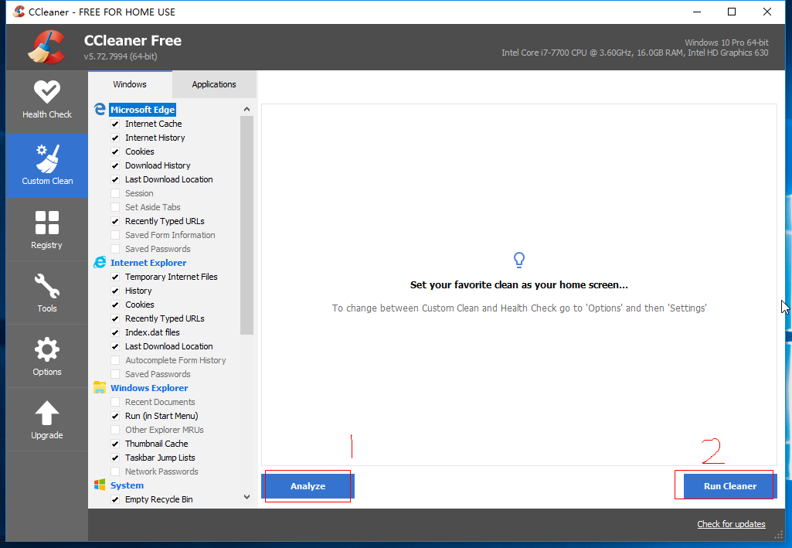

图12.4

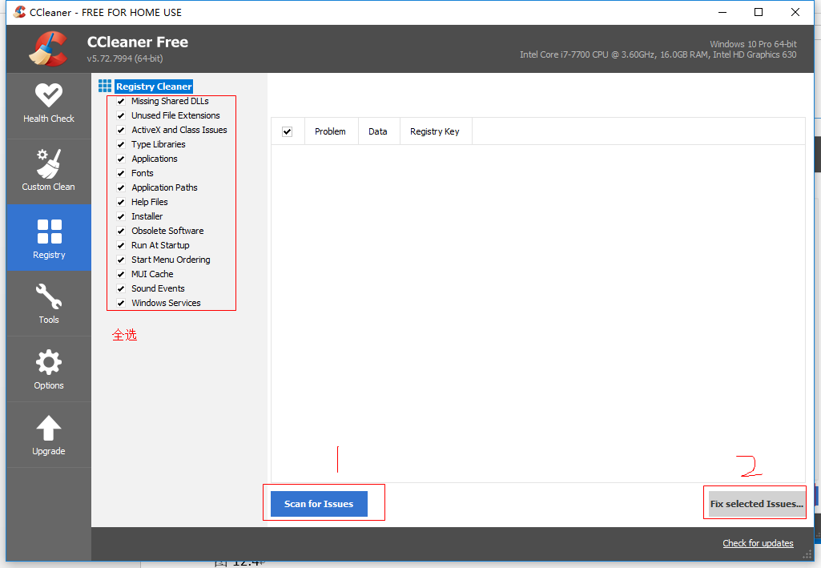

图12.5

确定：哪个Signal来了触发Send（上位机设置）

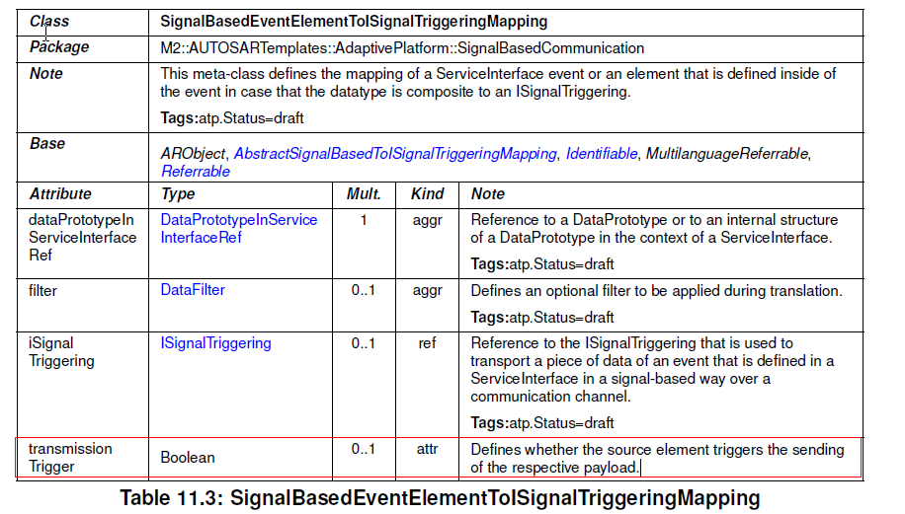

用户实例；

1. 根据上位机配置上传PDU结构体

或者读取配置文件获取

如 ：

typedef struct {

    uint8 length;

uint32 ISignal1 : 8;

     nion{

uint32 ISignal2 : 8;

uint32 ISignal3 : 16;

}ISignalGroup1

} PDU1;

If（true == event1.update()）

data = **samples.begin();

Set（PDU1. ISignal1 = data）

If（true == transmissionTrigger）{

Send（PDU1）

}

If（true == event2.update()）

data = **samples.begin();

Set（PDU1. ISignalGroup1.ISignal2 = data）

If（true == transmissionTrigger）{

Send（PDU1）

}

autosar@autosar-virtual-machine:~$ cd /home/autosar/cm_output/release/

autosar@autosar-virtual-machine:~/cm_output/release$ ls

etc opt

autosar@autosar-virtual-machine:~/cm_output/release$

autosar@autosar-virtual-machine:~/cm_output/release$ cd ..

autosar@autosar-virtual-machine:~/cm_output$ ls

code manifest release

autosar@autosar-virtual-machine:~/cm_output$ cd release/

autosar@autosar-virtual-machine:~/cm_output/release$ ls

etc opt

autosar@autosar-virtual-machine:~/cm_output/release$ ls etc/

network system vsomeip.json

autosar@autosar-virtual-machine:~/cm_output/release$ cat etc/vsomeip.json

{

"logging": {

"level": "debug",

"console": "true",

"file": {

"path": "/var/log/vsomeip.log",

"enable": "false"

},

"dlt": "true"

},

"unicast": "192.168.1.100",

"applications": [

{

"name": "vsomeipd",

"id": "0x1"

}

],

"netmask": "255.255.255.0",

"routing": "vsomeipd",

"services": [],

"service-discovery": {

"enable": "true",

"repetitions_max": "5",

"repetitions_base_delay": "20000",

"initial_delay_min": "10000",

"cyclic_offer_delay": "1800000",

"multicast": "239.20.20.20",

"request_response_delay": "20000",

"initial_delay_max": "20000",

"ttl": "86400",

"request_response_delay_min": "10000",

"protocol": "udp",

"port": "30491"

}

}autosar@autosar-virtual-machine:~/cm_output/release$ ls

etc opt

autosar@autosar-virtual-machine:~/cm_output/release$ ls etc/

network system vsomeip.json

autosar@autosar-virtual-machine:~/cm_output/release$ scp -P 456 etc/vsomeip.json root@10.170.242.68:/etc

The authenticity of host '[10.170.242.68]:456 ([10.170.242.68]:456)' can't be established.

RSA key fingerprint is SHA256:8zaPyDg5/Tr39Y38OgSdxRM2lMpP6ZDx8xwLH+K2BGs.

Are you sure you want to continue connecting (yes/no)? yes

Warning: Permanently added '[10.170.242.68]:456' (RSA) to the list of known hosts.

vsomeip.json 100% 810 0.8KB/s 00:00

autosar@autosar-virtual-machine:~/cm_output/release$

autosar@autosar-virtual-machine:~/cm_output/release$

autosar@autosar-virtual-machine:~/cm_output/release$

autosar@autosar-virtual-machine:~/cm_output/release$ ls

etc opt

autosar@autosar-virtual-machine:~/cm_output/release$ cd opt/

autosar@autosar-virtual-machine:~/cm_output/release/opt$ ls

myClient myServer

autosar@autosar-virtual-machine:~/cm_output/release/opt$ scp -r -P 456 myClient/ root@10.170.242.68:/opt

NeuSAR_ARA_Version 100% 6 0.0KB/s 00:00

processLogConfig.json 100% 332 0.3KB/s 00:00

vsomeip.json 100% 891 0.9KB/s 00:00

MANIFEST.json 100% 3637 3.6KB/s 00:00

myClient 100% 17MB 8.7MB/s 00:02

kvsdatabase.json 100% 127 0.1KB/s 00:00

autosar@autosar-virtual-machine:~/cm_output/release/opt$

autosar@autosar-virtual-machine:~/cm_output/release/opt$

autosar@autosar-virtual-machine:~/cm_output/release/opt$ scp -r -P 456 myServer// root@10.170.242.68:/opt

NeuSAR_ARA_Version 100% 6 0.0KB/s 00:00

processLogConfig.json 100% 332 0.3KB/s 00:00

vsomeip.json 100% 1759 1.7KB/s 00:00

MANIFEST.json 100% 3637 3.6KB/s 00:00

myServer 100% 18MB 17.5MB/s 00:01

kvsdatabase.json 100% 127 0.1KB/s 00:00

autosar@autosar-virtual-machine:~/cm_output/release/opt$

//连接其他电脑

ssh –p 22 autosar@10.170.242.68

//查看编译环境

$ env

autosar@autosar-virtual-machine:~$ ssh -p 789 autosar@10.170.242.68

autosar@10.170.242.68's password:

Permission denied, please try again.

autosar@10.170.242.68's password:

Permission denied, please try again.

autosar@10.170.242.68's password:

autosar@autosar-virtual-machine:~$ ssh -p 456 autosar@10.170.242.68

autosar@10.170.242.68's password:

Permission denied, please try again.

autosar@10.170.242.68's password:

autosar@autosar-virtual-machine:~$ ssh -p 456 root@10.170.242.68

root@NeuSAR:~#

root@NeuSAR:~#

root@NeuSAR:~#

root@NeuSAR:~# find / -name libvsomeip*

/var/lib/apd_ucm/install/NeuSARPlatform/1.0.0.0000/usr/lib/libvsomeip.so.2.10.10

/var/lib/apd_ucm/install/NeuSARPlatform/1.0.0.0000/usr/lib/libvsomeip-cfg.so.2

/var/lib/apd_ucm/install/NeuSARPlatform/1.0.0.0000/usr/lib/libvsomeip-sd.so.2.10.10

/var/lib/apd_ucm/install/NeuSARPlatform/1.0.0.0000/usr/lib/libvsomeip-sd.so.2

/var/lib/apd_ucm/install/NeuSARPlatform/1.0.0.0000/usr/lib/libvsomeip-cfg.so

/var/lib/apd_ucm/install/NeuSARPlatform/1.0.0.0000/usr/lib/libvsomeip.so

/var/lib/apd_ucm/install/NeuSARPlatform/1.0.0.0000/usr/lib/libvsomeip-sd.so

/var/lib/apd_ucm/install/NeuSARPlatform/1.0.0.0000/usr/lib/libvsomeip.so.2

/var/lib/apd_ucm/install/NeuSARPlatform/1.0.0.0000/usr/lib/libvsomeip-cfg.so.2.10.10

root@NeuSAR:~# ps aux

USER PID %CPU %MEM VSZ RSS TTY STAT START TIME COMMAND

root 1 0.0 0.1 2104 1272 ? Ss 14:43 0:01 init [5]

root 2 0.0 0.0 0 0 ? S 14:43 0:00 [kthreadd]

root 4 0.0 0.0 0 0 ? S< 14:43 0:00 [kworker/0:0H]

root 6 0.0 0.0 0 0 ? S< 14:43 0:00 [mm_percpu_wq]

root 7 0.0 0.0 0 0 ? S 14:43 0:00 [ksoftirqd/0]

root 8 0.0 0.0 0 0 ? S 14:43 0:00 [rcu_preempt]

root 9 0.0 0.0 0 0 ? S 14:43 0:00 [rcu_sched]

root 10 0.0 0.0 0 0 ? S 14:43 0:00 [rcu_bh]

root 11 0.0 0.0 0 0 ? S 14:43 0:00 [migration/0]

root 12 0.0 0.0 0 0 ? S 14:43 0:00 [cpuhp/0]

root 13 0.0 0.0 0 0 ? S 14:43 0:00 [cpuhp/1]

root 14 0.0 0.0 0 0 ? S 14:43 0:00 [migration/1]

root 15 0.0 0.0 0 0 ? S 14:43 0:00 [ksoftirqd/1]

root 16 0.0 0.0 0 0 ? S 14:43 0:00 [kworker/1:0]

root 17 0.0 0.0 0 0 ? S< 14:43 0:00 [kworker/1:0H]

root 18 0.0 0.0 0 0 ? S 14:43 0:00 [kdevtmpfs]

root 19 0.0 0.0 0 0 ? S< 14:43 0:00 [netns]

root 20 0.0 0.0 0 0 ? S 14:43 0:00 [kworker/0:1]

root 21 0.0 0.0 0 0 ? S 14:43 0:00 [oom_reaper]

root 22 0.0 0.0 0 0 ? S< 14:43 0:00 [writeback]

root 23 0.0 0.0 0 0 ? S 14:43 0:00 [kcompactd0]

root 24 0.0 0.0 0 0 ? S< 14:43 0:00 [crypto]

root 25 0.0 0.0 0 0 ? S< 14:43 0:00 [bioset]

root 26 0.0 0.0 0 0 ? S< 14:43 0:00 [kblockd]

root 27 0.0 0.0 0 0 ? S< 14:43 0:00 [ata_sff]

root 28 0.0 0.0 0 0 ? S< 14:43 0:00 [md]

root 29 0.0 0.0 0 0 ? S< 14:43 0:00 [watchdogd]

root 30 0.0 0.0 0 0 ? S< 14:43 0:00 [rpciod]

root 31 0.0 0.0 0 0 ? S< 14:43 0:00 [xprtiod]

root 32 0.0 0.0 0 0 ? S 14:43 0:00 [kswapd0]

root 33 0.0 0.0 0 0 ? S< 14:43 0:00 [bioset]

root 34 0.0 0.0 0 0 ? S< 14:43 0:00 [nfsiod]

root 57 0.0 0.0 0 0 ? S 14:43 0:03 [kworker/1:1]

root 58 0.0 0.0 0 0 ? S< 14:43 0:00 [acpi_thermal_p

root 60 0.0 0.0 0 0 ? S< 14:43 0:00 [bioset]

root 61 0.0 0.0 0 0 ? S< 14:43 0:00 [bioset]

root 62 0.0 0.0 0 0 ? S< 14:43 0:00 [bioset]

root 63 0.0 0.0 0 0 ? S< 14:43 0:00 [bioset]

root 64 0.0 0.0 0 0 ? S< 14:43 0:00 [bioset]

root 65 0.0 0.0 0 0 ? S< 14:43 0:00 [bioset]

root 66 0.0 0.0 0 0 ? S< 14:43 0:00 [bioset]

root 67 0.0 0.0 0 0 ? S< 14:43 0:00 [bioset]

root 68 0.0 0.0 0 0 ? S< 14:43 0:00 [bioset]

root 69 0.0 0.0 0 0 ? S< 14:43 0:00 [bioset]

root 70 0.0 0.0 0 0 ? S< 14:43 0:00 [bioset]

root 71 0.0 0.0 0 0 ? S< 14:43 0:00 [bioset]

root 72 0.0 0.0 0 0 ? S< 14:43 0:00 [bioset]

root 73 0.0 0.0 0 0 ? S< 14:43 0:00 [bioset]

root 74 0.0 0.0 0 0 ? S< 14:43 0:00 [bioset]

root 75 0.0 0.0 0 0 ? S< 14:43 0:00 [bioset]

root 76 0.0 0.0 0 0 ? S< 14:43 0:00 [bioset]

root 77 0.0 0.0 0 0 ? S< 14:43 0:00 [bioset]

root 78 0.0 0.0 0 0 ? S< 14:43 0:00 [bioset]

root 79 0.0 0.0 0 0 ? S< 14:43 0:00 [bioset]

root 80 0.0 0.0 0 0 ? S< 14:43 0:00 [bioset]

root 81 0.0 0.0 0 0 ? S< 14:43 0:00 [bioset]

root 82 0.0 0.0 0 0 ? S< 14:43 0:00 [bioset]

root 83 0.0 0.0 0 0 ? S< 14:43 0:00 [bioset]

root 84 0.0 0.0 0 0 ? S< 14:43 0:00 [bioset]

root 85 0.0 0.0 0 0 ? S< 14:43 0:01 [kworker/0:1H]

root 86 0.0 0.0 0 0 ? S< 14:43 0:00 [nvme]

root 87 0.0 0.0 0 0 ? S 14:43 0:00 [scsi_eh_0]

root 88 0.0 0.0 0 0 ? S< 14:43 0:00 [scsi_tmf_0]

root 89 0.0 0.0 0 0 ? S 14:43 0:00 [scsi_eh_1]

root 90 0.0 0.0 0 0 ? S< 14:43 0:00 [scsi_tmf_1]

root 91 0.0 0.0 0 0 ? S 14:43 0:00 [scsi_eh_2]

root 92 0.0 0.0 0 0 ? S< 14:43 0:00 [scsi_tmf_2]

root 93 0.0 0.0 0 0 ? S 14:43 0:00 [scsi_eh_3]

root 94 0.0 0.0 0 0 ? S< 14:43 0:00 [scsi_tmf_3]

root 95 0.0 0.0 0 0 ? S 14:43 0:00 [scsi_eh_4]

root 96 0.0 0.0 0 0 ? S< 14:43 0:00 [scsi_tmf_4]

root 97 0.0 0.0 0 0 ? S 14:43 0:00 [scsi_eh_5]

root 98 0.0 0.0 0 0 ? S< 14:43 0:00 [scsi_tmf_5]

root 99 0.0 0.0 0 0 ? S 14:43 0:00 [scsi_eh_6]

root 100 0.0 0.0 0 0 ? S< 14:43 0:00 [scsi_tmf_6]

root 101 0.0 0.0 0 0 ? S 14:43 0:00 [scsi_eh_7]

root 102 0.0 0.0 0 0 ? S< 14:43 0:00 [scsi_tmf_7]

root 103 0.0 0.0 0 0 ? S 14:43 0:00 [scsi_eh_8]

root 104 0.0 0.0 0 0 ? S< 14:43 0:00 [scsi_tmf_8]

root 105 0.0 0.0 0 0 ? S 14:43 0:00 [scsi_eh_9]

root 106 0.0 0.0 0 0 ? S< 14:43 0:00 [scsi_tmf_9]

root 107 0.0 0.0 0 0 ? S 14:43 0:00 [scsi_eh_10]

root 108 0.0 0.0 0 0 ? S< 14:43 0:00 [scsi_tmf_10]

root 109 0.0 0.0 0 0 ? S 14:43 0:00 [scsi_eh_11]

root 110 0.0 0.0 0 0 ? S< 14:43 0:00 [scsi_tmf_11]

root 111 0.0 0.0 0 0 ? S 14:43 0:00 [scsi_eh_12]

root 112 0.0 0.0 0 0 ? S< 14:43 0:00 [scsi_tmf_12]

root 113 0.0 0.0 0 0 ? S 14:43 0:00 [scsi_eh_13]

root 114 0.0 0.0 0 0 ? S< 14:43 0:00 [scsi_tmf_13]

root 115 0.0 0.0 0 0 ? S 14:43 0:00 [scsi_eh_14]

root 116 0.0 0.0 0 0 ? S< 14:43 0:00 [scsi_tmf_14]

root 117 0.0 0.0 0 0 ? S 14:43 0:00 [scsi_eh_15]

root 118 0.0 0.0 0 0 ? S< 14:43 0:00 [scsi_tmf_15]

root 119 0.0 0.0 0 0 ? S 14:43 0:00 [scsi_eh_16]

root 120 0.0 0.0 0 0 ? S< 14:43 0:00 [scsi_tmf_16]

root 121 0.0 0.0 0 0 ? S 14:43 0:00 [scsi_eh_17]

root 122 0.0 0.0 0 0 ? S< 14:43 0:00 [scsi_tmf_17]

root 123 0.0 0.0 0 0 ? S 14:43 0:00 [scsi_eh_18]

root 124 0.0 0.0 0 0 ? S< 14:43 0:00 [scsi_tmf_18]

root 125 0.0 0.0 0 0 ? S 14:43 0:00 [scsi_eh_19]

root 126 0.0 0.0 0 0 ? S< 14:43 0:00 [scsi_tmf_19]

root 127 0.0 0.0 0 0 ? S 14:43 0:00 [scsi_eh_20]

root 128 0.0 0.0 0 0 ? S< 14:43 0:00 [scsi_tmf_20]

root 129 0.0 0.0 0 0 ? S 14:43 0:00 [scsi_eh_21]

root 130 0.0 0.0 0 0 ? S< 14:43 0:00 [scsi_tmf_21]

root 131 0.0 0.0 0 0 ? S 14:43 0:00 [scsi_eh_22]

root 132 0.0 0.0 0 0 ? S< 14:43 0:00 [scsi_tmf_22]

root 133 0.0 0.0 0 0 ? S 14:43 0:00 [scsi_eh_23]

root 134 0.0 0.0 0 0 ? S< 14:43 0:00 [scsi_tmf_23]

root 135 0.0 0.0 0 0 ? S 14:43 0:00 [scsi_eh_24]

root 136 0.0 0.0 0 0 ? S< 14:43 0:00 [scsi_tmf_24]

root 137 0.0 0.0 0 0 ? S 14:43 0:00 [scsi_eh_25]

root 138 0.0 0.0 0 0 ? S< 14:43 0:00 [scsi_tmf_25]

root 139 0.0 0.0 0 0 ? S 14:43 0:00 [scsi_eh_26]

root 140 0.0 0.0 0 0 ? S< 14:43 0:00 [scsi_tmf_26]

root 141 0.0 0.0 0 0 ? S 14:43 0:00 [scsi_eh_27]

root 142 0.0 0.0 0 0 ? S< 14:43 0:00 [scsi_tmf_27]

root 143 0.0 0.0 0 0 ? S 14:43 0:00 [scsi_eh_28]

root 144 0.0 0.0 0 0 ? S< 14:43 0:00 [scsi_tmf_28]

root 145 0.0 0.0 0 0 ? S 14:43 0:00 [scsi_eh_29]

root 146 0.0 0.0 0 0 ? S< 14:43 0:00 [scsi_tmf_29]

root 173 0.0 0.0 0 0 ? S 14:43 0:00 [kworker/u16:28

root 176 0.0 0.0 0 0 ? S< 14:43 0:00 [bioset]

root 178 0.0 0.0 0 0 ? S< 14:43 0:00 [dm_bufio_cache

root 179 0.0 0.0 0 0 ? S< 14:43 0:00 [ipv6_addrconf]

root 180 0.0 0.0 0 0 ? S< 14:43 0:00 [bioset]

root 185 0.0 0.0 0 0 ? S 14:43 0:02 [kworker/0:3]

root 186 0.0 0.0 0 0 ? S< 14:43 0:00 [bioset]

root 187 0.0 0.0 0 0 ? S< 14:43 0:00 [kworker/1:1H]

root 188 0.0 0.0 0 0 ? S 14:43 0:00 [jbd2/hda4-8]

root 189 0.0 0.0 0 0 ? S< 14:43 0:00 [ext4-rsv-conve

root 203 0.0 0.0 0 0 ? S 14:43 0:00 [jbd2/hda2-8]

root 204 0.0 0.0 0 0 ? S< 14:43 0:00 [ext4-rsv-conve

root 215 0.0 0.2 3624 2200 ? Ss 14:43 0:00 /sbin/udevd -d

root 246 0.0 0.0 2488 488 ? Ss 14:43 0:00 /sbin/v86d

root 397 0.0 0.1 2696 1384 ? Ss 14:43 0:00 /usr/sbin/dropb

root 406 0.0 0.1 3544 1356 ? S 14:43 0:00 /sbin/syslogd -

root 408 0.0 0.0 3548 632 ? S 14:43 0:00 /sbin/klogd -n

root 416 0.0 0.2 3596 2732 tty1 Ss+ 14:43 0:00 -sh

root 629 0.0 0.1 2840 2024 ? Ss 14:44 0:00 /usr/sbin/dropb

root 630 0.0 0.2 3612 2720 pts/0 Ss+ 14:45 0:00 -sh

root 633 0.0 0.1 2840 2016 ? Ss 14:45 0:00 /usr/sbin/dropb

root 634 0.0 0.2 3484 2512 ? S 14:45 0:00 -sh

root 813 0.0 0.1 2840 2024 ? Ss 14:49 0:00 /usr/sbin/dropb

root 814 0.0 0.2 3600 2756 pts/1 Ss+ 14:49 0:00 -sh

root 1526 0.0 0.1 2840 2024 ? Ss 15:12 0:00 /usr/sbin/dropb

root 1527 0.0 0.2 3484 2716 pts/2 Ss+ 15:12 0:00 -sh

root 1758 0.0 0.1 2840 2028 ? Ss 15:13 0:00 /usr/sbin/dropb

root 1759 0.0 0.2 3612 2720 pts/3 Ss+ 15:13 0:00 -sh

root 1933 0.0 0.1 2840 2020 ? Ss 15:14 0:00 /usr/sbin/dropb

root 1934 0.0 0.2 3484 2516 ? S 15:14 0:00 -sh

root 6009 0.0 0.0 0 0 ? S 17:11 0:00 [kworker/u16:0]

root 6099 0.0 0.2 3344 2228 ? Ss 17:12 0:00 /bin/sh /bin/st

root 6116 0.0 0.0 3548 640 ttyS0 Ss+ 17:12 0:00 /sbin/getty -L

root 7144 0.0 0.1 2840 2024 ? Rs 17:41 0:00 /usr/sbin/dropb

root 7145 0.0 0.2 3484 2720 pts/4 Ss 17:41 0:00 -sh

root 7149 30.7 0.1 2840 2020 ? Rs 17:42 0:02 /usr/sbin/dropb

root 7150 5.6 0.0 2712 716 ? S 17:42 0:00 scp -d -t /var/

root 7151 0.0 0.1 2996 1780 pts/4 R+ 17:42 0:00 ps aux

root@NeuSAR:~# execution-manager -DEBUG

[10806.695071]~DLT~ 7157~INFO ~FIFO /tmp/dlt cannot be opened. Retrying later...

INFO: EM: Starting with root path: '/'

INFO: EM: Initializing execution-manager...

INFO: EM: Starting initialization.

INFO: EM: Loading Machine Manifest

INFO: EM: Loading Machine Manifest - done

INFO: EM: Initialize Cgroups

ERROR: EM: Invalid definition of Resource Groups! Check Resource Group configuration!

INFO: EM: Loading Executable Manifests

INFO: StartupConfig: some required param is missed: scheduling_priority.

111111111111111111111constructor of Application: /opt/myClient/bin/myClient

alreadyReportKRunning: 0

ERROR: EM: /opt/myClient/bin/myClient: get cgroup failed with Cgroup not initialized

INFO: insert startupConfiguration myClient to state MachineState.Verify

INFO: insert startupConfiguration myClient to state MachineState.Startup

INFO: StartupConfig: some required param is missed: scheduling_priority.

111111111111111111111constructor of Application: /opt/myServer/bin/myServer

alreadyReportKRunning: 0

ERROR: EM: /opt/myServer/bin/myServer: get cgroup failed with Cgroup not initialized

INFO: insert startupConfiguration myServer to state MachineState.Verify

INFO: insert startupConfiguration myServer to state MachineState.Startup

ERROR: StartupConfig: machine state or function group state should be referenced

INFO: StartupConfig: some required param is missed: scheduling_priority.

111111111111111111111constructor of Application: /opt/ucm_client/bin/ucm_client

alreadyReportKRunning: 0

ERROR: EM: Application ucm_client has no valid system states specified. Check state configuration in Manifest!

ERROR: EM: /opt/ucm_client/bin/ucm_client: get cgroup failed with Cgroup not initialized

111111111111111111111constructor of Application: /opt/gptp2d/bin/gptp2d

alreadyReportKRunning: 0

ERROR: EM: /opt/gptp2d/bin/gptp2d: get cgroup failed with Cgroup not initialized

INFO: insert startupConfiguration gptp2d to state MachineState.Startup

INFO: StartupConfig: some required param is missed: scheduling_priority.

111111111111111111111constructor of Application: /opt/ara_dlt_daemon/bin/ara_dlt_daemon

alreadyReportKRunning: 0

ERROR: EM: /opt/ara_dlt_daemon/bin/ara_dlt_daemon: get cgroup failed with Cgroup not initialized

INFO: insert startupConfiguration ara_dlt_daemon to state MachineState.Verify

INFO: insert startupConfiguration ara_dlt_daemon to state MachineState.Startup

INFO: insert startupConfiguration ara_dlt_daemon to state MachineState.Update

111111111111111111111constructor of Application: /opt/filesys_init/bin/filesys_init

alreadyReportKRunning: 0

ERROR: EM: /opt/filesys_init/bin/filesys_init: get cgroup failed with Cgroup not initialized

INFO: insert startupConfiguration filesys_init to state MachineState.Startup

111111111111111111111constructor of Application: /opt/system_restart/bin/system_restart

alreadyReportKRunning: 0

ERROR: EM: /opt/system_restart/bin/system_restart: get cgroup failed with Cgroup not initialized

INFO: insert startupConfiguration system_restart to state MachineState.Restart

111111111111111111111constructor of Application: /opt/network_init/bin/network_init

alreadyReportKRunning: 0

ERROR: EM: /opt/network_init/bin/network_init: get cgroup failed with Cgroup not initialized

INFO: insert startupConfiguration network_init to state MachineState.Startup

111111111111111111111constructor of Application: /opt/ara-getty/bin/ara-getty

alreadyReportKRunning: 0

ERROR: EM: /opt/ara-getty/bin/ara-getty: get cgroup failed with Cgroup not initialized

INFO: insert startupConfiguration ara-getty to state MachineState.Startup

ERROR: StartupConfig: machine state or function group state should be referenced

INFO: StartupConfig: some required param is missed: scheduling_priority.

111111111111111111111constructor of Application: /opt/DiagnosticManager/bin/DiagnosticManager

alreadyReportKRunning: 0

ERROR: EM: Application DiagnosticManager has no valid system states specified. Check state configuration in Manifest!

ERROR: EM: /opt/DiagnosticManager/bin/DiagnosticManager: get cgroup failed with Cgroup not initialized

INFO: StartupConfig: some required param is missed: scheduling_priority.

111111111111111111111constructor of Application: /opt/state_manager/bin/state_manager

alreadyReportKRunning: 0

ERROR: EM: /opt/state_manager/bin/state_manager: get cgroup failed with Cgroup not initialized

INFO: insert startupConfiguration state_manager to state MachineState.Verify

INFO: insert startupConfiguration state_manager to state MachineState.Startup

INFO: insert startupConfiguration state_manager to state MachineState.Restart

INFO: insert startupConfiguration state_manager to state MachineState.Shutdown

INFO: insert startupConfiguration state_manager to state MachineState.Update

INFO: StartupConfig: some required param is missed: scheduling_priority.

111111111111111111111constructor of Application: /opt/ara_vsomeipd/bin/ara_vsomeipd

alreadyReportKRunning: 0

ERROR: EM: /opt/ara_vsomeipd/bin/ara_vsomeipd: get cgroup failed with Cgroup not initialized

INFO: insert startupConfiguration ara_vsomeipd to state MachineState.Verify

INFO: insert startupConfiguration ara_vsomeipd to state MachineState.Startup

INFO: insert startupConfiguration ara_vsomeipd to state MachineState.Update

INFO: StartupConfig: some required param is missed: scheduling_priority.

111111111111111111111constructor of Application: /opt/ucmapp1/bin/ucmapp1

alreadyReportKRunning: 0

ERROR: EM: /opt/ucmapp1/bin/ucmapp1: get cgroup failed with Cgroup not initialized

INFO: insert startupConfiguration ucmapp1 to state FunctionGroup1.Verify

INFO: insert startupConfiguration ucmapp1 to state FunctionGroup1.Running

111111111111111111111constructor of Application: /opt/ara-dropbear/bin/ara-dropbear

alreadyReportKRunning: 0

ERROR: EM: /opt/ara-dropbear/bin/ara-dropbear: get cgroup failed with Cgroup not initialized

INFO: insert startupConfiguration ara-dropbear to state MachineState.Startup

INFO: insert startupConfiguration ara-dropbear to state MachineState.Update

INFO: insert startupConfiguration ara-dropbear to state MachineState.Verify

INFO: StartupConfig: some required param is missed: scheduling_priority.

111111111111111111111constructor of Application: /opt/ucm_server/bin/ucm_server

alreadyReportKRunning: 0

ERROR: EM: /opt/ucm_server/bin/ucm_server: get cgroup failed with Cgroup not initialized

INFO: insert startupConfiguration ucm_server to state MachineState.Verify

INFO: insert startupConfiguration ucm_server to state MachineState.Startup

INFO: insert startupConfiguration ucm_server to state MachineState.Update

111111111111111111111constructor of Application: /opt/system_shutdown/bin/system_shutdown

alreadyReportKRunning: 0

ERROR: EM: /opt/system_shutdown/bin/system_shutdown: get cgroup failed with Cgroup not initialized

INFO: insert startupConfiguration system_shutdown to state MachineState.Shutdown

111111111111111111111constructor of Application: /opt/ph_manager/bin/ph_manager

alreadyReportKRunning: 0

ERROR: EM: /opt/ph_manager/bin/ph_manager: get cgroup failed with Cgroup not initialized

INFO: insert startupConfiguration ph_manager to state MachineState.Startup

INFO: EM: Loading Executable Manifests - done

INFO: EM: Initialization finished.

INFO: EM: ----------Running execution-manager----------

INFO: EM: Initial switching to Machine State 'Startup'

INFO: EM: SetState() begin 1

INFO: EM: Activating MachineState.Startup

executedStartupConfigurations_:

INFO: toStart application: ara_dlt_daemon

INFO: toStart application: myServer

INFO: toStart application: filesys_init

INFO: toStart application: ara-getty

INFO: toStart application: gptp2d

INFO: toStart application: myClient

INFO: toStart application: network_init

INFO: toStart application: ucm_server

INFO: toStart application: state_manager

INFO: toStart application: ara_vsomeipd

INFO: toStart application: ph_manager

INFO: toStart application: ara-dropbear

INFO: EM: Starting executable /opt/filesys_init/bin/filesys_init

INFO: EM: Forked child '/opt/filesys_init/bin/filesys_init' with PID 7160

INFO: Process filesys_init was started, the first time

ERROR: EM: /opt/filesys_init/bin/filesys_init: attach cgroup failed with Cgroup not initialized

*****************************************************************

** Redirecting output of "filesys_init" to /var/redirected/filesys_init

*****************************************************************

INFO: EM: Process filesys_init terminated with cause 0

INFO: EM: Starting executable /opt/network_init/bin/network_init

INFO: EM: Forked child '/opt/network_init/bin/network_init' with PID 7161

ERROR: EM: /opt/network_init/bin/network_init: attach cgroup failed with Cgroup not initialized

*****************************************************************

** Redirecting output of "network_init" to /log/redirected/network_init

*****************************************************************

INFO: Process network_init was started, the first time

/opt/network_init/bin/network_initSetAlreadyReportKRunning: 0

/opt/network_init/bin/network_initSetAlreadyReportKRunning: 1

INFO: EM: Process network_init 7161 reported state Running

INFO: EM: Process network_init terminated with cause 0

INFO: EM: Starting executable /opt/ara_dlt_daemon/bin/ara_dlt_daemon

INFO: EM: Forked child '/opt/ara_dlt_daemon/bin/ara_dlt_daemon' with PID 7182

INFO: Process ara_dlt_daemon was started, the first time

ERROR: EM: /opt/ara_dlt_daemon/bin/ara_dlt_daemon: attach cgroup failed with Cgroup not initialized

*****************************************************************

** Redirecting output of "ara_dlt_daemon" to /log/redirected/ara_dlt_daemon

*****************************************************************

/opt/ara_dlt_daemon/bin/ara_dlt_daemonSetAlreadyReportKRunning: 0

/opt/ara_dlt_daemon/bin/ara_dlt_daemonSetAlreadyReportKRunning: 1

INFO: EM: Process ara_dlt_daemon 7182 reported state Running

INFO: EM: Starting executable /opt/ara-getty/bin/ara-getty

INFO: EM: Forked child '/opt/ara-getty/bin/ara-getty' with PID 7183

ERROR: EM: /opt/ara-getty/bin/ara-getty: attach cgroup failed with Cgroup not initialized

INFO: Process ara-getty was started, the first time

*****************************************************************

** Redirecting output of "ara-getty" to /log/redirected/ara-getty

*****************************************************************

/opt/ara-getty/bin/ara-gettySetAlreadyReportKRunning: 0

/opt/ara-getty/bin/ara-gettySetAlreadyReportKRunning: 1

INFO: EM: Process ara-getty 7183 reported state Running

INFO: EM: Starting executable /opt/gptp2d/bin/gptp2d

INFO: EM: Forked child '/opt/gptp2d/bin/gptp2d' with PID 7184

ERROR: EM: /opt/gptp2d/bin/gptp2d: attach cgroup failed with Cgroup not initialized

*****************************************************************

** Redirecting output of "gptp2d" to /log/redirected/gptp2d

*****************************************************************

INFO: Process gptp2d was started, the first time

INFO: EM: Starting executable /opt/ara_vsomeipd/bin/ara_vsomeipd

INFO: EM: Forked child '/opt/ara_vsomeipd/bin/ara_vsomeipd' with PID 7185

ERROR: EM: /opt/ara_vsomeipd/bin/ara_vsomeipd: attach cgroup failed with Cgroup not initialized

INFO: Process ara_vsomeipd was started, the first time

*****************************************************************

** Redirecting output of "ara_vsomeipd" to /log/redirected/ara_vsomeipd

*****************************************************************

INFO: EM: Process gptp2d terminated with cause 0

INFO: EM: Process ara_vsomeipd terminated with cause 0

WARNING: EM: Failed to find a process with id 7185

ERROR: EM: Got execution state report from unknown process 7185, reported state: 0

INFO: EM: Starting executable /opt/ara-dropbear/bin/ara-dropbear

INFO: EM: Forked child '/opt/ara-dropbear/bin/ara-dropbear' with PID 7186

ERROR: EM: /opt/ara-dropbear/bin/ara-dropbear: attach cgroup failed with Cgroup not initialized

*****************************************************************

** Redirecting output of "ara-dropbear" to /log/redirected/ara-dropbear

*****************************************************************

INFO: Process ara-dropbear was started, the first time

INFO: EM: Process ara-dropbear terminated with cause 0

WARNING: EM: Failed to find a process with id 7186

ERROR: EM: Got execution state report from unknown process 7186, reported state: 0

INFO: EM: Starting executable /opt/myServer/bin/myServer

INFO: EM: Forked child '/opt/myServer/bin/myServer' with PID 7187

ERROR: EM: /opt/myServer/bin/myServer: attach cgroup failed with Cgroup not initialized

*****************************************************************

INFO: Process myServer was started, the first time

** Redirecting output of "myServer" to /log/redirected/myServer

*****************************************************************

INFO: EM: Process myServer terminated with cause 0

INFO: EM: Starting executable /opt/myClient/bin/myClient

INFO: EM: Forked child '/opt/myClient/bin/myClient' with PID 7188

INFO: Process myClient was started, the first time

ERROR: EM: /opt/myClient/bin/myClient: attach cgroup failed with Cgroup not initialized

*****************************************************************

** Redirecting output of "myClient" to /log/redirected/myClient

*****************************************************************

INFO: EM: Process myClient terminated with cause 0

INFO: EM: Starting executable /opt/state_manager/bin/state_manager

INFO: EM: Forked child '/opt/state_manager/bin/state_manager' with PID 7189

ERROR: EM: /opt/state_manager/bin/state_manager: attach cgroup failed with Cgroup not initialized

*****************************************************************

** Redirecting output of "state_manager" to /log/redirected/state_manager

*****************************************************************

INFO: Process state_manager was started, the first time

INFO: EM: Process state_manager terminated with cause 0

INFO: EM: Starting executable /opt/ph_manager/bin/ph_manager

INFO: EM: Forked child '/opt/ph_manager/bin/ph_manager' with PID 7190

ERROR: EM: /opt/ph_manager/bin/ph_manager: attach cgroup failed with Cgroup not initialized

*****************************************************************

** Redirecting output of "ph_manager" to /log/redirected/ph_manager

*****************************************************************

INFO: Process ph_manager was started, the first time

INFO: EM: Process ph_manager terminated with cause 0

INFO: EM: Starting executable /opt/ucm_server/bin/ucm_server

INFO: EM: Forked child '/opt/ucm_server/bin/ucm_server' with PID 7191

ERROR: EM: /opt/ucm_server/bin/ucm_server: attach cgroup failed with Cgroup not initialized

*****************************************************************

** Redirecting output of "ucm_server" to /log/redirected/ucm_server

*****************************************************************

INFO: Process ucm_server was started, the first time

INFO: EM: Process ucm_server terminated with cause 0

INFO: EM: Process myServer removed from the list of executed processes

INFO: EM: Process filesys_init removed from the list of executed processes

INFO: EM: Process gptp2d removed from the list of executed processes

INFO: EM: Process myClient removed from the list of executed processes

INFO: EM: Process network_init removed from the list of executed processes

INFO: EM: Process ucm_server removed from the list of executed processes

INFO: EM: Process state_manager removed from the list of executed processes

INFO: EM: Process ara_vsomeipd removed from the list of executed processes

INFO: EM: Process ph_manager removed from the list of executed processes

INFO: EM: Process ara-dropbear removed from the list of executed processes

INFO: EM: Judge if currentstate failed 4MachineState.Startupara_dlt_daemon

terminationCause:0

processState:2

startupConfiguration->IsExecutableReporting():1

startupConfiguration->isAlreadyReportKRunning():/opt/ara_dlt_daemon/bin/ara_dlt_daemonisAlreadyReportKRunning: 1

1

INFO: EM: Judge if currentstate failed 4MachineState.StartupmyServer

terminationCause:0

processState:4

startupConfiguration->IsExecutableReporting():1

startupConfiguration->isAlreadyReportKRunning():/opt/myServer/bin/myServerisAlreadyReportKRunning: 0

0

INFO: EM: Judge if currentstate failed 4MachineState.Startupfilesys_init

terminationCause:0

processState:4

startupConfiguration->IsExecutableReporting():0

startupConfiguration->isAlreadyReportKRunning():/opt/filesys_init/bin/filesys_initisAlreadyReportKRunning: 0

0

INFO: EM: Judge if currentstate failed 4MachineState.Startupara-getty

terminationCause:0

processState:2

startupConfiguration->IsExecutableReporting():1

startupConfiguration->isAlreadyReportKRunning():/opt/ara-getty/bin/ara-gettyisAlreadyReportKRunning: 1

1

INFO: EM: Judge if currentstate failed 4MachineState.Startupgptp2d

terminationCause:0

processState:4

startupConfiguration->IsExecutableReporting():0

startupConfiguration->isAlreadyReportKRunning():/opt/gptp2d/bin/gptp2disAlreadyReportKRunning: 0

0

INFO: EM: Judge if currentstate failed 4MachineState.StartupmyClient

terminationCause:0

processState:4

startupConfiguration->IsExecutableReporting():1

startupConfiguration->isAlreadyReportKRunning():/opt/myClient/bin/myClientisAlreadyReportKRunning: 0

0

INFO: EM: Judge if currentstate failed 4MachineState.Startupnetwork_init

terminationCause:0

processState:4

startupConfiguration->IsExecutableReporting():1

startupConfiguration->isAlreadyReportKRunning():/opt/network_init/bin/network_initisAlreadyReportKRunning: 1

1

INFO: EM: Judge if currentstate failed 4MachineState.Startupucm_server

terminationCause:0

processState:4

startupConfiguration->IsExecutableReporting():1

startupConfiguration->isAlreadyReportKRunning():/opt/ucm_server/bin/ucm_serverisAlreadyReportKRunning: 0

0

INFO: EM: Judge if currentstate failed 4MachineState.Startupstate_manager

terminationCause:0

processState:4

startupConfiguration->IsExecutableReporting():1

startupConfiguration->isAlreadyReportKRunning():/opt/state_manager/bin/state_managerisAlreadyReportKRunning: 0

0

INFO: EM: Judge if currentstate failed 4MachineState.Startupara_vsomeipd

terminationCause:0

processState:4

startupConfiguration->IsExecutableReporting():1

startupConfiguration->isAlreadyReportKRunning():/opt/ara_vsomeipd/bin/ara_vsomeipdisAlreadyReportKRunning: 0

0

INFO: EM: Judge if currentstate failed 4MachineState.Startupph_manager

terminationCause:0

processState:4

startupConfiguration->IsExecutableReporting():1

startupConfiguration->isAlreadyReportKRunning():/opt/ph_manager/bin/ph_managerisAlreadyReportKRunning: 0

0

INFO: EM: Judge if currentstate failed 4MachineState.Startupara-dropbear

terminationCause:0

processState:4

startupConfiguration->IsExecutableReporting():1

startupConfiguration->isAlreadyReportKRunning():/opt/ara-dropbear/bin/ara-dropbearisAlreadyReportKRunning: 0

0

INFO: EM: State MachineState.Startup successfully activated

ERROR: EM: Ignoring signal 34 to state_manager because the process does not exists.

INFO: EM: State ConfirmtoSM

INFO: EM: SetState() end 1

WARNING: EM: Failed to find a process with id 7366

ERROR: EM: Got execution state report from unknown process 7366, reported state: 0

WARNING: EM: Failed to find a process with id 7366

ERROR: EM: Got execution state report from unknown process 7366, reported state: 1

WARNING: EM: Failed to find a process with id 7368

ERROR: EM: Got execution state report from unknown process 7368, reported state: 0

WARNING: EM: Failed to find a process with id 7370

ERROR: EM: Got execution state report from unknown process 7370, reported state: 0

autosar@autosar-virtual-machine:~$ ps aux

USER PID %CPU %MEM VSZ RSS TTY STAT START TIME COMMAND

root 1 0.0 0.0 185124 3772 ? Ss 2020 2:09 /sbin/init spl

root 2 0.0 0.0 0 0 ? S 2020 0:02 [kthreadd]

root 4 0.0 0.0 0 0 ? I< 2020 0:00 [kworker/0:0H]

root 6 0.0 0.0 0 0 ? I< 2020 0:01 [mm_percpu_wq]

root 7 0.0 0.0 0 0 ? S 2020 0:07 [ksoftirqd/0]

root 8 0.0 0.0 0 0 ? I 2020 2:32 [rcu_sched]

root 9 0.0 0.0 0 0 ? I 2020 0:00 [rcu_bh]

root 10 0.0 0.0 0 0 ? S 2020 0:00 [migration/0]

root 11 0.0 0.0 0 0 ? S 2020 0:01 [watchdog/0]

root 12 0.0 0.0 0 0 ? S 2020 0:00 [cpuhp/0]

root 13 0.0 0.0 0 0 ? S 2020 0:00 [cpuhp/1]

root 14 0.0 0.0 0 0 ? S 2020 0:01 [watchdog/1]

root 15 0.0 0.0 0 0 ? S 2020 0:00 [migration/1]

root 16 0.0 0.0 0 0 ? S 2020 0:06 [ksoftirqd/1]

root 18 0.0 0.0 0 0 ? I< 2020 0:00 [kworker/1:0H]

root 19 0.0 0.0 0 0 ? S 2020 0:00 [cpuhp/2]

root 20 0.0 0.0 0 0 ? S 2020 0:02 [watchdog/2]

root 21 0.0 0.0 0 0 ? S 2020 0:04 [migration/2]

root 22 0.1 0.0 0 0 ? S 2020 26:21 [ksoftirqd/2]

root 24 0.0 0.0 0 0 ? I< 2020 0:00 [kworker/2:0H]

root 25 0.0 0.0 0 0 ? S 2020 0:00 [cpuhp/3]

root 26 0.0 0.0 0 0 ? S 2020 0:01 [watchdog/3]

root 27 0.0 0.0 0 0 ? S 2020 0:00 [migration/3]

root 28 0.0 0.0 0 0 ? S 2020 3:04 [ksoftirqd/3]

root 30 0.0 0.0 0 0 ? I< 2020 0:00 [kworker/3:0H]

root 31 0.0 0.0 0 0 ? S 2020 0:00 [cpuhp/4]

root 32 0.0 0.0 0 0 ? S 2020 0:01 [watchdog/4]

root 33 0.0 0.0 0 0 ? S 2020 0:00 [migration/4]

root 34 0.0 0.0 0 0 ? S 2020 5:52 [ksoftirqd/4]

root 36 0.0 0.0 0 0 ? I< 2020 0:00 [kworker/4:0H]

root 37 0.0 0.0 0 0 ? S 2020 0:00 [cpuhp/5]

root 38 0.0 0.0 0 0 ? S 2020 0:01 [watchdog/5]

root 39 0.0 0.0 0 0 ? S 2020 0:00 [migration/5]

root 40 0.0 0.0 0 0 ? S 2020 4:39 [ksoftirqd/5]

root 42 0.0 0.0 0 0 ? I< 2020 0:00 [kworker/5:0H]

root 43 0.0 0.0 0 0 ? S 2020 0:00 [cpuhp/6]

root 44 0.0 0.0 0 0 ? S 2020 0:01 [watchdog/6]

root 45 0.0 0.0 0 0 ? S 2020 0:00 [migration/6]

root 46 0.0 0.0 0 0 ? S 2020 4:45 [ksoftirqd/6]

root 48 0.0 0.0 0 0 ? I< 2020 0:00 [kworker/6:0H]

root 49 0.0 0.0 0 0 ? S 2020 0:00 [cpuhp/7]

root 50 0.0 0.0 0 0 ? S 2020 0:02 [watchdog/7]

root 51 0.0 0.0 0 0 ? S 2020 0:00 [migration/7]

root 52 0.0 0.0 0 0 ? S 2020 4:24 [ksoftirqd/7]

root 54 0.0 0.0 0 0 ? I< 2020 0:00 [kworker/7:0H]

root 55 0.0 0.0 0 0 ? S 2020 0:00 [kdevtmpfs]

root 56 0.0 0.0 0 0 ? I< 2020 0:00 [netns]

root 57 0.0 0.0 0 0 ? S 2020 0:00 [rcu_tasks_kth

root 58 0.0 0.0 0 0 ? S 2020 0:00 [kauditd]

root 62 0.0 0.0 0 0 ? S 2020 0:07 [khungtaskd]

root 63 0.0 0.0 0 0 ? S 2020 0:01 [oom_reaper]

root 64 0.0 0.0 0 0 ? I< 2020 0:00 [writeback]

root 65 0.0 0.0 0 0 ? S 2020 21:16 [kcompactd0]

root 66 0.0 0.0 0 0 ? SN 2020 0:00 [ksmd]

root 67 0.0 0.0 0 0 ? SN 2020 0:00 [khugepaged]

root 68 0.0 0.0 0 0 ? I< 2020 0:00 [crypto]

root 69 0.0 0.0 0 0 ? I< 2020 0:00 [kintegrityd]

root 70 0.0 0.0 0 0 ? I< 2020 0:00 [kblockd]

root 75 0.0 0.0 0 0 ? I< 2020 0:00 [ata_sff]

root 76 0.0 0.0 0 0 ? I< 2020 0:00 [md]

root 77 0.0 0.0 0 0 ? I< 2020 0:00 [edac-poller]

root 78 0.0 0.0 0 0 ? I< 2020 0:00 [devfreq_wq]

root 79 0.0 0.0 0 0 ? I< 2020 0:00 [watchdogd]

root 82 0.1 0.0 0 0 ? S 2020 40:48 [kswapd0]

root 83 0.0 0.0 0 0 ? I< 2020 0:00 [kworker/u257:

root 84 0.0 0.0 0 0 ? S 2020 0:00 [ecryptfs-kthr

root 126 0.0 0.0 0 0 ? I< 2020 0:00 [kthrotld]

root 128 0.0 0.0 0 0 ? I< 2020 0:00 [acpi_thermal_

root 129 0.0 0.0 0 0 ? S 2020 0:00 [scsi_eh_0]

root 130 0.0 0.0 0 0 ? I< 2020 0:00 [scsi_tmf_0]

root 131 0.0 0.0 0 0 ? S 2020 0:00 [scsi_eh_1]

root 132 0.0 0.0 0 0 ? I< 2020 0:00 [scsi_tmf_1]

root 138 0.0 0.0 0 0 ? I< 2020 0:00 [ipv6_addrconf

root 147 0.0 0.0 0 0 ? I< 2020 0:00 [kstrp]

root 164 0.0 0.0 0 0 ? I< 2020 0:00 [charger_manag

root 224 0.0 0.0 0 0 ? I< 2020 0:00 [mpt_poll_0]

root 225 0.0 0.0 0 0 ? I< 2020 0:00 [mpt/0]

root 227 0.0 0.0 0 0 ? S 2020 0:00 [scsi_eh_2]

root 228 0.0 0.0 0 0 ? I< 2020 0:00 [scsi_tmf_2]

root 229 0.0 0.0 0 0 ? I< 2020 0:00 [ttm_swap]

root 230 0.0 0.0 0 0 ? S 2020 0:03 [irq/16-vmwgfx

root 231 0.0 0.0 0 0 ? S 2020 0:00 [scsi_eh_3]

root 232 0.0 0.0 0 0 ? I< 2020 0:00 [scsi_tmf_3]

root 233 0.0 0.0 0 0 ? S 2020 0:00 [scsi_eh_4]

root 234 0.0 0.0 0 0 ? I< 2020 0:00 [scsi_tmf_4]

root 235 0.0 0.0 0 0 ? S 2020 0:00 [scsi_eh_5]

root 236 0.0 0.0 0 0 ? I< 2020 0:00 [scsi_tmf_5]

root 237 0.0 0.0 0 0 ? S 2020 0:00 [scsi_eh_6]

root 238 0.0 0.0 0 0 ? I< 2020 0:00 [scsi_tmf_6]

root 239 0.0 0.0 0 0 ? S 2020 0:00 [scsi_eh_7]

root 240 0.0 0.0 0 0 ? I< 2020 0:00 [scsi_tmf_7]

root 241 0.0 0.0 0 0 ? S 2020 0:00 [scsi_eh_8]

root 242 0.0 0.0 0 0 ? I< 2020 0:00 [scsi_tmf_8]

root 243 0.0 0.0 0 0 ? S 2020 0:00 [scsi_eh_9]

root 244 0.0 0.0 0 0 ? I< 2020 0:00 [scsi_tmf_9]

root 245 0.0 0.0 0 0 ? S 2020 0:00 [scsi_eh_10]

root 246 0.0 0.0 0 0 ? I< 2020 0:00 [scsi_tmf_10]

root 247 0.0 0.0 0 0 ? S 2020 0:00 [scsi_eh_11]

root 248 0.0 0.0 0 0 ? I< 2020 0:00 [scsi_tmf_11]

root 249 0.0 0.0 0 0 ? S 2020 0:00 [scsi_eh_12]

root 250 0.0 0.0 0 0 ? I< 2020 0:00 [scsi_tmf_12]

root 251 0.0 0.0 0 0 ? S 2020 0:00 [scsi_eh_13]

root 252 0.0 0.0 0 0 ? I< 2020 0:00 [scsi_tmf_13]

root 253 0.0 0.0 0 0 ? S 2020 0:00 [scsi_eh_14]

root 254 0.0 0.0 0 0 ? I< 2020 0:00 [scsi_tmf_14]

root 255 0.0 0.0 0 0 ? S 2020 0:00 [scsi_eh_15]

root 256 0.0 0.0 0 0 ? I< 2020 0:00 [scsi_tmf_15]

root 257 0.0 0.0 0 0 ? S 2020 0:00 [scsi_eh_16]

root 258 0.0 0.0 0 0 ? I< 2020 0:00 [scsi_tmf_16]

root 259 0.0 0.0 0 0 ? S 2020 0:00 [scsi_eh_17]

root 260 0.0 0.0 0 0 ? I< 2020 0:00 [scsi_tmf_17]

root 261 0.0 0.0 0 0 ? S 2020 0:00 [scsi_eh_18]

root 262 0.0 0.0 0 0 ? I< 2020 0:00 [scsi_tmf_18]

root 263 0.0 0.0 0 0 ? S 2020 0:00 [scsi_eh_19]

root 264 0.0 0.0 0 0 ? I< 2020 0:00 [scsi_tmf_19]

root 265 0.0 0.0 0 0 ? S 2020 0:00 [scsi_eh_20]

root 266 0.0 0.0 0 0 ? I< 2020 0:00 [scsi_tmf_20]

root 267 0.0 0.0 0 0 ? S 2020 0:00 [scsi_eh_21]

root 268 0.0 0.0 0 0 ? I< 2020 0:00 [scsi_tmf_21]

root 269 0.0 0.0 0 0 ? S 2020 0:00 [scsi_eh_22]

root 270 0.0 0.0 0 0 ? I< 2020 0:00 [scsi_tmf_22]

root 271 0.0 0.0 0 0 ? S 2020 0:00 [scsi_eh_23]

root 272 0.0 0.0 0 0 ? I< 2020 0:00 [scsi_tmf_23]

root 273 0.0 0.0 0 0 ? S 2020 0:00 [scsi_eh_24]

root 274 0.0 0.0 0 0 ? I< 2020 0:00 [scsi_tmf_24]

root 275 0.0 0.0 0 0 ? S 2020 0:00 [scsi_eh_25]

root 276 0.0 0.0 0 0 ? I< 2020 0:00 [scsi_tmf_25]

root 277 0.0 0.0 0 0 ? S 2020 0:00 [scsi_eh_26]

root 278 0.0 0.0 0 0 ? I< 2020 0:00 [scsi_tmf_26]

root 279 0.0 0.0 0 0 ? S 2020 0:00 [scsi_eh_27]

root 280 0.0 0.0 0 0 ? I< 2020 0:00 [scsi_tmf_27]

root 281 0.0 0.0 0 0 ? S 2020 0:00 [scsi_eh_28]

root 282 0.0 0.0 0 0 ? I< 2020 0:00 [scsi_tmf_28]

root 283 0.0 0.0 0 0 ? S 2020 0:00 [scsi_eh_29]

root 284 0.0 0.0 0 0 ? I< 2020 0:00 [scsi_tmf_29]

root 285 0.0 0.0 0 0 ? S 2020 0:00 [scsi_eh_30]

root 286 0.0 0.0 0 0 ? I< 2020 0:00 [scsi_tmf_30]

root 287 0.0 0.0 0 0 ? S 2020 0:00 [scsi_eh_31]

root 288 0.0 0.0 0 0 ? I< 2020 0:00 [scsi_tmf_31]

root 289 0.0 0.0 0 0 ? S 2020 0:00 [scsi_eh_32]

root 290 0.0 0.0 0 0 ? I< 2020 0:00 [scsi_tmf_32]

root 319 0.0 0.0 0 0 ? I< 2020 1:14 [kworker/7:1H]

root 321 0.0 0.0 0 0 ? I< 2020 0:21 [kworker/0:1H]

root 322 0.0 0.0 0 0 ? I< 2020 2:15 [kworker/5:1H]

root 323 0.0 0.0 0 0 ? I< 2020 3:16 [kworker/2:1H]

root 334 0.0 0.0 0 0 ? I< 2020 1:27 [kworker/4:1H]

root 340 0.0 0.0 0 0 ? I< 2020 1:05 [kworker/6:1H]

root 348 0.0 0.0 0 0 ? S 2020 18:04 [jbd2/sda1-8]

root 349 0.0 0.0 0 0 ? I< 2020 0:00 [ext4-rsv-conv

root 384 0.0 0.0 43984 8080 ? Ss 2020 4:10 /lib/systemd/s

root 419 0.0 0.0 0 0 ? I< 2020 0:10 [kworker/3:1H]

root 436 0.0 0.0 232492 124 ? Ssl 2020 0:02 vmware-vmblock

root 439 0.3 0.0 196216 1936 ? Ssl 2020 78:23 /usr/bin/vmtoo

root 469 0.0 0.0 0 0 ? I< 2020 0:05 [kworker/1:1H]

systemd+ 513 0.0 0.0 102384 136 ? Ssl 2020 0:19 /lib/systemd/s

message+ 907 0.0 0.0 44332 1768 ? Ss 2020 0:45 /usr/bin/dbus-

syslog 909 0.0 0.0 256392 840 ? Ssl 2020 2:04 /usr/sbin/rsys

root 911 0.0 0.0 277632 520 ? Ssl 2020 0:22 /usr/lib/accou

root 932 0.0 0.0 30748 1152 ? Ss 2020 0:46 /usr/sbin/cron

avahi 935 0.0 0.0 44908 668 ? Ss 2020 3:55 avahi-daemon:

root 937 0.0 0.0 85436 0 ? Ss 2020 0:00 /usr/bin/VGAut

root 941 0.0 0.2 455336 22316 ? Ssl 2020 1:38 /usr/sbin/Netw

root 956 0.0 0.0 4396 0 ? Ss 2020 0:07 /usr/sbin/acpi

avahi 976 0.0 0.0 44784 4 ? S 2020 0:00 avahi-daemon:

root 984 0.0 0.0 276676 308 ? SLsl 2020 0:00 /usr/sbin/ligh

root 1008 0.0 0.0 19592 164 ? Ss 2020 1:14 /usr/sbin/irqb

root 1012 0.0 0.0 283624 3536 ? Ssl 2020 0:25 /usr/lib/polic

root 1023 0.3 0.8 509352 70224 tty7 Ssl+ 2020 85:05 /usr/lib/xorg/

root 1031 0.0 0.0 176368 0 ? Ssl 2020 0:00 /usr/bin/pytho

root 1056 0.0 0.0 65512 0 ? Ss 2020 0:00 /usr/sbin/sshd

root 1072 0.0 0.0 16132 1904 ? S 2020 0:37 /sbin/dhclient

root 1079 0.0 0.0 16132 1804 ? S 2020 0:29 /sbin/dhclient

nobody 1131 0.0 0.0 54604 88 ? S 2020 10:25 /usr/sbin/dnsm

whoopsie 1447 0.0 0.0 475144 5688 ? Ssl 2020 0:27 /usr/bin/whoop

root 1482 0.0 0.0 17676 0 tty1 Ss+ 2020 0:00 /sbin/agetty -

root 1503 0.0 0.0 230304 4 ? Sl 2020 0:00 lightdm --sess

rtkit 1579 0.0 0.0 183544 32 ? SNsl 2020 1:15 /usr/lib/rtkit

root 1603 0.0 0.0 28664 932 ? Ss 2020 1:11 /lib/systemd/s

root 1608 0.0 0.0 45224 1844 ? Ss 2020 0:34 /lib/systemd/s

root 1614 0.0 0.0 241744 2152 ? Ss 2020 1:50 /usr/sbin/nmbd

root 1630 0.0 0.0 339660 1740 ? Ss 2020 0:16 /usr/sbin/smbd

root 1632 0.0 0.0 331548 76 ? S 2020 0:00 /usr/sbin/smbd

root 1635 0.0 0.0 339660 3124 ? S 2020 0:37 /usr/sbin/smbd

systemd+ 1693 0.0 0.0 26700 144 ? Ss 2020 0:12 /lib/systemd/s

autosar 1780 0.0 0.0 45456 364 ? Ss 2020 0:24 /lib/systemd/s

autosar 1781 0.0 0.0 210564 348 ? S 2020 0:00 (sd-pam)

autosar 1787 0.0 0.0 280680 2540 ? Sl 2020 0:28 /usr/bin/gnome

autosar 1790 0.0 0.0 48220 2796 ? Ss 2020 0:40 /sbin/upstart

autosar 1871 0.0 0.0 43864 3292 ? Ss 2020 2:24 dbus-daemon --

autosar 1884 0.0 0.0 88088 3072 ? Ss 2020 0:26 /usr/lib/x86_6

autosar 1887 0.0 0.0 34600 140 ? S 2020 0:08 upstart-udev-b

autosar 1908 0.0 0.0 34532 172 ? S 2020 0:12 upstart-dbus-b

autosar 1909 0.0 0.0 34532 128 ? S 2020 0:08 upstart-dbus-b

autosar 1914 0.0 0.9 355964 78124 ? Rsl 2020 13:57 /usr/bin/ibus-

autosar 1936 0.0 0.0 43024 1188 ? S 2020 0:06 upstart-file-b

autosar 1940 0.0 0.0 276276 412 ? Sl 2020 0:06 /usr/lib/gvfs/

autosar 1945 0.0 0.0 406864 0 ? Sl 2020 0:00 /usr/lib/gvfs/

autosar 1961 0.0 0.0 265996 696 ? Sl 2020 0:02 /usr/lib/ibus/

autosar 1966 0.0 0.3 526272 30720 ? Sl 2020 3:38 /usr/lib/ibus/

autosar 1975 0.0 0.1 529476 14776 ? Ssl 2020 4:04 /usr/lib/x86_6

autosar 1977 0.0 0.0 430268 4684 ? Sl 2020 0:40 /usr/lib/ibus/

autosar 1978 0.0 0.0 168276 1176 ? Ss 2020 1:03 gpg-agent --ho

autosar 1996 0.0 0.0 337996 340 ? Sl 2020 0:14 /usr/lib/at-sp

autosar 2001 0.0 0.0 43024 344 ? S 2020 0:15 /usr/bin/dbus-

autosar 2004 0.0 0.0 206968 636 ? Sl 2020 1:10 /usr/lib/at-sp

autosar 2022 0.0 0.0 190128 444 ? Sl 2020 1:11 /usr/lib/ibus/

autosar 2028 0.5 7.8 1467812 640732 ? Ssl 2020 108:46 /usr/lib/x86_6

autosar 2030 0.0 0.1 930736 11848 ? Ssl 2020 2:20 /usr/lib/unity

autosar 2037 0.0 0.0 714332 3340 ? Ssl 2020 0:17 /usr/lib/gnome

root 2064 0.0 0.0 348856 1176 ? Ssl 2020 0:08 /usr/lib/upowe

autosar 2085 0.0 0.0 429880 3308 ? Ssl 2020 0:30 /usr/lib/x86_6

autosar 2086 0.0 0.0 408852 3056 ? Ssl 2020 0:25 /usr/lib/x86_6

autosar 2089 0.0 0.0 569880 2748 ? Ssl 2020 0:04 /usr/lib/x86_6

autosar 2093 0.0 0.0 1234828 2784 ? Ssl 2020 1:31 /usr/lib/x86_6

autosar 2096 0.0 0.0 651468 5044 ? Ssl 2020 0:44 /usr/lib/x86_6

autosar 2097 0.0 0.0 738768 1044 ? Ssl 2020 0:07 /usr/lib/x86_6

autosar 2098 0.0 0.0 549872 7084 ? Ssl 2020 0:35 /usr/lib/x86_6

autosar 2099 0.0 0.0 954612 1656 ? Ssl 2020 0:25 /usr/lib/x86_6

autosar 2133 0.0 0.0 578896 1556 ? Sl 2020 0:04 /usr/bin/pulse

colord 2158 0.0 0.0 302856 560 ? Ssl 2020 0:20 /usr/lib/color

autosar 2159 0.0 0.0 403148 396 ? Ssl 2020 0:05 /usr/lib/x86_6

autosar 2170 0.0 0.0 1244624 3080 ? Sl 2020 0:25 /usr/lib/evolu

autosar 2177 0.0 0.0 178664 2128 ? Sl 2020 0:43 /usr/lib/dconf

autosar 2218 0.3 0.9 1375068 76572 ? Ssl 2020 76:40 compiz

autosar 2249 0.3 0.1 545852 16016 ? Sl 2020 80:57 /usr/bin/vmtoo

autosar 2250 0.1 0.9 1502536 79760 ? Sl 2020 31:05 nautilus -n

autosar 2264 0.0 0.0 579248 2868 ? Sl 2020 0:52 /usr/lib/unity

autosar 2265 0.0 0.1 591336 8152 ? Sl 2020 0:48 nm-applet

autosar 2266 0.0 0.3 1434964 28356 ? SLl 2020 3:11 /usr/bin/gnome

autosar 2272 0.0 0.0 431752 2496 ? Sl 2020 0:39 /usr/lib/polic

autosar 2320 0.0 0.0 287192 748 ? Sl 2020 0:11 /usr/lib/gvfs/

autosar 2323 0.0 0.0 864644 0 ? Sl 2020 0:15 /usr/lib/evolu

root 2331 0.0 0.0 432312 512 ? Ssl 2020 0:15 /usr/lib/udisk

autosar 2363 0.0 0.0 259276 376 ? Sl 2020 0:07 /usr/lib/gvfs/

autosar 2373 0.0 0.0 405348 392 ? Sl 2020 0:10 /usr/lib/gvfs/

autosar 2392 0.0 0.0 273464 488 ? Sl 2020 0:04 /usr/lib/gvfs/

root 2398 0.0 0.0 506532 5636 ? Ssl 2020 1:14 /usr/lib/x86_6

autosar 2403 0.0 0.0 261264 380 ? Sl 2020 0:07 /usr/lib/gvfs/

autosar 2409 0.0 0.0 514300 5080 ? Sl 2020 0:44 /usr/lib/gnome

autosar 2419 0.0 0.0 150300 0 ? S 2020 0:00 /usr/lib/bluet

autosar 2423 0.0 0.0 370488 4840 ? Sl 2020 3:47 /usr/lib/gvfs/

autosar 2430 0.0 0.0 616668 2936 ? Sl 2020 0:21 zeitgeist-data

autosar 2438 0.0 0.0 4504 0 ? S 2020 0:00 /bin/sh -c /us

autosar 2442 0.0 0.0 410448 6088 ? Sl 2020 0:49 /usr/bin/zeitg

autosar 2449 0.0 0.0 317328 4136 ? Sl 2020 0:40 /usr/lib/x86_6

autosar 2486 0.0 0.0 809528 680 ? Sl 2020 0:38 /usr/lib/evolu

autosar 2502 0.0 0.0 692304 0 ? Sl 2020 0:00 /usr/lib/evolu

autosar 2505 0.0 0.0 801972 720 ? Sl 2020 0:55 /usr/lib/evolu

autosar 2512 0.0 0.0 767796 0 ? Sl 2020 0:01 /usr/lib/evolu

autosar 2589 0.0 0.0 568888 5972 ? Sl 2020 1:13 update-notifie

autosar 2825 0.0 0.0 437184 0 ? Sl 2020 0:00 /usr/lib/x86_6

autosar 3098 0.0 0.0 428404 620 ? Sl 2020 0:12 /usr/lib/gvfs/

autosar 3124 0.0 0.0 363456 84 ? Sl 2020 0:04 /usr/lib/gvfs/

autosar 3142 0.0 0.0 187932 1524 ? Sl 2020 0:21 /usr/lib/gvfs/

root 9186 0.1 0.0 0 0 ? I 14:18 0:18 [kworker/2:2]

autosar 25734 0.1 0.5 648208 41144 ? Ssl 14:57 0:08 /usr/lib/x86_6

autosar 26605 0.0 0.0 62908 5464 ? S 14:58 0:00 /usr/lib/x86_6

root 26644 0.0 0.0 0 0 ? I 14:59 0:00 [kworker/5:2]

root 28345 0.0 0.0 0 0 ? I 15:08 0:00 [kworker/5:1]

root 28400 0.1 0.0 0 0 ? I 15:21 0:08 [kworker/u256:

root 43723 0.0 0.0 0 0 ? I 15:49 0:00 [kworker/7:0]

root 60470 0.0 0.0 0 0 ? R 15:58 0:02 [kworker/u256:

root 68987 0.0 0.0 0 0 ? I 16:03 0:00 [kworker/3:0]

autosar 72024 0.7 1.7 4994536 141748 ? SLsl 16:13 0:23 /usr/share/cod

autosar 72026 0.0 0.5 349536 41168 ? S 16:13 0:00 /usr/share/cod

autosar 72027 0.0 0.5 349536 41460 ? S 16:13 0:00 /usr/share/cod

autosar 72049 0.7 1.1 559808 94224 ? Sl 16:13 0:23 /usr/share/cod

autosar 72059 0.0 0.6 422532 54620 ? Sl 16:13 0:01 /usr/share/cod

autosar 72089 2.4 3.6 15410960 294740 ? Sl 16:13 1:16 /usr/share/cod

autosar 72115 0.3 1.4 4787428 115984 ? Sl 16:13 0:12 /usr/share/cod

autosar 72261 1.1 1.1 4681872 89880 ? Sl 16:14 0:36 /usr/share/cod

autosar 72277 0.9 1.7 4699100 142580 ? Sl 16:14 0:27 /usr/share/cod

autosar 72302 0.0 0.7 4587528 61076 ? Sl 16:14 0:00 /usr/share/cod

autosar 72477 2.1 3.9 1533620 317808 ? Sl 16:14 1:04 /home/autosar/

root 73971 0.1 0.0 0 0 ? I 16:15 0:04 [kworker/4:0]

autosar 85602 0.0 0.0 331212 72 ? Sl 2020 0:01 /usr/lib/libun

autosar 86896 0.0 0.4 697340 37160 ? Rl 2020 5:45 /usr/lib/gnome

autosar 86903 0.0 0.0 24936 4052 pts/0 Ss+ 2020 0:10 bash

root 94864 0.0 0.0 94984 3004 ? Ss 07:35 0:03 /usr/sbin/cups

root 94865 0.0 0.0 274812 1152 ? Ssl 07:35 0:00 /usr/sbin/cups

lp 94877 0.0 0.0 81244 768 ? S 07:35 0:00 /usr/lib/cups/

root 97986 0.0 0.0 0 0 ? I 16:29 0:01 [kworker/4:1]

root 105055 0.0 0.0 0 0 ? I 16:37 0:00 [kworker/0:2]

root 109977 0.0 0.0 0 0 ? I 16:41 0:00 [kworker/u256:

root 111998 0.0 0.0 0 0 ? I 16:41 0:00 [kworker/6:1]

root 112000 0.0 0.0 0 0 ? I 16:41 0:00 [kworker/7:2]

autosar 114819 0.0 0.4 4893032 35056 ? Sl 16:46 0:00 /home/autosar/

autosar 114850 0.0 0.4 4892900 36784 ? Sl 16:47 0:00 /home/autosar/

root 115167 0.0 0.0 0 0 ? I 16:55 0:00 [kworker/0:1]

root 115180 0.0 0.0 0 0 ? I 16:55 0:00 [kworker/1:1]

root 115209 0.0 0.0 0 0 ? I 16:56 0:00 [kworker/6:0]

root 115210 0.0 0.0 0 0 ? I 16:56 0:00 [kworker/3:1]

root 115220 0.0 0.0 0 0 ? I 16:57 0:00 [kworker/2:1]

autosar 115240 0.0 0.0 24432 5452 pts/20 Ss 17:00 0:00 bash

autosar 115278 0.0 0.0 44924 5264 pts/20 S+ 17:03 0:00 ssh -p 456 roo

autosar 115303 0.0 0.0 24424 5380 pts/19 Ss 17:03 0:00 bash

autosar 115313 0.1 0.0 44924 5332 pts/19 S+ 17:03 0:00 ssh -p 456 roo

root 115317 0.0 0.0 0 0 ? I 17:04 0:00 [kworker/0:0]

autosar 115325 0.6 0.0 24420 5376 pts/21 Ss 17:04 0:00 bash

autosar 115336 0.0 0.0 39104 3448 pts/21 R+ 17:04 0:00 ps aux

autosar 125387 0.0 0.0 24620 4968 pts/2 Ss+ 13:30 0:00 bash

root 125778 4.0 0.0 0 0 ? I 13:38 8:21 [kworker/1:2]

autosar 125791 0.0 0.0 25452 5824 pts/18 Ss+ 13:38 0:01 bash

autosar@autosar-virtual-machine:~$ ps aux|grep vsomeip

autosar 115338 0.0 0.0 15964 1088 pts/21 S+ 17:04 0:00 grep --color=auto vsomeip

autosar@autosar-virtual-machine:~$ ssh -p 456 root@10.170.242.68

root@NeuSAR:~#

root@NeuSAR:~#

root@NeuSAR:~#

root@NeuSAR:~# ps aux

USER PID %CPU %MEM VSZ RSS TTY STAT START TIME COMMAND

root 1 0.3 0.1 2104 1268 ? Ss 16:59 0:01 init [5]

root 2 0.0 0.0 0 0 ? S 16:59 0:00 [kthreadd]

root 3 0.0 0.0 0 0 ? R 16:59 0:00 [kworker/0:0]

root 4 0.0 0.0 0 0 ? S< 16:59 0:00 [kworker/0:0H]

root 6 0.0 0.0 0 0 ? S< 16:59 0:00 [mm_percpu_wq]

root 7 0.0 0.0 0 0 ? S 16:59 0:00 [ksoftirqd/0]

root 8 0.0 0.0 0 0 ? R 16:59 0:00 [rcu_preempt]

root 9 0.0 0.0 0 0 ? S 16:59 0:00 [rcu_sched]

root 10 0.0 0.0 0 0 ? S 16:59 0:00 [rcu_bh]

root 11 0.0 0.0 0 0 ? S 16:59 0:00 [migration/0]

root 12 0.0 0.0 0 0 ? S 16:59 0:00 [cpuhp/0]

root 13 0.0 0.0 0 0 ? S 16:59 0:00 [cpuhp/1]

root 14 0.0 0.0 0 0 ? S 16:59 0:00 [migration/1]

root 15 0.0 0.0 0 0 ? S 16:59 0:00 [ksoftirqd/1]

root 16 0.0 0.0 0 0 ? S 16:59 0:00 [kworker/1:0]

root 17 0.0 0.0 0 0 ? S< 16:59 0:00 [kworker/1:0H]

root 18 0.0 0.0 0 0 ? S 16:59 0:00 [kdevtmpfs]

root 19 0.0 0.0 0 0 ? S< 16:59 0:00 [netns]

root 20 0.0 0.0 0 0 ? S 16:59 0:00 [kworker/0:1]

root 21 0.0 0.0 0 0 ? S 16:59 0:00 [oom_reaper]

root 22 0.0 0.0 0 0 ? S< 16:59 0:00 [writeback]

root 23 0.0 0.0 0 0 ? S 16:59 0:00 [kcompactd0]

root 24 0.0 0.0 0 0 ? S< 16:59 0:00 [crypto]

root 25 0.0 0.0 0 0 ? S< 16:59 0:00 [bioset]

root 26 0.0 0.0 0 0 ? S< 16:59 0:00 [kblockd]

root 27 0.0 0.0 0 0 ? S< 16:59 0:00 [ata_sff]

root 28 0.0 0.0 0 0 ? S< 16:59 0:00 [md]

root 29 0.0 0.0 0 0 ? S< 16:59 0:00 [watchdogd]

root 30 0.0 0.0 0 0 ? S< 16:59 0:00 [rpciod]

root 31 0.0 0.0 0 0 ? S< 16:59 0:00 [xprtiod]

root 32 0.0 0.0 0 0 ? S 16:59 0:00 [kswapd0]

root 33 0.0 0.0 0 0 ? S< 16:59 0:00 [bioset]

root 34 0.0 0.0 0 0 ? S< 16:59 0:00 [nfsiod]

root 57 0.0 0.0 0 0 ? S 16:59 0:00 [kworker/1:1]

root 58 0.0 0.0 0 0 ? S< 16:59 0:00 [acpi_thermal_p

root 60 0.0 0.0 0 0 ? S< 16:59 0:00 [bioset]

root 61 0.0 0.0 0 0 ? S< 16:59 0:00 [bioset]

root 62 0.0 0.0 0 0 ? S< 16:59 0:00 [bioset]

root 63 0.0 0.0 0 0 ? S< 16:59 0:00 [bioset]

root 64 0.0 0.0 0 0 ? S< 16:59 0:00 [bioset]

root 65 0.0 0.0 0 0 ? S< 16:59 0:00 [bioset]

root 66 0.0 0.0 0 0 ? S< 16:59 0:00 [bioset]

root 67 0.0 0.0 0 0 ? S< 16:59 0:00 [bioset]

root 68 0.0 0.0 0 0 ? S< 16:59 0:00 [bioset]

root 69 0.0 0.0 0 0 ? S< 16:59 0:00 [bioset]

root 70 0.0 0.0 0 0 ? S< 16:59 0:00 [bioset]

root 71 0.0 0.0 0 0 ? S< 16:59 0:00 [bioset]

root 72 0.0 0.0 0 0 ? S< 16:59 0:00 [bioset]

root 73 0.0 0.0 0 0 ? S< 16:59 0:00 [bioset]

root 74 0.0 0.0 0 0 ? S< 16:59 0:00 [bioset]

root 75 0.0 0.0 0 0 ? S< 16:59 0:00 [bioset]

root 76 0.0 0.0 0 0 ? S< 16:59 0:00 [bioset]

root 77 0.0 0.0 0 0 ? S< 16:59 0:00 [bioset]

root 78 0.0 0.0 0 0 ? S< 16:59 0:00 [bioset]

root 79 0.0 0.0 0 0 ? S< 16:59 0:00 [bioset]

root 80 0.0 0.0 0 0 ? S< 16:59 0:00 [bioset]

root 81 0.0 0.0 0 0 ? S< 16:59 0:00 [bioset]

root 82 0.0 0.0 0 0 ? S< 16:59 0:00 [bioset]

root 83 0.0 0.0 0 0 ? S< 16:59 0:00 [bioset]

root 84 0.0 0.0 0 0 ? S< 16:59 0:00 [bioset]

root 85 0.3 0.0 0 0 ? R< 16:59 0:01 [kworker/0:1H]

root 86 0.0 0.0 0 0 ? S< 16:59 0:00 [nvme]

root 87 0.0 0.0 0 0 ? S 16:59 0:00 [scsi_eh_0]

root 88 0.0 0.0 0 0 ? S< 16:59 0:00 [scsi_tmf_0]

root 89 0.0 0.0 0 0 ? S 16:59 0:00 [scsi_eh_1]

root 90 0.0 0.0 0 0 ? S< 16:59 0:00 [scsi_tmf_1]

root 91 0.0 0.0 0 0 ? S 16:59 0:00 [scsi_eh_2]

root 92 0.0 0.0 0 0 ? S< 16:59 0:00 [scsi_tmf_2]

root 93 0.0 0.0 0 0 ? S 16:59 0:00 [scsi_eh_3]

root 94 0.0 0.0 0 0 ? S< 16:59 0:00 [scsi_tmf_3]

root 95 0.0 0.0 0 0 ? S 16:59 0:00 [scsi_eh_4]

root 96 0.0 0.0 0 0 ? S< 16:59 0:00 [scsi_tmf_4]

root 97 0.0 0.0 0 0 ? S 16:59 0:00 [scsi_eh_5]

root 98 0.0 0.0 0 0 ? S< 16:59 0:00 [scsi_tmf_5]

root 99 0.0 0.0 0 0 ? S 16:59 0:00 [scsi_eh_6]

root 100 0.0 0.0 0 0 ? S< 16:59 0:00 [scsi_tmf_6]

root 101 0.0 0.0 0 0 ? S 16:59 0:00 [scsi_eh_7]

root 102 0.0 0.0 0 0 ? S< 16:59 0:00 [scsi_tmf_7]

root 103 0.0 0.0 0 0 ? S 16:59 0:00 [scsi_eh_8]

root 104 0.0 0.0 0 0 ? S< 16:59 0:00 [scsi_tmf_8]

root 105 0.0 0.0 0 0 ? S 16:59 0:00 [scsi_eh_9]

root 106 0.0 0.0 0 0 ? S< 16:59 0:00 [scsi_tmf_9]

root 107 0.0 0.0 0 0 ? S 16:59 0:00 [scsi_eh_10]

root 108 0.0 0.0 0 0 ? S< 16:59 0:00 [scsi_tmf_10]

root 109 0.0 0.0 0 0 ? S 16:59 0:00 [scsi_eh_11]

root 110 0.0 0.0 0 0 ? S< 16:59 0:00 [scsi_tmf_11]

root 111 0.0 0.0 0 0 ? S 16:59 0:00 [scsi_eh_12]

root 112 0.0 0.0 0 0 ? S< 16:59 0:00 [scsi_tmf_12]

root 113 0.0 0.0 0 0 ? S 16:59 0:00 [scsi_eh_13]

root 114 0.0 0.0 0 0 ? S< 16:59 0:00 [scsi_tmf_13]

root 115 0.0 0.0 0 0 ? S 16:59 0:00 [scsi_eh_14]

root 116 0.0 0.0 0 0 ? S< 16:59 0:00 [scsi_tmf_14]

root 117 0.0 0.0 0 0 ? S 16:59 0:00 [scsi_eh_15]

root 118 0.0 0.0 0 0 ? S< 16:59 0:00 [scsi_tmf_15]

root 119 0.0 0.0 0 0 ? S 16:59 0:00 [scsi_eh_16]

root 120 0.0 0.0 0 0 ? S< 16:59 0:00 [scsi_tmf_16]

root 121 0.0 0.0 0 0 ? S 16:59 0:00 [scsi_eh_17]

root 122 0.0 0.0 0 0 ? S< 16:59 0:00 [scsi_tmf_17]

root 123 0.0 0.0 0 0 ? S 16:59 0:00 [scsi_eh_18]

root 124 0.0 0.0 0 0 ? S< 16:59 0:00 [scsi_tmf_18]

root 125 0.0 0.0 0 0 ? S 16:59 0:00 [scsi_eh_19]

root 126 0.0 0.0 0 0 ? S< 16:59 0:00 [scsi_tmf_19]

root 127 0.0 0.0 0 0 ? S 16:59 0:00 [scsi_eh_20]

root 128 0.0 0.0 0 0 ? S< 16:59 0:00 [scsi_tmf_20]

root 129 0.0 0.0 0 0 ? S 16:59 0:00 [scsi_eh_21]

root 130 0.0 0.0 0 0 ? S< 16:59 0:00 [scsi_tmf_21]

root 131 0.0 0.0 0 0 ? S 16:59 0:00 [scsi_eh_22]

root 132 0.0 0.0 0 0 ? S< 16:59 0:00 [scsi_tmf_22]

root 133 0.0 0.0 0 0 ? S 16:59 0:00 [scsi_eh_23]

root 134 0.0 0.0 0 0 ? S< 16:59 0:00 [scsi_tmf_23]

root 135 0.0 0.0 0 0 ? S 16:59 0:00 [scsi_eh_24]

root 136 0.0 0.0 0 0 ? S< 16:59 0:00 [scsi_tmf_24]

root 137 0.0 0.0 0 0 ? S 16:59 0:00 [scsi_eh_25]

root 138 0.0 0.0 0 0 ? S< 16:59 0:00 [scsi_tmf_25]

root 139 0.0 0.0 0 0 ? S 16:59 0:00 [scsi_eh_26]

root 140 0.0 0.0 0 0 ? S< 16:59 0:00 [scsi_tmf_26]

root 141 0.0 0.0 0 0 ? S 16:59 0:00 [scsi_eh_27]

root 142 0.0 0.0 0 0 ? S< 16:59 0:00 [scsi_tmf_27]

root 143 0.0 0.0 0 0 ? S 16:59 0:00 [scsi_eh_28]

root 144 0.0 0.0 0 0 ? S< 16:59 0:00 [scsi_tmf_28]

root 145 0.0 0.0 0 0 ? S 16:59 0:00 [scsi_eh_29]

root 146 0.0 0.0 0 0 ? S< 16:59 0:00 [scsi_tmf_29]

root 172 0.0 0.0 0 0 ? R 16:59 0:00 [kworker/u16:27

root 173 0.0 0.0 0 0 ? R 16:59 0:00 [kworker/u16:28

root 174 0.0 0.0 0 0 ? S 16:59 0:00 [kworker/u16:29

root 176 0.0 0.0 0 0 ? S< 16:59 0:00 [bioset]

root 177 0.0 0.0 0 0 ? R 16:59 0:00 [kworker/0:2]

root 178 0.0 0.0 0 0 ? S< 16:59 0:00 [dm_bufio_cache

root 179 0.0 0.0 0 0 ? S< 16:59 0:00 [ipv6_addrconf]

root 180 0.0 0.0 0 0 ? S< 16:59 0:00 [bioset]

root 185 0.0 0.0 0 0 ? R 16:59 0:00 [kworker/0:3]

root 186 0.0 0.0 0 0 ? S< 16:59 0:00 [bioset]

root 187 0.0 0.0 0 0 ? D 16:59 0:00 [jbd2/hdc4-8]

root 188 0.0 0.0 0 0 ? S< 16:59 0:00 [ext4-rsv-conve

root 191 0.0 0.0 0 0 ? S< 16:59 0:00 [kworker/1:1H]

root 208 0.0 0.0 0 0 ? S 16:59 0:00 [jbd2/hdc2-8]

root 209 0.0 0.0 0 0 ? S< 16:59 0:00 [ext4-rsv-conve

root 237 0.0 0.2 3896 2588 ? Ss 16:59 0:00 /sbin/udevd -d

root 271 0.0 0.0 2488 492 ? Ss 16:59 0:00 /sbin/v86d

root 366 0.0 0.1 3544 1356 ? S 16:59 0:00 /sbin/syslogd -

root 368 0.0 0.0 3548 644 ? S 16:59 0:00 /sbin/klogd -n

root 376 0.0 0.2 3484 2728 tty1 Ss+ 16:59 0:00 -sh

root 583 0.0 0.1 2856 2024 ? Ss 17:03 0:00 /usr/sbin/dropb

root 584 0.0 0.2 3484 2480 pts/0 Ss+ 17:03 0:00 -sh

root 595 0.0 0.1 2856 2024 ? Ss 17:03 0:00 /usr/sbin/dropb

root 596 0.0 0.2 3584 2728 pts/1 Ss 17:03 0:00 -sh

root 657 0.0 0.2 3344 2236 ? Ss 17:04 0:00 /bin/sh /bin/st

root 674 0.0 0.0 3548 640 ? Ss 17:04 0:00 /sbin/getty -L

root 675 76.8 0.7 55648 7408 pts/1 Rl+ 17:04 0:35 execution-manag

root 700 0.0 0.0 2712 716 pts/1 S+ 17:04 0:00 /usr/sbin/dropb

root 701 0.0 0.2 3144 2252 pts/1 S+ 17:04 0:00 /usr/bin/dlt-da

root 702 0.0 0.7 73968 7840 pts/1 Sl+ 17:04 0:00 /usr/bin/vsomei

root 710 0.0 0.0 3548 640 ttyS0 Ss+ 17:04 0:00 /sbin/getty -L

root 712 0.0 0.7 67248 7992 pts/1 Sl+ 17:04 0:00 /opt/state_mana

root 719 0.0 0.5 82536 5656 pts/1 Sl+ 17:04 0:00 /opt/myServer/b

root 910 0.0 0.9 70448 9968 pts/1 Sl+ 17:04 0:00 /opt/ucm_server

root 919 0.6 0.1 2856 2032 ? Ss 17:05 0:00 /usr/sbin/dropb

root 920 0.0 0.2 3484 2712 pts/2 Ss 17:05 0:00 -sh

root 923 0.0 0.1 2996 1784 pts/2 R+ 17:05 0:00 ps aux

root@NeuSAR:~# ps aux|grep someip

root 702 0.0 0.7 73968 7840 pts/1 Sl+ 17:04 0:00 /usr/bin/vsomeipd

root 926 0.0 0.0 3548 644 pts/2 R+ 17:05 0:00 grep someip

root@NeuSAR:~#

root@NeuSAR:~#

root@NeuSAR:~#

root@NeuSAR:~#

root@NeuSAR:~#

root@NeuSAR:~# cat /log/redirected/ara_vsomeipd

2021-01-06 17:04:38.857147 [info] Parsed vsomeip configuration in 0ms

2021-01-06 17:04:38.857213 [info] Using configuration file: "/etc/vsomeip.json".

2021-01-06 17:04:38.857236 [info] Default configuration module loaded.

2021-01-06 17:04:38.857250 [info] Initializing vsomeip application "vsomeipd".

2021-01-06 17:04:38.857286 [warning] Routing Manager seems to be inactive. Taking over...

2021-01-06 17:04:38.857308 [info] SOME/IP client identifier configured. Using 0003 (was: 0001)

2021-01-06 17:04:38.857322 [info] Instantiating routing manager [Host].

2021-01-06 17:04:38.857409 [info] init_routing_endpoint Routing endpoint at /tmp/vsomeip-0

2021-01-06 17:04:38.857464 [info] Client [3] is connecting to [0] at /tmp/vsomeip-0

2021-01-06 17:04:38.857688 [info] Application(vsomeipd, 3) is initialized (11, 100).

2021-01-06 17:04:38.857706 [info] Starting vsomeip application "vsomeipd" using 2 threads

2021-01-06 17:04:38.857878 [info] main dispatch thread id from application: 0003 (vsomeipd) is: b5531b40

2021-01-06 17:04:38.857908 [info] Watchdog is disabled!

2021-01-06 17:04:38.857938 [info] io thread id from application: 0003 (vsomeipd) is: b6e04380

2021-01-06 17:04:38.858014 [info] shutdown thread id from application: 0003 (vsomeipd) is: b4d30b40

2021-01-06 17:04:38.858074 [info] io thread id from application: 0003 (vsomeipd) is: b392eb40

2021-01-06 17:04:39.908121 [info] Application/Client 0004 is registering.

2021-01-06 17:04:39.908166 [info] Client [3] is connecting to [4] at /tmp/vsomeip-4

2021-01-06 17:04:39.908373 [info] REGISTERED_ACK(0004)

2021-01-06 17:04:39.908614 [info] OFFER(0004): [8b86.03e7:1.0]

2021-01-06 17:04:39.908642 [info] DISCOVERY OFFER[8b86.03e7]

2021-01-06 17:04:39.908711 [info] routing_manager_impl::register_shadow_event(0004): [8b86.03e7.0003:is_provider=true:reliable=false]

2021-01-06 17:04:39.908762 [info] routing_manager_impl::register_shadow_event(0004): [8b86.03e7.0005:is_provider=true:reliable=false]

2021-01-06 17:04:39.908963 [info] OFFER(0004): [ff43.034b:1.0]

2021-01-06 17:04:39.908986 [info] DISCOVERY OFFER[ff43.034b]

2021-01-06 17:04:39.909017 [info] routing_manager_impl::register_shadow_event(0004): [ff43.034b.8003:is_provider=true:reliable=true]

2021-01-06 17:04:39.909205 [info] OFFER(0004): [ff41.0341:1.0]

2021-01-06 17:04:39.909229 [info] DISCOVERY OFFER[ff41.0341]

2021-01-06 17:04:39.909345 [info] OFFER(0004): [ff42.0346:1.0]

2021-01-06 17:04:39.909368 [info] DISCOVERY OFFER[ff42.0346]

2021-01-06 17:04:39.909386 [info] routing_manager_impl::register_shadow_event(0004): [ff42.0346.8002:is_provider=true:reliable=true]

2021-01-06 17:04:39.909505 [info] OFFER(0004): [ff43.0347:1.0]

2021-01-06 17:04:39.909527 [info] DISCOVERY OFFER[ff43.0347]

2021-01-06 17:04:39.909545 [info] routing_manager_impl::register_shadow_event(0004): [ff43.0347.8003:is_provider=true:reliable=true]

2021-01-06 17:04:39.912979 [info] OFFER(0004): [ff41.033d:1.0]

2021-01-06 17:04:39.913002 [info] DISCOVERY OFFER[ff41.033d]

2021-01-06 17:04:39.913117 [info] OFFER(0004): [ff42.0342:1.0]

2021-01-06 17:04:39.913139 [info] DISCOVERY OFFER[ff42.0342]

2021-01-06 17:04:39.913157 [info] routing_manager_impl::register_shadow_event(0004): [ff42.0342.8002:is_provider=true:reliable=true]

2021-01-06 17:04:39.913282 [info] OFFER(0004): [ff43.0348:1.0]

2021-01-06 17:04:39.913305 [info] DISCOVERY OFFER[ff43.0348]

2021-01-06 17:04:39.913323 [info] routing_manager_impl::register_shadow_event(0004): [ff43.0348.8003:is_provider=true:reliable=true]

2021-01-06 17:04:39.913443 [info] OFFER(0004): [ff41.033e:1.0]

2021-01-06 17:04:39.913468 [info] DISCOVERY OFFER[ff41.033e]

2021-01-06 17:04:39.913576 [info] OFFER(0004): [ff42.0343:1.0]

2021-01-06 17:04:39.913599 [info] DISCOVERY OFFER[ff42.0343]

2021-01-06 17:04:39.913617 [info] routing_manager_impl::register_shadow_event(0004): [ff42.0343.8002:is_provider=true:reliable=true]

2021-01-06 17:04:39.913723 [info] OFFER(0004): [ff43.0349:1.0]

2021-01-06 17:04:39.913746 [info] DISCOVERY OFFER[ff43.0349]

2021-01-06 17:04:39.913763 [info] routing_manager_impl::register_shadow_event(0004): [ff43.0349.8003:is_provider=true:reliable=true]

2021-01-06 17:04:39.913890 [info] OFFER(0004): [ff41.033f:1.0]

2021-01-06 17:04:39.913910 [info] DISCOVERY OFFER[ff41.033f]

2021-01-06 17:04:39.914038 [info] OFFER(0004): [ff42.0344:1.0]

2021-01-06 17:04:39.914058 [info] DISCOVERY OFFER[ff42.0344]

2021-01-06 17:04:39.915012 [info] routing_manager_impl::register_shadow_event(0004): [ff42.0344.8002:is_provider=true:reliable=true]

2021-01-06 17:04:39.915189 [info] OFFER(0004): [ff43.034a:1.0]

2021-01-06 17:04:39.915210 [info] DISCOVERY OFFER[ff43.034a]

2021-01-06 17:04:39.915223 [info] routing_manager_impl::register_shadow_event(0004): [ff43.034a.8003:is_provider=true:reliable=true]

2021-01-06 17:04:39.915352 [info] OFFER(0004): [ff41.0340:1.0]

2021-01-06 17:04:39.915372 [info] DISCOVERY OFFER[ff41.0340]

2021-01-06 17:04:39.915477 [info] OFFER(0004): [ff42.0345:1.0]

2021-01-06 17:04:39.915497 [info] DISCOVERY OFFER[ff42.0345]

2021-01-06 17:04:39.915525 [info] routing_manager_impl::register_shadow_event(0004): [ff42.0345.8002:is_provider=true:reliable=true]

2021-01-06 17:04:39.915643 [info] Application/Client 0005 is registering.

2021-01-06 17:04:39.915671 [info] Client [3] is connecting to [5] at /tmp/vsomeip-5

2021-01-06 17:04:39.915781 [info] REGISTERED_ACK(0005)

2021-01-06 17:04:39.919180 [info] REQUEST(0004): [ff40.033c:255.4294967295]

2021-01-06 17:04:39.926010 [info] REQUEST(0005): [0058.ffff:255.4294967295]

2021-01-06 17:04:39.931355 [info] Application/Client 0006 is registering.

2021-01-06 17:04:39.931399 [info] Client [3] is connecting to [6] at /tmp/vsomeip-6

2021-01-06 17:04:39.931579 [info] REGISTERED_ACK(0006)

2021-01-06 17:04:39.931890 [info] OFFER(0006): [0058.0063:1.1]

2021-01-06 17:04:39.931936 [info] DISCOVERY OFFER[0058.0063]

2021-01-06 17:04:39.931979 [info] routing_manager_impl::register_shadow_event(0006): [0058.0063.8021:is_provider=true:reliable=true]

2021-01-06 17:04:39.932000 [info] routing_manager_impl::register_shadow_event(0006): [0058.0063.8022:is_provider=true:reliable=true]

2021-01-06 17:04:39.943196 [info] REQUEST(0005): [0058.0063:255.4294967295]

2021-01-06 17:04:40.416229 [info] routing_manager_impl::register_shadow_event(0005): [0058.0063.8021:is_provider=false:reliable=false]

2021-01-06 17:04:40.416258 [info] routing_manager_impl::register_shadow_event(0005): [0058.0063.8022:is_provider=false:reliable=false]

2021-01-06 17:04:40.421651 [info] Application/Client 0005 is deregistering.

2021-01-06 17:04:40.421984 [info] local socket shutdown and close, recrate:false

2021-01-06 17:04:40.422019 [info] Client [3] is closing connection to [5]

2021-01-06 17:04:40.422034 [info] RELEASE(0005): [0058.ffff]

2021-01-06 17:04:40.971908 [info] Application/Client 0007 is registering.

2021-01-06 17:04:40.971955 [info] Client [3] is connecting to [7] at /tmp/vsomeip-7

2021-01-06 17:04:40.972159 [info] REGISTERED_ACK(0007)

2021-01-06 17:04:40.972343 [info] OFFER(0007): [ff40.033c:1.0]

2021-01-06 17:04:40.972364 [info] DISCOVERY OFFER[ff40.033c]

2021-01-06 17:04:40.972573 [info] routing_manager_impl::register_shadow_event(0007): [ff40.033c.8001:is_provider=true:reliable=true]

2021-01-06 17:04:40.972596 [info] routing_manager_impl::register_shadow_event(0004): [ff40.033c.8001:is_provider=false:reliable=false]

2021-01-06 17:04:42.058989 [warning] Releasing client identifier 0001. Its corresponding application went offline while no routing manager was running.

2021-01-06 17:04:42.059026 [info] Application/Client 0001 is deregistering.

2021-01-06 17:04:42.059051 [warning] Releasing client identifier 0002. Its corresponding application went offline while no routing manager was running.

2021-01-06 17:04:42.059063 [info] Application/Client 0002 is deregistering.

2021-01-06 17:04:42.059072 [warning] Releasing client identifier 1053. Its corresponding application went offline while no routing manager was running.

2021-01-06 17:04:42.059081 [info] Application/Client 1053 is deregistering.

2021-01-06 17:04:42.059089 [warning] Releasing client identifier 569a. Its corresponding application went offline while no routing manager was running.

2021-01-06 17:04:42.059119 [info] Application/Client 569a is deregistering.

2021-01-06 17:04:42.059134 [warning] Releasing client identifier 8ea2. Its corresponding application went offline while no routing manager was running.

2021-01-06 17:04:42.059147 [info] Application/Client 8ea2 is deregistering.

2021-01-06 17:04:42.059171 [warning] Releasing client identifier c744. Its corresponding application went offline while no routing manager was running.

2021-01-06 17:04:42.059185 [info] Application/Client c744 is deregistering.

root@NeuSAR:~#

root@NeuSAR:~#

root@NeuSAR:~#

root@NeuSAR:~#

root@NeuSAR:~#

root@NeuSAR:~# cat /log/redirected/myServer

Now, let's start doing something...

server object address 0xb5e37310

enter ServerActivity init()

~logLocalData_ size: 30

2021/01/06 17:04:38.928806 3105918 000 ECU1 DFLT INTM log info V 1 [Enabled console output.]

~logLocalData_ size: 111

2021/01/06 17:04:38.928910 3105919 000 ECU1 DFLT PER- log warn V 1 [The Storage<persistency_manifest> location </opt/myServer/etc/persistency_manifest.json> was not found.

]

~logLocalData_ size: 54

2021/01/06 17:04:38.928934 3105919 001 ECU1 DFLT PER- log error V 2 [Failed to load manifest database due to: ]

2021-01-06 17:04:39.930807 [info] Parsed vsomeip configuration in 0ms

2021-01-06 17:04:39.930848 [info] Using configuration file: "/opt/myServer/etc/vsomeip.json".

2021-01-06 17:04:39.930883 [info] Default configuration module loaded.

2021-01-06 17:04:39.930896 [info] Initializing vsomeip application "myServer".

2021-01-06 17:04:39.930939 [info] SOME/IP client identifier configured. Using 0006 (was: 8ea2)

2021-01-06 17:04:39.930951 [info] Instantiating routing manager [Proxy].

2021-01-06 17:04:39.931025 [info] Client [6] is connecting to [0] at /tmp/vsomeip-0

2021-01-06 17:04:39.931045 [info] Using e2e configuration file: /opt/myServer/etc/e2e_configuration.json

2021-01-06 17:04:39.931063 [info] E2E protection disabled.

2021-01-06 17:04:39.931097 [info] Listening at /tmp/vsomeip-6

2021-01-06 17:04:39.931107 [info] Application(myServer, 6) is initialized (11, 100).

2021-01-06 17:04:39.931219 [info] Starting vsomeip application "myServer" using 2 threads

2021-01-06 17:04:39.931301 [info] io thread id from application: 0006 (myServer) is: b4affb40

2021-01-06 17:04:39.931318 [info] Client 6 successfully connected to routing ~> registering..

2021-01-06 17:04:39.931359 [info] shutdown thread id from application: 0006 (myServer) is: b38feb40

2021-01-06 17:04:39.931333 [info] io thread id from application: 0006 (myServer) is: b30fdb40

2021-01-06 17:04:39.931411 [info] main dispatch thread id from application: 0006 (myServer) is: b40ffb40

2021-01-06 17:04:39.931499 [info] Application/Client 6 is registered.

2021-01-06 17:04:39.931621 [info] routing_manager_proxy::offer_service service 88 instance 99

2021-01-06 17:04:39.931635 [info] create server endpoint, reliable port: 30567 unreliable port: 30501 local : true reliable security channel enable: false unreliable security channel enable: false

2021-01-06 17:04:39.931760 [info] routing_manager_proxy::register_event service 88 instance 99 state 0

2021-01-06 17:04:39.931789 [info] REGISTER EVENT(0006): [0058.0063.8021:is_provider=true]

2021-01-06 17:04:39.931800 [info] routing_manager_proxy::register_event service 88 instance 99 state 0

2021-01-06 17:04:39.931829 [info] REGISTER EVENT(0006): [0058.0063.8022:is_provider=true]

enter server act

send myEvent: 2

2021-01-06 17:04:40.416355 [info] Client [6] is connecting to [5] at /tmp/vsomeip-5

2021-01-06 17:04:40.419006 [info] SUBSCRIBE(0005): [0058.0063.0001:8021:1]

2021-01-06 17:04:40.419052 [info] SUBSCRIBE(0005): [0058.0063.0002:8022:1]

2021-01-06 17:04:40.421529 [info] Client 0x6 handles a client error(5)

2021-01-06 17:04:40.421557 [info] local socket shutdown and close, recrate:false

2021-01-06 17:04:40.421572 [info] Client [6] is closing connection to [5]

enter server act

send myEvent: 2

enter server act

send myEvent: 2

enter server act

send myEvent: 2

enter server act

send myEvent: 2

enter server act

send myEvent: 2

enter server act

send myEvent: 2

enter server act

send myEvent: 2

enter server act

send myEvent: 2

enter server act

send myEvent: 2

enter server act

send myEvent: 2

enter server act

send myEvent: 2

enter server act

send myEvent: 2

enter server act

send myEvent: 2

enter server act

send myEvent: 2

enter server act

send myEvent: 2

enter server act

send myEvent: 2

enter server act

send myEvent: 2

enter server act

send myEvent: 2

enter server act

send myEvent: 2

enter server act

send myEvent: 2

enter server act

send myEvent: 2

enter server act

send myEvent: 2

enter server act

send myEvent: 2

enter server act

send myEvent: 2

enter server act

send myEvent: 2

enter server act

send myEvent: 2

enter server act

send myEvent: 2

enter server act

send myEvent: 2

enter server act

send myEvent: 2

enter server act

send myEvent: 2

enter server act

send myEvent: 2

enter server act

send myEvent: 2

enter server act

send myEvent: 2

enter server act

send myEvent: 2

enter server act

send myEvent: 2

enter server act

send myEvent: 2

enter server act

send myEvent: 2

enter server act

send myEvent: 2

enter server act

send myEvent: 2

enter server act

send myEvent: 2

enter server act

send myEvent: 2

enter server act

send myEvent: 2

enter server act

send myEvent: 2

enter server act

send myEvent: 2

enter server act

send myEvent: 2

enter server act

send myEvent: 2

enter server act

send myEvent: 2

enter server act

send myEvent: 2

enter server act

send myEvent: 2

enter server act

send myEvent: 2

enter server act

send myEvent: 2

enter server act

send myEvent: 2

enter server act

send myEvent: 2

enter server act

send myEvent: 2

enter server act

send myEvent: 2

enter server act

send myEvent: 2

enter server act

send myEvent: 2

enter server act

send myEvent: 2

enter server act

send myEvent: 2

enter server act

send myEvent: 2

enter server act

send myEvent: 2

enter server act

send myEvent: 2

enter server act

send myEvent: 2

enter server act

send myEvent: 2

enter server act

send myEvent: 2

enter server act

send myEvent: 2

enter server act

send myEvent: 2

enter server act

send myEvent: 2

enter server act

send myEvent: 2

enter server act

send myEvent: 2

enter server act

send myEvent: 2

enter server act

send myEvent: 2

enter server act

send myEvent: 2

enter server act

send myEvent: 2

enter server act

send myEvent: 2

enter server act

send myEvent: 2

enter server act

send myEvent: 2

enter server act

send myEvent: 2

enter server act

send myEvent: 2

enter server act

send myEvent: 2

enter server act

send myEvent: 2

enter server act

send myEvent: 2

enter server act

send myEvent: 2

enter server act

send myEvent: 2

enter server act

send myEvent: 2

enter server act

send myEvent: 2

enter server act

send myEvent: 2

enter server act

send myEvent: 2

enter server act

send myEvent: 2

enter server act

send myEvent: 2

enter server act

send myEvent: 2

enter server act

send myEvent: 2

enter server act

send myEvent: 2

enter server act

send myEvent: 2

enter server act

send myEvent: 2

enter server act

send myEvent: 2

enter server act

send myEvent: 2

enter server act

send myEvent: 2

enter server act

send myEvent: 2

enter server act

send myEvent: 2

enter server act

send myEvent: 2

enter server act

send myEvent: 2

enter server act

send myEvent: 2

enter server act

send myEvent: 2

enter server act

send myEvent: 2

enter server act

send myEvent: 2

enter server act

send myEvent: 2

enter server act

send myEvent: 2

enter server act

send myEvent: 2

enter server act

send myEvent: 2

enter server act

send myEvent: 2

enter server act

send myEvent: 2

enter server act

send myEvent: 2

enter server act

send myEvent: 2

enter server act

send myEvent: 2

enter server act

send myEvent: 2

enter server act

send myEvent: 2

enter server act

send myEvent: 2

enter server act

send myEvent: 2

enter server act

send myEvent: 2

enter server act

send myEvent: 2

enter server act

send myEvent: 2

enter server act

send myEvent: 2

enter server act

send myEvent: 2

enter server act

send myEvent: 2

enter server act

send myEvent: 2

enter server act

send myEvent: 2

enter server act

send myEvent: 2

enter server act

send myEvent: 2

enter server act

send myEvent: 2

enter server act

send myEvent: 2

enter server act

send myEvent: 2

enter server act

send myEvent: 2

enter server act

send myEvent: 2

enter server act

send myEvent: 2

enter server act

send myEvent: 2

enter server act

send myEvent: 2

enter server act

send myEvent: 2

enter server act

send myEvent: 2

enter server act

send myEvent: 2

enter server act

send myEvent: 2

enter server act

send myEvent: 2

enter server act

send myEvent: 2

enter server act

send myEvent: 2

enter server act

send myEvent: 2

enter server act

send myEvent: 2

enter server act

send myEvent: 2

enter server act

send myEvent: 2

enter server act

send myEvent: 2

enter server act

send myEvent: 2

root@NeuSAR:~#

root@NeuSAR:~#

root@NeuSAR:~#

root@NeuSAR:~#

root@NeuSAR:~# tail -f /log/redirected/myServer

enter server act

send myEvent: 2

enter server act

send myEvent: 2

enter server act

send myEvent: 2

enter server act

send myEvent: 2

enter server act

send myEvent: 2

enter server act

send myEvent: 2

enter server act

send myEvent: 2

enter server act

send myEvent: 2

enter server act

send myEvent: 2

enter server act

send myEvent: 2

enter server act

send myEvent: 2

enter server act

send myEvent: 2

enter server act

send myEvent: 2

enter server act

send myEvent: 2

enter server act

send myEvent: 2

enter server act

send myEvent: 2

enter server act

send myEvent: 2

root@NeuSAR:~# tail -f /log/redirected/myClient

Service.instance is not available: 19806.65535

Service.instance is not available: 19806.65535

2021-01-06 17:04:39.932056 [info] ON_AVAILABLE(0005): [0058.0063:1.1]

Instance 99 is available

Created proxy from handle with instance: 99

2021-01-06 17:04:39.943279 [info] ON_AVAILABLE(0005): [0058.0063:1.1]

enter client act

2021-01-06 17:04:40.416005 [info] routing_manager_proxy::register_event service 88 instance 99 state 0

2021-01-06 17:04:40.416095 [info] Client [5] is connecting to [6] at /tmp/vsomeip-6

2021-01-06 17:04:40.416152 [info] routing_manager_proxy::register_event service 88 instance 99 state 0

^C^C^X^C^C

**touch** /home/autosar/1911_auth/build_auth_1911P2_20201231/toolchain/sysroots/i586-poky-linux/usr/NeuSAR_ARA_Version

十七、别人模拟机编译替换

history | grep nm //查看历史命令

ps aux //查看所有在运行进程

ps aux | grep execu* //按名称查看在运行进程

kill -9 线程号 //按进程号删除

//lib库替换：重编了vsomeip，需要替换

autosar@autosar-virtual-machine:~/1911_auth/build_auth_x86/toolchain/sysroots/i586-poky-linux/usr/lib$ scp -P 456 libvsomeip* root@10.170.242.68:/var/lib/apd_ucm/install/NeuSARPlatform/1.0.0.0000/usr/lib/

如下需要可以替换libboost库

scp -P 456 libboost_filesystem-mt.so* root@10.170.242.68:/var/lib/apd_ucm/install/NeuSARPlatform/1.0.0.0000/usr/lib/

执行文件替换

//替换配置文件

autosar@autosar-virtual-machine:~/cm_output/release$ scp -P 456 etc/vsomeip.json root@10.170.242.68:/etc

//替换Server

autosar@autosar-virtual-machine:~/cm_output/release/opt$ scp -r -P 456 myServer/ root@10.170.242.68:/opt

//替换Client

autosar@autosar-virtual-machine:~/cm_output/release/opt$ scp -r -P 456 myClient/ root@10.170.242.68:/opt

autosar@autosar-virtual-machine:~$ ssh -p 456 root@10.170.242.68

//新窗口启动EM

root@NeuSAR:~# execution-manager -DEBUG

//再新窗口执行，启动log

root@NeuSAR:~# tail -f /log/redirected/myServer

//再新串口执行

root@NeuSAR:~# tail -f /log/redirected/myClient

make software-vsomeip-clean;make software-vsomeip;make software-ara_com-clean;make software-ara_com

root@NeuSAR:~# ps aux|grep exec

root@NeuSAR:~# grep ara_s2sbinding -rn *

编译上位

make software

cd ../../toolchain/

ls

cp ../scripts/makeSdk/compile_app ./

cp ../product/access/config/toolchain.cmake .

ls

./compile_app -s /home/autosar/cm_output_trunk

./compile_app -s /home/autosar/cm_output_trunk -a all

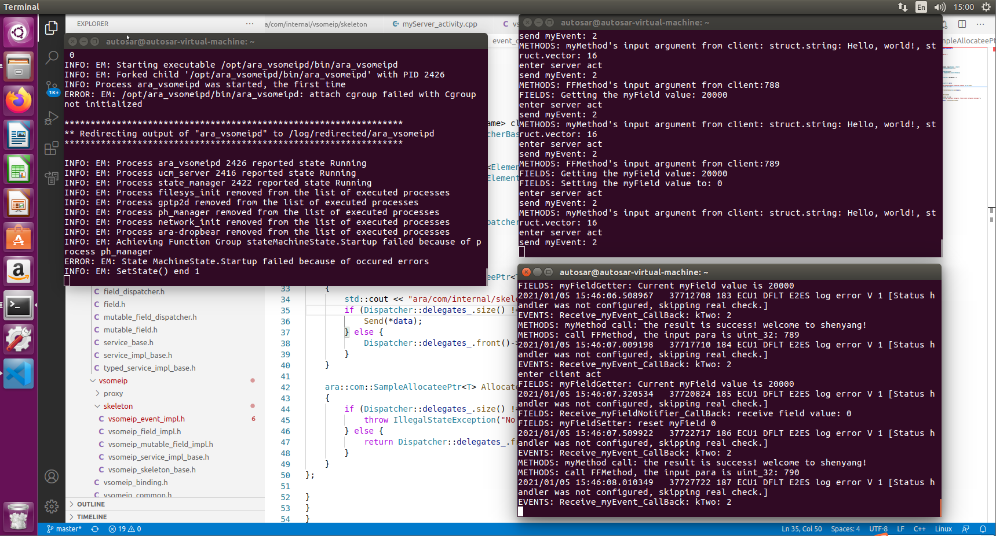

/*string convert to hex convert to uint*/

std::string its_value = itISignalToIPduMapping.getServiceId();

std::stringstream its_converter;

if (its_value.size() > 1 && its_value[0] == '0' && its_value[1] == 'x') {

its_converter << std::hex << its_value;

} else {

its_converter << std::dec << its_value;

}

its_converter >> serviceid;

/home/autosar/cm_output_trunk/code/myClient/gen/myClient/includes/ara/com/sample/myinterface_proxy.h: In instantiation of ‘ara::core::Future<T> ara::com::sample::proxy::fields::myFieldProxy<T, E2E>::Get() [with T = unsigned int; bool E2E = true]’:

/home/autosar/cm_output_trunk/code/myClient/src/myClient_activity.cpp:109:44: required from here

/home/autosar/cm_output_trunk/code/myClient/gen/myClient/includes/ara/com/sample/myinterface_proxy.h:105:24: error: could not convert ‘ara::com::internal::proxy::Method<ara::com::internal::FieldGetResultType<unsigned int>()>::operator()()’ from ‘ara::core::Future<ara::com::internal::FieldGetResultType<unsigned int>, ara::core::ErrorCode>’ to ‘ara::core::Future<unsigned int, ara::core::ErrorCode>’

return field.Get();

^

/home/autosar/cm_output_trunk/code/myClient/gen/myClient/includes/ara/com/sample/myinterface_proxy.h: In instantiation of ‘ara::core::Future<T> ara::com::sample::proxy::fields::myFieldProxy<T, E2E>::Set(ara::com::sample::proxy::fields::myFieldProxy<T, E2E>::const_reference) [with T = unsigned int; bool E2E = true; ara::com::sample::proxy::fields::myFieldProxy<T, E2E>::const_reference = const unsigned int&; ara::com::internal::BaseType<unsigned int> = unsigned int]’:

/home/autosar/cm_output_trunk/code/myClient/src/myClient_activity.cpp:125:49: required from here

/home/autosar/cm_output_trunk/code/myClient/gen/myClient/includes/ara/com/sample/myinterface_proxy.h:112:29: error: could not convert ‘ara::com::internal::proxy::Method<ara::com::internal::FieldGetResultType<unsigned int>(const unsigned int&)>::operator()((* & value))’ from ‘ara::core::Future<ara::com::internal::FieldGetResultType<unsigned int>, ara::core::ErrorCode>’ to ‘ara::core::Future<unsigned int, ara::core::ErrorCode>’

return field.Set(value);

^

myClient/CMakeFiles/myClient.dir/build.make:185: recipe for target 'myClient/CMakeFiles/myClient.dir/src/myClient_activity.cpp.o' failed

make[2]: *** [myClient/CMakeFiles/myClient.dir/src/myClient_activity.cpp.o] Error 1

CMakeFiles/Makefile2:85: recipe for target 'myClient/CMakeFiles/myClient.dir/all' failed

make[1]: *** [myClient/CMakeFiles/myClient.dir/all] Error 2

Makefile:129: recipe for target 'all' failed

make: *** [all] Error 2

[ 7%] Building CXX object myClient/CMakeFiles/myClient.dir/src/myClient_activity.cpp.o

In file included from /home/autosar/cm_output_trunk/code/myClient/includes/myClient_activity.h:36:0,

from /home/autosar/cm_output_trunk/code/myClient/src/myClient_activity.cpp:25:

/home/autosar/cm_output_trunk/code/myClient/gen/myClient/includes/ara/com/sample/myinterface_proxy.h: In instantiation of ‘ara::core::Future<T> ara::com::sample::proxy::fields::myFieldProxy<T, E2E>::Get() [with T = unsigned int; bool E2E = true]’:

/home/autosar/cm_output_trunk/code/myClient/src/myClient_activity.cpp:109:44: required from here

/home/autosar/cm_output_trunk/code/myClient/gen/myClient/includes/ara/com/sample/myinterface_proxy.h:105:24: error: could not convert ‘ara::com::internal::proxy::Method<ara::com::internal::FieldGetResultType<unsigned int>()>::operator()()’ from ‘ara::core::Future<ara::com::internal::FieldGetResultType<unsigned int>, ara::core::ErrorCode>’ to ‘ara::core::Future<unsigned int, ara::core::ErrorCode>’

return field.Get();

^

/home/autosar/cm_output_trunk/code/myClient/gen/myClient/includes/ara/com/sample/myinterface_proxy.h: In instantiation of ‘ara::core::Future<T> ara::com::sample::proxy::fields::myFieldProxy<T, E2E>::Set(ara::com::sample::proxy::fields::myFieldProxy<T, E2E>::const_reference) [with T = unsigned int; bool E2E = true; ara::com::sample::proxy::fields::myFieldProxy<T, E2E>::const_reference = const unsigned int&; ara::com::internal::BaseType<unsigned int> = unsigned int]’:

/home/autosar/cm_output_trunk/code/myClient/src/myClient_activity.cpp:125:49: required from here

/home/autosar/cm_output_trunk/code/myClient/gen/myClient/includes/ara/com/sample/myinterface_proxy.h:112:29: error: could not convert ‘ara::com::internal::proxy::Method<ara::com::internal::FieldGetResultType<unsigned int>(const unsigned int&)>::operator()((* & value))’ from ‘ara::core::Future<ara::com::internal::FieldGetResultType<unsigned int>, ara::core::ErrorCode>’ to ‘ara::core::Future<unsigned int, ara::core::ErrorCode>’

return field.Set(value);

^

myClient/CMakeFiles/myClient.dir/build.make:185: recipe for target 'myClient/CMakeFiles/myClient.dir/src/myClient_activity.cpp.o' failed

make[2]: *** [myClient/CMakeFiles/myClient.dir/src/myClient_activity.cpp.o] Error 1

CMakeFiles/Makefile2:85: recipe for target 'myClient/CMakeFiles/myClient.dir/all' failed

make[1]: *** [myClient/CMakeFiles/myClient.dir/all] Error 2

Makefile:129: recipe for target 'all' failed

make: *** [all] Error 2

十八、模板函数标签查看



nm -C /home/autosar/cm_output_trunk/release/opt/myServer/bin/myServer | grep s2s_cast

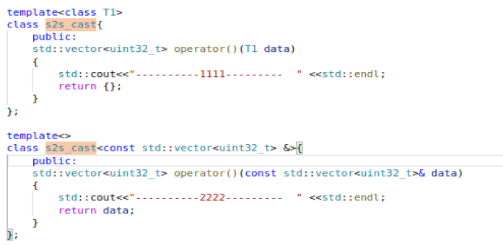

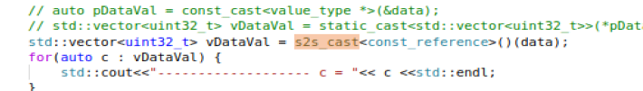

十九、编译盘验证方法：

1. 盘安装

新建虚拟机（选择**IDE**）；

把ISO安装得到（修改IP地址为192.168.83.100,使其和虚拟机同网段）

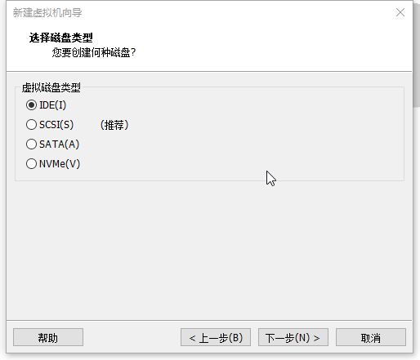

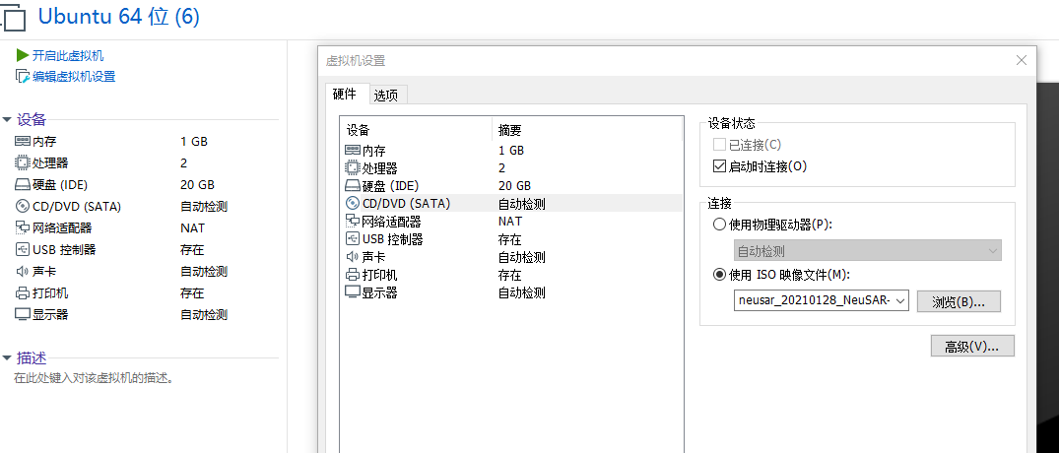

选择第三个，VMware开启x86虚拟机，密码/用户名是root

ifconfig

vi /etc/network/interfaces 配置IP和网关

/etc/init.d/networking restart 重启网络配置

1. 安装sh文件

autosar@autosar-virtual-machine:~$ mkdir sdk

autosar@autosar-virtual-machine:~$ cd sdk

autosar@autosar-virtual-machine:~/sdk$ ls

autosar@autosar-virtual-machine:~/sdk$

autosar@autosar-virtual-machine:~/sdk$

autosar@autosar-virtual-machine:~/sdk$ **rz -y** //弹出文件选择框，选择对应sh文件

rz waiting to receive.

zmodem trl+C ȡ

100% 387737 KB 18463 KB/s 00:00:21 0 ErrorsSAR-A1911_21Q2_001_02N_13965_x86_linux.sh...

autosar@autosar-virtual-machine:~/sdk$ ls

sdk_neusar_20210128_NeuSAR-A1911_21Q2_001_02N_13965_x86_linux.sh

autosar@autosar-virtual-machine:~/sdk$ chmod +x sdk_neusar_20210128_NeuSAR-A1911_21Q2_001_02N_13965_x86_linux.sh //改变sh文件可操作性

autosar@autosar-virtual-machine:~/sdk$ ls

sdk_neusar_20210128_NeuSAR-A1911_21Q2_001_02N_13965_x86_linux.sh

autosar@autosar-virtual-machine:~/sdk$ ./sdk_neusar_20210128_NeuSAR-A1911_21Q2_001_02N_13965_x86_linux.sh //解压缩

Extracting SRC files...

===========================================================================================================================Create hardware toolchain.

===========================================================================================================================Poky (Yocto Project Reference Distro) SDK installer version 2.4.4

=================================================================

You are about to install the SDK to "/home/autosar/sdk/toolchain". Proceed[Y/n]? Y

Extracting SDK..........................done

Setting it up...done

SDK has been successfully set up and is ready to be used.

Each time you wish to use the SDK in a new shell session, you need to source the environment setup script e.g.

$ . /home/autosar/sdk/toolchain/environment-setup-i586-poky-linux

===========================================================================================================================Create NeuSAR.

===========================================================================================================================OK,done.

autosar@autosar-virtual-machine:~/sdk$ ls

sdk_neusar_20210128_NeuSAR-A1911_21Q2_001_02N_13965_x86_linux.sh toolchain

autosar@autosar-virtual-machine:~/sdk$

autosar@autosar-virtual-machine:~/sdk$

autosar@autosar-virtual-machine:~/sdk$ cd toolchain/

autosar@autosar-virtual-machine:~/sdk/toolchain$ ls

compile_app environment-setup-i586-poky-linux site-config-i586-poky-linux toolchain.cmake

environment.config extract_ara_sdk sysroots version-i586-poky-linux

autosar@autosar-virtual-machine:~/sdk/toolchain$

autosar@autosar-virtual-machine:~/sdk/toolchain$

autosar@autosar-virtual-machine:~/sdk/toolchain$ pwd

/home/autosar/sdk/toolchain

autosar@autosar-virtual-machine:~/sdk/toolchain$

1. 上位机编译连接Path

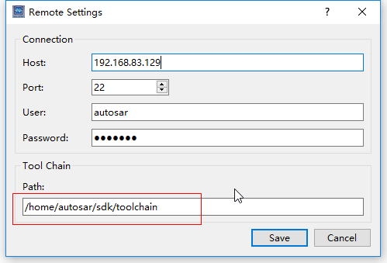

1. 把生成的copy到本地x86环境

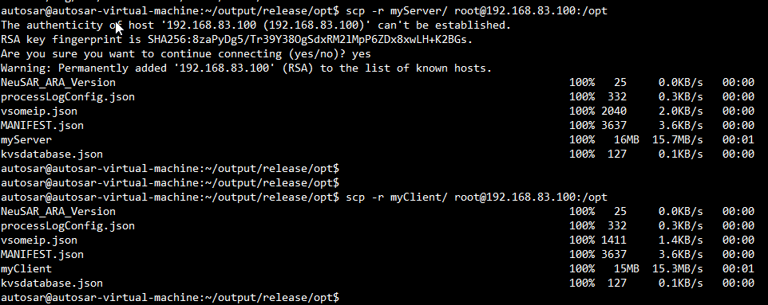

如果需要vsomeip库：

autosar@autosar-virtual-machine:~/1911_auth/build_auth_1911P2_20201231/toolchain/sysroots/i586-poky-linux/usr/lib$ scp -r libvsomeip* root@192.168.83.100:/var/lib/apd_ucm/install/NeuSARPlatform/1.0.0.0000/usr/lib/

拷贝时，如果虚拟机连接失败，执行如下：

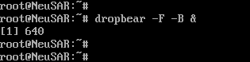

1. 连接本地

ssh root@192.168.83.100

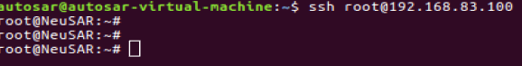

1. 编译小问题总结

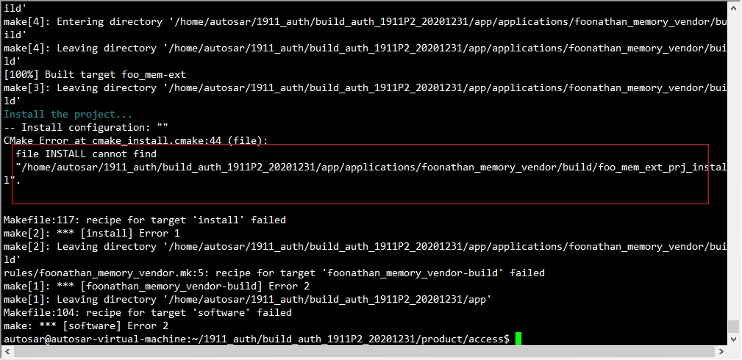

问题现象：先执行make software-clean，再执行make software，报错如上找不到foo_mem_ext_prj*文件；

问题解决：直接删除foonathan_memory_vendor文件夹，重新svn up，再编译。

二十、Gdb调试

autosar@autosar-virtual-machine:~$ ssh -p 456 root@10.170.242.68

root@NeuSAR:~#

root@NeuSAR:~#

root@NeuSAR:~# ps aux | grep exec

root 24308 0.0 0.0 3548 644 pts/6 S+ 14:48 0:00 grep exec

root@NeuSAR:~#

root@NeuSAR:~# gdb myClient

GNU gdb (GDB) 8.0

Copyright (C) 2017 Free Software Foundation, Inc.

License GPLv3+: GNU GPL version 3 or later <http://gnu.org/licenses/gpl.html>

This is free software: you are free to change and redistribute it.

There is NO WARRANTY, to the extent permitted by law. Type "show copying"

and "show warranty" for details.

This GDB was configured as "i586-poky-linux".

Type "show configuration" for configuration details.

For bug reporting instructions, please see:

<http://www.gnu.org/software/gdb/bugs/>.

Find the GDB manual and other documentation resources online at:

<http://www.gnu.org/software/gdb/documentation/>.

For help, type "help".

Type "apropos word" to search for commands related to "word"...

Reading symbols from myClient...done.

(gdb) source dbinit_stl_views-1.03.txt

Redefine command "pvector"? (y or n) [answered Y; input not from terminal]

Redefine command "plist"? (y or n) [answered Y; input not from terminal]

Redefine command "plist_member"? (y or n) [answered Y; input not from terminal]

Redefine command "pmap"? (y or n) [answered Y; input not from terminal]

Redefine command "pmap_member"? (y or n) [answered Y; input not from terminal]

Redefine command "pset"? (y or n) [answered Y; input not from terminal]

Redefine command "pdequeue"? (y or n) [answered Y; input not from terminal]

Redefine command "pstack"? (y or n) [answered Y; input not from terminal]

Redefine command "pqueue"? (y or n) [answered Y; input not from terminal]

Redefine command "ppqueue"? (y or n) [answered Y; input not from terminal]

Redefine command "pbitset"? (y or n) [answered Y; input not from terminal]

Redefine command "pstring"? (y or n) [answered Y; input not from terminal]

Redefine command "pwstring"? (y or n) [answered Y; input not from terminal]

(gdb) start

Temporary breakpoint 1 at 0x811632e: file /home/autosar/cm_output_trunk/code/myClient/myClient.cpp, line 58.

Starting program: /home/root/myClient

[Thread debugging using libthread_db enabled]

Using host libthread_db library "/lib/libthread_db.so.1".

[268377.125425]~DLT~24679~INFO ~FIFO /tmp/dlt cannot be opened. Retrying later...

[New Thread 0xb767bb40 (LWP 24683)]

[New Thread 0xb6e7ab40 (LWP 24684)]

Thread 1 "myClient" hit Temporary breakpoint 1, main (argc=1, argv=0xbffffd74)

at /home/autosar/cm_output_trunk/code/myClient/myClient.cpp:58

58 /home/autosar/cm_output_trunk/code/myClient/myClient.cpp: No such file or directory.

(gdb) b ara::com::internal::vsomeip::proxy::EventImpl<ara::com::sample::myinterface_binding::vsomeip::descriptors::myEvent, std::vector<unsigned int, std::allocator<unsigned int> > >::GetNewSamples(std::function<void (ara::com::Sampl

Function "ara::com::internal::vsomeip::proxy::EventImpl<ara::com::sample::myinterface_binding::vsomeip::descriptors::myEvent, std::vector<unsigned int, std::allocator<unsigned int> > >::GetNewSamples(std::function<void (ara::com::Sampl" not defined.

Make breakpoint pending on future shared library load? (y or [n]) ePtr<std::vector<unsigned int, std::allocator<unsigned int> > const>)>&&, unsigned int)

Please answer y or [n].

Make breakpoint pending on future shared library load? (y or [n]) Quit

(gdb) b ara::com::internal::vsomeip::proxy::EventImpl<ara::com::sample::myinterface_binding::vsomeip::descriptors::myEvent, std::vector<unsigned int, std::allocator<unsigned int> > >::GetNewSamples(std::function<void (ara::com::Sampl

Function "ara::com::internal::vsomeip::proxy::EventImpl<ara::com::sample::myinterface_binding::vsomeip::descriptors::myEvent, std::vector<unsigned int, std::allocator<unsigned int> > >::GetNewSamples(std::function<void (ara::com::Sampl" not defined.

Make breakpoint pending on future shared library load? (y or [n]) ePtr<std::vector<unsigned int, std::allocator<unsigned int> > const>)>&&, unsigned int)

Please answer y or [n].

Make breakpoint pending on future shared library load? (y or [n]) n

(gdb)

Function "ara::com::internal::vsomeip::proxy::EventImpl<ara::com::sample::myinterface_binding::vsomeip::descriptors::myEvent, std::vector<unsigned int, std::allocator<unsigned int> > >::GetNewSamples(std::function<void (ara::com::Sampl" not defined.

Make breakpoint pending on future shared library load? (y or [n])

(gdb)

Function "ara::com::internal::vsomeip::proxy::EventImpl<ara::com::sample::myinterface_binding::vsomeip::descriptors::myEvent, std::vector<unsigned int, std::allocator<unsigned int> > >::GetNewSamples(std::function<void (ara::com::Sampl" not defined.

Make breakpoint pending on future shared library load? (y or [n]) n

(gdb) b ara::com::internal::vsomeip::proxy::EventImpl<ara::com::sample::myinterface_binding::vsomeip::descriptors::myEvent, std::vector<unsigned int, std::allocator<unsigned int> > >::GetNewSamples(std::function<void (ara::com::SamplePtr<std::vector<unsigned int, std::allocator<unsigned int> > const>)>&&, unsigned int)

Breakpoint 2 at 0x812ca5f: file /home/autosar/1911_auth/build_auth_x86/toolchain/sysroots/i586-poky-linux/usr/include/ara/com/internal/vsomeip/proxy/vsomeip_event_impl.h, line 108.

(gdb) set scheduler-locking on //当前线程追踪

(gdb) c

Continuing.

Now, let's start doing something...

[New Thread 0xb6679b40 (LWP 24685)]

client object address 0xb6679240

enter ClientActivity init()

~logLocalData_ size: 108

~logLocalData_ size: 54

~logLocalData_ size: 92

2021-01-25 14:59:30.862030 [info] Parsed vsomeip configuration in 0ms

2021-01-25 14:59:30.862098 [info] Using configuration file: "/etc/vsomeip.json".

2021-01-25 14:59:30.862117 [info] Default configuration module loaded.

2021-01-25 14:59:30.862127 [info] Initializing vsomeip application "no-name".

2021-01-25 14:59:30.862353 [info] SOME/IP client identifier configured. Using 002c (was: 0000)

2021-01-25 14:59:30.862379 [info] Instantiating routing manager [Proxy].

2021-01-25 14:59:30.862477 [info] Client [2c] is connecting to [0] at /tmp/vsomeip-0

2021-01-25 14:59:30.862517 [info] Using e2e configuration file: /etc/e2e_configuration.json

2021-01-25 14:59:30.862551 [info] E2E protection disabled.

2021-01-25 14:59:30.862632 [info] Listening at /tmp/vsomeip-2c

2021-01-25 14:59:30.862656 [info] Application(no-name, 2c) is initialized (11, 100).

[New Thread 0xb5cffb40 (LWP 24686)]

2021-01-25 14:59:30.862927 [info] Starting vsomeip application "no-name" using 2 threads

[New Thread 0xb52ffb40 (LWP 24687)]

2021-01-25 14:59:30.863437 [info] main dispatch thread id from application: 002c (no-name) is: b52ffb40

[New Thread 0xb48ffb40 (LWP 24688)]

2021-01-25 14:59:30.863818 [info] shutdown thread id from application: 002c (no-name) is: b48ffb40

[New Thread 0xb40feb40 (LWP 24689)]

2021-01-25 14:59:30.864183 [info] io thread id from application: 002c (no-name) is: b40feb40

2021-01-25 14:59:30.864220 [info] Client 2c successfully connected to routing ~> registering..

2021-01-25 14:59:30.864434 [info] Application/Client 2c is registered.

2021-01-25 14:59:30.864448 [info] io thread id from application: 002c (no-name) is: b5cffb40

enter client act

Service.instance is not available: 19806.65535

Service.instance is not available: 19806.65535

2021-01-25 14:59:30.874947 [info] ON_AVAILABLE(002c): [0058.0063:1.1]

Instance 99 is available

Created proxy from handle with instance: 99

2021-01-25 14:59:30.885850 [info] ON_AVAILABLE(002c): [0058.0063:1.1]

enter client act

2021-01-25 14:59:31.366101 [info] routing_manager_proxy::register_event service 88 instance 99 state 0

2021-01-25 14:59:31.366409 [info] Client [2c] is connecting to [2b] at /tmp/vsomeip-2b

2021-01-25 14:59:31.367946 [info] SUBSCRIBE ACK(002b): [0058.0063.0001.8021]

enter client act

enter client act

configutation_impl.cpp: serialize_type_: SOMEIP

!!!!!!!!!!!!!!!!!!!!!!!!!!!serialize_type: SOMEIP

someip serialize_type checkmessage

checkmessage success!

[Switching to Thread 0xb52ffb40 (LWP 24687)]

Thread 6 "myClient" hit Breakpoint 2, ara::com::internal::vsomeip::proxy::EventImpl<ara::com::sample::myinterface_binding::vsomeip::descriptors::myEvent, std::vector<unsigned int, std::allocator<unsigned int> > >::GetNewSamples(std::function<void (ara::com::SamplePtr<std::vector<unsigned int, std::allocator<unsigned int> > const>)>&&, unsigned int) (this=0xb4902284, f=..., maxNumberOfSamples=1)

at /home/autosar/1911_auth/build_auth_x86/toolchain/sysroots/i586-poky-linux/usr/include/ara/com/internal/vsomeip/proxy/vsomeip_event_impl.h:108

108 /home/autosar/1911_auth/build_auth_x86/toolchain/sysroots/i586-poky-linux/usr/include/ara/com/internal/vsomeip/proxy/vsomeip_event_impl.h: No such file or directory.

(gdb) n

110 in /home/autosar/1911_auth/build_auth_x86/toolchain/sysroots/i586-poky-linux/usr/include/ara/com/internal/vsomeip/proxy/vsomeip_event_impl.h

(gdb)

115 in /home/autosar/1911_auth/build_auth_x86/toolchain/sysroots/i586-poky-linux/usr/include/ara/com/internal/vsomeip/proxy/vsomeip_event_impl.h

(gdb)

117 in /home/autosar/1911_auth/build_auth_x86/toolchain/sysroots/i586-poky-linux/usr/include/ara/com/internal/vsomeip/proxy/vsomeip_event_impl.h

(gdb)

124 in /home/autosar/1911_auth/build_auth_x86/toolchain/sysroots/i586-poky-linux/usr/include/ara/com/internal/vsomeip/proxy/vsomeip_event_impl.h

(gdb)

125 in /home/autosar/1911_auth/build_auth_x86/toolchain/sysroots/i586-poky-linux/usr/include/ara/com/internal/vsomeip/proxy/vsomeip_event_impl.h

(gdb)

127 in /home/autosar/1911_auth/build_auth_x86/toolchain/sysroots/i586-poky-linux/usr/include/ara/com/internal/vsomeip/proxy/vsomeip_event_impl.h

(gdb)

129 in /home/autosar/1911_auth/build_auth_x86/toolchain/sysroots/i586-poky-linux/usr/include/ara/com/internal/vsomeip/proxy/vsomeip_event_impl.h

(gdb)

130 in /home/autosar/1911_auth/build_auth_x86/toolchain/sysroots/i586-poky-linux/usr/include/ara/com/internal/vsomeip/proxy/vsomeip_event_impl.h

(gdb)

132 in /home/autosar/1911_auth/build_auth_x86/toolchain/sysroots/i586-poky-linux/usr/include/ara/com/internal/vsomeip/proxy/vsomeip_event_impl.h

(gdb)

135 in /home/autosar/1911_auth/build_auth_x86/toolchain/sysroots/i586-poky-linux/usr/include/ara/com/internal/vsomeip/proxy/vsomeip_event_impl.h

(gdb)

138 in /home/autosar/1911_auth/build_auth_x86/toolchain/sysroots/i586-poky-linux/usr/include/ara/com/internal/vsomeip/proxy/vsomeip_event_impl.h

(gdb)

144 in /home/autosar/1911_auth/build_auth_x86/toolchain/sysroots/i586-poky-linux/usr/include/ara/com/internal/vsomeip/proxy/vsomeip_event_impl.h

(gdb)

146 in /home/autosar/1911_auth/build_auth_x86/toolchain/sysroots/i586-poky-linux/usr/include/ara/com/internal/vsomeip/proxy/vsomeip_event_impl.h

(gdb)

148 in /home/autosar/1911_auth/build_auth_x86/toolchain/sysroots/i586-poky-linux/usr/include/ara/com/internal/vsomeip/proxy/vsomeip_event_impl.h

(gdb)

147 in /home/autosar/1911_auth/build_auth_x86/toolchain/sysroots/i586-poky-linux/usr/include/ara/com/internal/vsomeip/proxy/vsomeip_event_impl.h

(gdb)

~logLocalData_ size: 62

149 in /home/autosar/1911_auth/build_auth_x86/toolchain/sysroots/i586-poky-linux/usr/include/ara/com/internal/vsomeip/proxy/vsomeip_event_impl.h

(gdb)

153 in /home/autosar/1911_auth/build_auth_x86/toolchain/sysroots/i586-poky-linux/usr/include/ara/com/internal/vsomeip/proxy/vsomeip_event_impl.h

(gdb)

154 in /home/autosar/1911_auth/build_auth_x86/toolchain/sysroots/i586-poky-linux/usr/include/ara/com/internal/vsomeip/proxy/vsomeip_event_impl.h

(gdb)

155 in /home/autosar/1911_auth/build_auth_x86/toolchain/sysroots/i586-poky-linux/usr/include/ara/com/internal/vsomeip/proxy/vsomeip_event_impl.h

(gdb)

157 in /home/autosar/1911_auth/build_auth_x86/toolchain/sysroots/i586-poky-linux/usr/include/ara/com/internal/vsomeip/proxy/vsomeip_event_impl.h

(gdb)

configutation_impl.cpp: serialize_type_: SOMEIP

158 in /home/autosar/1911_auth/build_auth_x86/toolchain/sysroots/i586-poky-linux/usr/include/ara/com/internal/vsomeip/proxy/vsomeip_event_impl.h

(gdb)

```````````````````````serialize_type: SOMEIP

160 in /home/autosar/1911_auth/build_auth_x86/toolchain/sysroots/i586-poky-linux/usr/include/ara/com/internal/vsomeip/proxy/vsomeip_event_impl.h

(gdb)

167 in /home/autosar/1911_auth/build_auth_x86/toolchain/sysroots/i586-poky-linux/usr/include/ara/com/internal/vsomeip/proxy/vsomeip_event_impl.h

(gdb)

169 in /home/autosar/1911_auth/build_auth_x86/toolchain/sysroots/i586-poky-linux/usr/include/ara/com/internal/vsomeip/proxy/vsomeip_event_impl.h

(gdb)

171 in /home/autosar/1911_auth/build_auth_x86/toolchain/sysroots/i586-poky-linux/usr/include/ara/com/internal/vsomeip/proxy/vsomeip_event_impl.h

(gdb) p pS

pS0 pS3 pS6 pS9 pSampleValue2

pS1 pS4 pS7 pSample

pS2 pS5 pS8 pSampleValue

(gdb) p *pSampleValue //打印pSampleValue

$1 = {

<std::_Vector_base<unsigned int, std::allocator<unsigned int> >> = {

_M_impl = {

<std::allocator<unsigned int>> = {

<__gnu_cxx::new_allocator<unsigned int>> = {<No data fields>}, <No data fields>},

members of std::_Vector_base<unsigned int, std::allocator<unsigned int> >::_Vector_impl:

_M_start = 0xb4902c50,

_M_finish = 0xb4902c68,

_M_end_of_storage = 0xb4902c68

}

}, <No data fields>}

(gdb) n

172 in /home/autosar/1911_auth/build_auth_x86/toolchain/sysroots/i586-poky-linux/usr/include/ara/com/internal/vsomeip/proxy/vsomeip_event_impl.h

(gdb) pvector aaa

elem[0]: $2 = 8

elem[1]: $3 = 100

elem[2]: $4 = 101

elem[3]: $5 = 102

elem[4]: $6 = 103

elem[5]: $7 = 104

Vector size = 6

Vector capacity = 6

Element type = std::_Vector_base<unsigned int, std::allocator<unsigned int> >::pointer

(gdb) n

173 in /home/autosar/1911_auth/build_auth_x86/toolchain/sysroots/i586-poky-linux/usr/include/ara/com/internal/vsomeip/proxy/vsomeip_event_impl.h

(gdb) n

============ c = 8

172 in /home/autosar/1911_auth/build_auth_x86/toolchain/sysroots/i586-poky-linux/usr/include/ara/com/internal/vsomeip/proxy/vsomeip_event_impl.h

(gdb)

173 in /home/autosar/1911_auth/build_auth_x86/toolchain/sysroots/i586-poky-linux/usr/include/ara/com/internal/vsomeip/proxy/vsomeip_event_impl.h

(gdb)

============ c = 100

172 in /home/autosar/1911_auth/build_auth_x86/toolchain/sysroots/i586-poky-linux/usr/include/ara/com/internal/vsomeip/proxy/vsomeip_event_impl.h

(gdb)

173 in /home/autosar/1911_auth/build_auth_x86/toolchain/sysroots/i586-poky-linux/usr/include/ara/com/internal/vsomeip/proxy/vsomeip_event_impl.h

(gdb)

============ c = 101

172 in /home/autosar/1911_auth/build_auth_x86/toolchain/sysroots/i586-poky-linux/usr/include/ara/com/internal/vsomeip/proxy/vsomeip_event_impl.h

(gdb)

173 in /home/autosar/1911_auth/build_auth_x86/toolchain/sysroots/i586-poky-linux/usr/include/ara/com/internal/vsomeip/proxy/vsomeip_event_impl.h

(gdb)

============ c = 102

172 in /home/autosar/1911_auth/build_auth_x86/toolchain/sysroots/i586-poky-linux/usr/include/ara/com/internal/vsomeip/proxy/vsomeip_event_impl.h

(gdb)

173 in /home/autosar/1911_auth/build_auth_x86/toolchain/sysroots/i586-poky-linux/usr/include/ara/com/internal/vsomeip/proxy/vsomeip_event_impl.h

(gdb)

============ c = 103

172 in /home/autosar/1911_auth/build_auth_x86/toolchain/sysroots/i586-poky-linux/usr/include/ara/com/internal/vsomeip/proxy/vsomeip_event_impl.h

(gdb)

173 in /home/autosar/1911_auth/build_auth_x86/toolchain/sysroots/i586-poky-linux/usr/include/ara/com/internal/vsomeip/proxy/vsomeip_event_impl.h

(gdb)

============ c = 104

172 in /home/autosar/1911_auth/build_auth_x86/toolchain/sysroots/i586-poky-linux/usr/include/ara/com/internal/vsomeip/proxy/vsomeip_event_impl.h

(gdb)

175 in /home/autosar/1911_auth/build_auth_x86/toolchain/sysroots/i586-poky-linux/usr/include/ara/com/internal/vsomeip/proxy/vsomeip_event_impl.h

(gdb) n

176 in /home/autosar/1911_auth/build_auth_x86/toolchain/sysroots/i586-poky-linux/usr/include/ara/com/internal/vsomeip/proxy/vsomeip_event_impl.h

(gdb) p bbb

$8 = 8 '\b'

(gdb) n

============ bbb =

178 in /home/autosar/1911_auth/build_auth_x86/toolchain/sysroots/i586-poky-linux/usr/include/ara/com/internal/vsomeip/proxy/vsomeip_event_impl.h

(gdb)

181 in /home/autosar/1911_auth/build_auth_x86/toolchain/sysroots/i586-poky-linux/usr/include/ara/com/internal/vsomeip/proxy/vsomeip_event_impl.h

(gdb) n

182 in /home/autosar/1911_auth/build_auth_x86/toolchain/sysroots/i586-poky-linux/usr/include/ara/com/internal/vsomeip/proxy/vsomeip_event_impl.h

(gdb) p pSampleValue2

$9 = (ara::com::internal::vsomeip::proxy::EventImpl<ara::com::sample::myinterface_binding::vsomeip::descriptors::myEvent, std::vector<unsigned int, std::allocator<unsigned int> > >::value_type *) 0xb4902180

(gdb)